# 2 Computing and reporting descriptive statistics The R-Team and the Troubling Transgender Health Care Problem

Leslie was excited for the second meeting of the R-Team. She met Kiara and Nancy at a local café for lunch.

Nancy said, “Today, I thought we would discuss descriptive statistics.” Consistent with the name, she explained, descriptive statistics are statistics that describe whatever is being studied, like people or organizations. Descriptive statistics are important since they provide information about the characteristics of the observations in a data set and provide context for interpretation of the results from complex statistical tests. Descriptive statistics may also be used to help choose the correct statistical test to use to answer your questions.

“Sounds good,” Leslie said. Then she shared the rest of her fries with the team. After getting used to the R environment and preparing data for analysis with the pot policy problem, Leslie had her own idea to propose. “So I was listening to a podcast about the issue of transgender health and how transgender patients are treated in a system that has traditionally focused on two sexes, and I wondered if we might tackle that with R?”

“Totally,” said Kiara.

“Right after I finish my sandwich,” Nancy said.

Kiara chuckled and said, “After that, let’s develop a list of R achievements to improve Leslie’s R skills while we work together on understanding transgender health care.”

# 2.1 Achievements to unlock

* Achievement 1: Understanding variable types and data types
* Achievement 2: Choosing and conducting descriptive analyses for categorical (factor) variables
* Achievement 3: Choosing and conducting descriptive analyses for continuous (numeric) variables
* Achievement 4: Developing clear tables for reporting descriptive statistics

# 2.2 The transgender health care problem

Before coming to meet with Nancy and Kiara, Leslie had done some reading on the problem, including a recent paper on mammography that demonstrated some of the challenges for transgender people in the current system. Over lunch, she summarized what she’d found.

First, Leslie wanted to clarify the definition of transgender to make sure they were all on the same page. Leslie told them she thought the term *sex* referred to biology and the term *gender* referred to identity. Nancy agreed with the definition of sex, but had heard broader definitions of gender that included biological, psychosocial, and cultural factors along with identity (Mayer et al., 2008). She looked up the World Health Organization’s definition for gender:

Gender refers to the socially constructed characteristics of women and men—such as norms, roles and relationships of and between groups of women and men. It varies from society to society and can be changed. While most people are born either male or female, they are taught appropriate norms and behaviours—including how they should interact with others of the same or opposite sex within households, communities and work places. (World Health Organization [WHO], 2019)

*Note:* In shaded sections throughout this text, the rows starting “##” show the output that will appear after running the R code just above it.

Leslie was glad they looked this up because it was much clearer than her initial description. She went on to explain that *transgender* people are people whose *biological sex* is not consistent with their *gender* (Mayer et al., 2008). She quoted an article from 2008 that she thought had a definition that might be helpful: “Transgender is an inclusive term to describe people who have gender identities, expressions, or behaviors not traditionally associated with their birth sex” (Mayer et al., 2008, p. 990).

The paper Leslie read gave a few examples of transgender, including a person who is biologically female but identifies as a man, a person who is biologically male but identifies as a woman, or someone who feels like both genders or neither gender (Mayer et al., 2008). Nancy looked at the Centers for Disease Control and Prevention (CDC) website, which explained that gender identity is the gender a person identifies as, and gender expression is the gender a person outwardly shows (CDC, n.d.). When describing individuals, typically the person’s chosen identity is included. So, a person who is biologically female but identifies as a man would be described as a “transgender man.” Kiara said that was consistent with what she’d experienced when she learned that her second cousin was transgender. For a while, it had been difficult to remember to refer to her cousin, who had previously been *she*, as *he*. Leslie and Nancy nodded. Sensing they were ready to proceed, Leslie gave some background on health and health care for transgender people.

Transgender people face serious physical and mental health disparities (Safer et al., 2016), often related to discrimination (Bradford, Reisner, Honnold, & Xavier, 2013). Among the most prevalent and concerning disparities are extremely high rates of HIV and other sexually transmitted infections, poor mental health, and high rates of substance use and abuse. For example, transgender women have a 19.1% prevalence of HIV worldwide (Baral et al., 2013), while reproductive-aged adults have an HIV prevalence of 0.4%. A survey of transgender adults in the United States found that 44.1% have clinical depression, 33.2% have anxiety, and 27.5% have somatization symptoms (i.e., physical symptoms stemming from depression, anxiety, or another psychiatric condition; Lombardi, 2010). Attempted suicide rates range from 32% to 50% of transgender people worldwide, with higher rates among younger age groups (Virupaksha, Muralidhar, & Ramakrishna, 2016).

In 2001, an Institute of Medicine report found that 35.5% of transgender adults are current smokers; this is more than twice the percentage of cisgender (i.e., people whose gender identity matches their biological sex) adults (14.9% smoking rate) (Institute of Medicine, 2001). Transgender adults also have higher rates of alcohol and substance abuse (Benotsch et al., 2013; Santos et al., 2014) and of overweight and obesity (Boehmer, Bowen, & Bauer, 2007). Exacerbating these health disparities are limitations on access to health care (Meyer, Brown, Herman, Reisner, & Bockting, 2017) and limitations of the health care system to effectively address the unique health needs of transgender people (Daniel & Butkus, 2015; Reisner et al., 2016).

Given the high smoking rate, substance and alcohol use, and the prevalence of overweight and obesity, it is important that transgender people are adequately screened for cancer and other health conditions. Leslie found conflicting evidence about screening for transgender people. A 2015 study that examined medical charts from 2012–2013 found that transgender adults had 47% lower odds of breast cancer screening than cisgender adults (Bazzi, Whorms, King, & Potter, 2015). However, a different study published in 2017 and based on 2014 survey data reported that transgender and nontransgender adults have comparable rates of mammography screening (Narayan, Lebron-Zapata, & Morris, 2017). Nancy suggested maybe the rate is increasing over time, but Kiara thought the data were not collected far enough apart for that to be the case. She thought the survey data, which were a representative sample of U.S. residents from the Behavioral Risk Factor Surveillance System (BRFSS) survey, in the 2017 study likely measured people with different characteristics from the people in the 2015 study, which reviewed charts from people seeking care at an urban clinic.

Leslie looked up the BRFSS (<https://www.cdc.gov/brfss/index.html>) and found that it is a large national survey conducted by the CDC in the United States by phone every year. The 2017 mammogram paper was based on data from participants who responded to the 2014 BRFSS survey. The 2014 BRFSS was administered by states and had 464,664 participants. The BRFSS sampling process was designed so that the sample would represent the U.S. population as much as possible. The survey included questions about characteristics like age, sex, and income, along with questions about health behaviors and outcomes.

In 2014, 19 states and Guam included a question on the BRFSS about transgender transition status, with choices of male to female (MtF), female to male (FtM), or non-conforming. The entire sample from the 19 states and Guam contained 151,456 people. Of the 151,456 participants, the study authors identified 222 survey participants who reported they were transgender, were 40–74 years old (the age range when mammograms are recommended), and were asked about having a mammogram (Narayan, Lebron-Zapata, & Morris, 2017). The mammogram question was only asked of those who described themselves as being female sex.

Leslie shared the first table of statistics, published as Table 1 in Narayan et al. (2017), with Kiara and Nancy.

Kiara explained that, prior to examining statistical relationships among variables, published studies in academic journals usually present descriptive statistics like the ones in [Table 2.1](https://jigsaw.vitalsource.com/books/9781506388144/epub/OEBPS/s9781506388175.i1382.xhtml#s9781506388175.i1393). She added that descriptive statistics are often displayed in the first table in a published article or report and are therefore sometimes referred to as the *Table 1* statistics or, even more commonly, as the *descriptives*. She also pointed out that, in this case, all the descriptives in the transgender health paper were percentages showing the percent of people in each category. She explained that percentages were computed for this table because of the types of variables the researchers examined. Now that they had some background and an idea of the topic and data they were working with, Nancy and Kiara were ready to get started.

**Table 2.1** Reproduced Table 1, “Transgender Survey Participant Demographics,” from Narayan et al. (2017)

| Table 2.1 Reproduced Table 1, “Transgender Survey Participant Demographics,” from Narayan et al. (2017) | |
| --- | --- |
| Survey participant demographics (*n* = 220) | Percent |
| **Transition status** | |
| Male to female | 35.0 |
| Female to male | 50.9 |
| Gender non-conforming | 14.1 |
| **Age category** | |
| 40–44 | 12.2 |
| 45–49 | 12.2 |
| 50–54 | 14.4 |
| 55–59 | 19.8 |
| 60–64 | 19.8 |
| 65–69 | 10.8 |
| 70–74 | 10.8 |
| **Race/ethnicity** | |
| White | 68.5 |
| Black | 14.0 |
| Native American | 1.8 |
| Asian/Pacific Islander | 2.7 |
| Other | 13.1 |
| **Income category** | |
| Less than $15,000 | 20.7 |
| $15,000 to less than $25,000 | 19.8 |
| $25,000 to less than $35,000 | 8.6 |
| $35,000 to less than $50,000 | 11.7 |
| $50,000 or more | 29.3 |
| Don’t know/not sure/missing | 9.9 |
| **Education category** | |
| Did not graduate high school | 10.8 |
| Graduated high school | 38.7 |
| Attended college/technical school | 30.6 |
| Graduated from college/technical school | 19.8 |
| **Health insurance?** | |
| Yes | 89.2 |

# 2.3 Data, codebook, and R packages for learning about descriptive statistics

Before they examined the data, Kiara made a list of all the data, documentation, and R packages needed for learning descriptive statistics.

* Two options for accessing the data[∗](https://jigsaw.vitalsource.com/books/9781506388144/epub/OEBPS/s9781506388175.i1382.xhtml#s9781506388175.i1420)
  + Download the clean data file **transgender_hc_ch2.csv** from [**edge.sagepub.com/harris1e**](http://edge.sagepub.com/harris1e)
  + Follow the instructions in [Box 2.1](https://jigsaw.vitalsource.com/books/9781506388144/epub/OEBPS/s9781506388175.i1382.xhtml#s9781506388175.i1440) to download and clean the data directly from the Internet
* Two options for accessing the codebook
  + Download **brfss_2014_codebook.pdf** from [**edge.sagepub.com/harris1e**](http://edge.sagepub.com/harris1e)
  + Download the codebook from the Behavioral Risk Factor Surveillance Survey website (<https://www.cdc.gov/brfss/index.html>)
* Install R packages if not already installed
  + **tidyverse**, by Hadley Wickham (<https://www.rdocumentation.org/packages/tidyverse/>)
  + [***haven***](https://jigsaw.vitalsource.com/books/9781506388144/epub/OEBPS/s9781506388175.i4970.xhtml#s9781506388175.i7112), by Hadley Wickham (<https://www.rdocumentation.org/packages/haven/>)
  + [***Hmisc***](https://jigsaw.vitalsource.com/books/9781506388144/epub/OEBPS/s9781506388175.i4970.xhtml#s9781506388175.i7115), by Frank E. Harrell Jr. (<https://www.rdocumentation.org/packages/Hmisc/>)
  + [***descr***](https://jigsaw.vitalsource.com/books/9781506388144/epub/OEBPS/s9781506388175.i4970.xhtml#s9781506388175.i7066), by Jakson Alves de Aquino (<https://www.rdocumentation.org/packages/descr/>)
  + [***tableone***](https://jigsaw.vitalsource.com/books/9781506388144/epub/OEBPS/s9781506388175.i4970.xhtml#s9781506388175.i7280) (Yoshida, n.d.)
  + [***kableExtra***](https://jigsaw.vitalsource.com/books/9781506388144/epub/OEBPS/s9781506388175.i4970.xhtml#s9781506388175.i7130), by Hao Zhu (<https://www.rdocumentation.org/packages/kableExtra/>)
  + [***semTools***](https://jigsaw.vitalsource.com/books/9781506388144/epub/OEBPS/s9781506388175.i4970.xhtml#s9781506388175.i7254), by Terry Jorgensen (<https://www.rdocumentation.org/packages/semTools/>)
  + [***qualvar***](https://jigsaw.vitalsource.com/books/9781506388144/epub/OEBPS/s9781506388175.i4970.xhtml#s9781506388175.i7228), by Joel Gombin (<https://cran.r-project.org/web/packages/qualvar/index.html>)
  + [***labelled***](https://jigsaw.vitalsource.com/books/9781506388144/epub/OEBPS/s9781506388175.i4970.xhtml#s9781506388175.i7135), by Joseph Larmarange (<https://www.rdocumentation.org/packages/labelled/>)
  + [***knitr***](https://jigsaw.vitalsource.com/books/9781506388144/epub/OEBPS/s9781506388175.i4970.xhtml#s9781506388175.i7131), by Yihui Xie (<https://www.rdocumentation.org/packages/knitr/>)

[∗](https://jigsaw.vitalsource.com/books/9781506388144/epub/OEBPS/s9781506388175.i1382.xhtml#s9781506388175.i1396) While many internet data sources are stable, some will be periodically updated or corrected. Use of updated data sources may result in slightly different results when following along with the examples in the text.

# 2.4 Achievement 1: Understanding variable types and data types

## 2.4.1 Data types for categorical variables

In [Section 1.7](https://jigsaw.vitalsource.com/books/9781506388144/epub/OEBPS/s9781506388175.i1081.xhtml#s9781506388175.i1193), Kiara introduced Leslie to several data types, including factor, numeric, integer, and character. Arguably, the two data types most commonly used in social science research are factor and numeric. Kiara reminded Leslie that the factor data type is used for information that is measured or coded in categories, or categorical variables. Leslie remembered from the previous meeting that there were two types of categorical variables, nominal and ordinal.

Nominal categorical variables are variables measured in categories that do not have any logical order, like marital status, religion, sex, and race. Ordinal categorical variables have categories with a logical order. One way Leslie liked to remember this was to notice that ordinal and order both start with *o-r-d*, so ordinal variables have an order. For example, income can be measured in categories such as <$10,000, $10,000–$24,999, $25,000–$99,999, and $100,000+. These categories have a logical order from the lowest income group to the highest income group.

One common ordinal way of measuring things is the use of a [***Likert scale***](https://jigsaw.vitalsource.com/books/9781506388144/epub/OEBPS/s9781506388175.i4970.xhtml#s9781506388175.i7143). Likert scales have categories that go in a logical order from *least to most* or *most to least*. For example, Leslie suggested that measuring agreement with the statement “R is awesome” could use a Likert scale with the following options: *strongly agree, somewhat agree, neutral, somewhat disagree, strongly disagree*. Leslie explained that often people refer to the number of categories as the *points* in a Likert scale. The agreement scale from *strongly agree* to *strongly disagree* is a 5-point Likert scale because there are five options along the scale.

## 2.4.2 Data types for continuous variables

On the other hand, explained Kiara, the numeric data type in R is used for continuous variables. Leslie confirmed that continuous variables are the variables that can take *any* value along some continuum, hence continuous. Just like *o-r-d* is in order and ordinal, *c-o-n* is in continuum and continuous, which can be a good way to remember this variable type. Examples of continuous variables include age, height, weight, distance, blood pressure, temperature, and so on.

Kiara explained that the numeric data type is also often used for variables that do not technically qualify as continuous but are measured along some sort of a continuum. Age in years would be one example since it falls along a continuum from 0 years old to over 100. However, by specifying age *in years,* the values for this variable cannot be any value between 0 and over 100, but instead are limited to the whole numbers in this range. Likewise, the number of cars in a parking lot, or the number of coins in a piggy bank, would be numeric but not truly continuous. If the variable is a whole number, the integer data type could also be used, but it has more limitations for analysis than does the numeric data type in R.

Leslie knew that each different type of variable required a different approach for analysis. Before getting into any complex statistical odelling, she remembered that descriptive statistics are key for understanding who or what is in the data set and often help in choosing an appropriate statistical test.

## 2.4.3 Achievement 1: Check your understanding

Identify the most appropriate data type for the following variables:

* Number of healthy days per month
* Marital status
* Religious affiliation
* Smoking status
* Number of alcoholic beverages per week

# 2.5 Achievement 2: Choosing and conducting descriptive analyses for categorical (factor) variables

Since the table from the paper ([Table 2.1](https://jigsaw.vitalsource.com/books/9781506388144/epub/OEBPS/s9781506388175.i1382.xhtml#s9781506388175.i1393)) shows all categorical variables, the R-Team started there. Leslie knew that the two most commonly used and reported descriptive statistics for categorical (or factor) data types are frequencies and percentages. For a categorical variable, frequencies are the number of observations—often people or organizations—that fall into a given category. Percentages are the proportion of all observations that fall into a given category.

## 2.5.1 Computing frequencies and frequency distributions

Leslie also remembered that a [***frequency distribution***](https://jigsaw.vitalsource.com/books/9781506388144/epub/OEBPS/s9781506388175.i4970.xhtml#s9781506388175.i7098) shows the number of observations in each category for a factor or categorical variable. She suggested that they could use a frequency distribution to examine how many observations there were for each transgender transition category in the BRFSS data set from the mammogram paper.

Before getting started, the team looked through the 2014 BRFSS codebook together, which they found on the CDC BRFSS website (CDC, 2015). They found the transgender transition status information on page 83 of the codebook. The frequency distribution shown in the codebook indicated 363 MtF transgender, 212 FtM transgender, 116 gender non-conforming, 150,765 not transgender, 1,138 don’t know/not sure, 1,468 refused, and 310,602 not asked or missing ([Figure 2.1](https://jigsaw.vitalsource.com/books/9781506388144/epub/OEBPS/s9781506388175.i1382.xhtml#s9781506388175.i1438)).

Kiara suggested that Leslie re-create this frequency distribution in R by first opening the BRFSS data file and then using an R function for frequencies. On the BRFSS website (<https://www.cdc.gov/brfss/index.html>), the data file is available in ***[xpt](https://jigsaw.vitalsource.com/books/9781506388144/epub/OEBPS/s9781506388175.i4970.xhtml" \l "s9781506388175.i7305)*** or [***ASCII***](https://jigsaw.vitalsource.com/books/9781506388144/epub/OEBPS/s9781506388175.i4970.xhtml#s9781506388175.i7011) format. The xpt is a file format used by SAS statistical software; Kiara explained that one of the great features of R is that it can open most data sets from most software packages. This is one of the features of R that makes it easier to do reproducible work. She said R can open the xpt file type by using the **haven** package that is part of the **tidyverse** in R. For now, Kiara said she had already downloaded, opened, and cleaned the data, so they did not need to do all of that. Leslie was interested in understanding how she did this, so Kiara shared with Leslie the code she used to download the data so that she could review it later ([Box 2.1](https://jigsaw.vitalsource.com/books/9781506388144/epub/OEBPS/s9781506388175.i1382.xhtml#s9781506388175.i1440)).

**Figure 2.1** 2014 Behavioral Risk Factor Surveillance Survey (BRFSS) codebook page 83

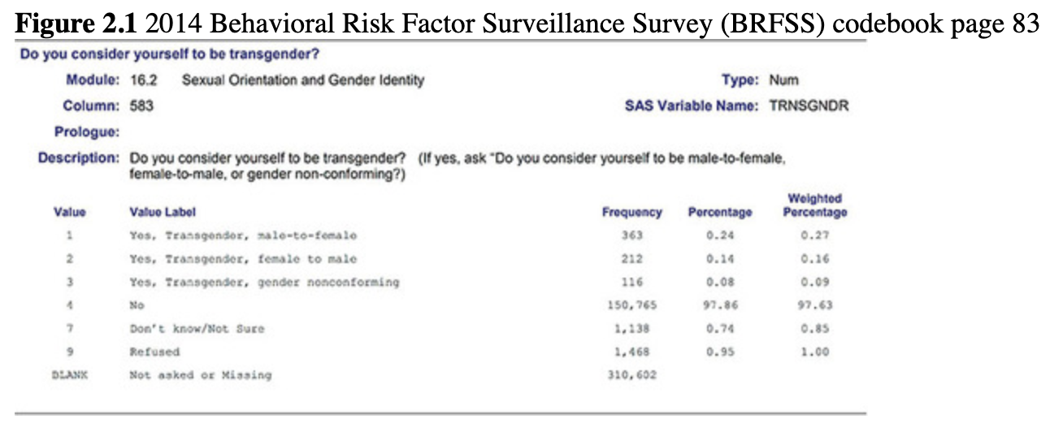

2.1 Kiara’s reproducibility resource: Bringing data in directly from the Internet

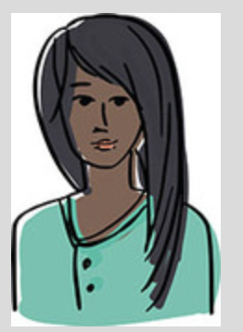

The more that can be done in R with documented and organized code, the more reproducible analyses will be. If the entire process of importing, managing, analyzing, and reporting results can all be together in a single document, the opportunity for errors is greatly decreased.

The BRFSS data set can be found on the CDC website in a zipped SAS transport file with the file extension of xpt. It is possible to bring data directly into R from websites. One of the ways to do this is with the **haven** package. The process is not straightforward like the read.csv() function or other importing functions are. The **haven** package cannot unzip and import an xpt file directly from the Internet, so the file has to be imported into a temporary location on a local computer and then read using read_xpt() from **haven**. Kiara wrote out the steps for downloading, importing, and exporting the data from a zipped xpt file online. Note that the download.file() function will take several minutes to run on most personal computers.

*# open the haven package to read an xpt*

**library**(package = "haven")

*# create a temporary file to store the zipped file*

*# before you open it*

temp <- **tempfile**(fileext = ".zip")

*# use download.file to put the zipped file in the temp file*

*# this will take a couple of minutes depending on computer speed*

**download.file**(url = "<http://www.cdc.gov/brfss/annual_data/2014/files/LLCP2014XPT.zip>",

destfile = temp)

*# unzip it and read it*

brfss.2014 <- **read_xpt**(file = temp)

# open tidyverse to select variables

**library**(package = "tidyverse")

# select variables for analysis

# use ` around variable names starting with underscores

transgender_hc_ch2 <- brfss.2014 **%>%**

**select**(TRNSGNDR, _AGEG5YR_AGEG5YR, _RACE_RACE, _INCOMG_INCOMG, _EDUCAG_EDUCAG,

   HLTHPLN1, HADMAM, _AGE80_AGE80, PHYSHLTH)

# export the data set to a csv file in a local folder called data

**write.csv**(x = transgender_hc_ch2,

      file = "[data folder location]/data/transgender_hc_ch2.csv",

      row.names = FALSE)

After importing the data, Kiara exported a [***csv***](https://jigsaw.vitalsource.com/books/9781506388144/epub/OEBPS/s9781506388175.i4970.xhtml#s9781506388175.i7053) (comma separated values) file with the variables needed to re-create the table. Nancy reminded Leslie of the read.csv() function to import the data from their previous meeting. Leslie wrote a line of code, being sure to use the object naming recommendations she’d learned during the data preparation day. She entered the location where the **transgender_hc_ch2.csv** data file was saved between the quote marks after file = in the read.csv() function.

*# read the 2014 BRFSS data*

brfss.trans.2014 <- **read.csv**(file = "[data folder location]/data/transgender_hc_ch2.csv")

Leslie highlighted the code and used the Run button to import the data. The data appeared in the Environment tab in the top right pane of RStudio. The entry in the Environment tab was under the Data heading and was called brfss.trans.2014 (the name given to the object). Next to the data frame name, Leslie saw that there were 464,664 observations and nine variables in the data frame.

This indicates that the data set contains 464,664 observations, or 464,664 people in this case. This was consistent with the codebook, so Leslie was assured that these were the data she was looking for.

Leslie used summary() to learn more about the data before starting to compute other statistics.

*# examine the data*

**summary**(object = brfss.trans.2014)

##  TRNSGNDR      X_AGEG5YR     X_RACE     X_INCOMG

## Min.  :1.00   Min.  : 1.000  Min.  : 1.000  Min.  :1.000

## 1st Qu.:4.00   1st Qu.: 5.000  1st Qu.: 1.000  1st Qu.:3.000

## Median :4.00   Median : 8.000  Median : 1.000  Median :5.000

## Mean  :4.06   Mean  : 7.822  Mean  : 1.992  Mean  :4.481

## 3rd Qu.:4.00   3rd Qu.:10.000  3rd Qu.: 1.000  3rd Qu.:5.000

## Max.  :9.00   Max.  :14.000  Max.  : 9.000  Max.  :9.000

## NA's  :310602            NA's  :94

##  X_EDUCAG     HLTHPLN1     HADMAM      X_AGE80

## Min.  :1.000   Min.  :1.000   Min.  : 1.00   Min.  :18.00

## 1st Qu.:2.000   1st Qu.:1.000   1st Qu.: 1.00   1st Qu.:44.00

## Median :3.000   Median :1.000   Median : 1.00   Median :58.00

## Mean  :2.966   Mean  :1.108   Mean  : 1.22   Mean  :55.49

## 3rd Qu.:4.000  3rd Qu.:1.000   3rd Qu.: 1.00   3rd Qu.:69.00

## Max.  :9.000   Max.  :9.000   Max.  : 9.00   Max.  :80.00

##                     NA's  :208322

##  PHYSHLTH

## Min.  : 1.0

## 1st Qu.:20.0

## Median :88.0

## Mean  :61.2

## 3rd Qu.:88.0

## Max.  :99.0

## NA's  : 4

Leslie thought it was good to see the variable names and some information about each variable before she started on the frequency tables. She slid her laptop over to Nancy, who looked ready to code.

## 2.5.2 Making a basic table of frequencies and percentages

Nancy started by showing Leslie an easy way to get a frequency distribution in R, which is to use table(). Using table() results in a plain table listing each value of a variable and the number of observations that have that value. The table() function takes the name of the data frame followed by $ and then the name of the variable for the table (e.g., data$variable). The data frame was called brfss.trans.2014, and the variable was called TRNSGNDR, so Nancy wrote table(brfss.trans.2014$TRNSGNDR) and used a keyboard shortcut to run the line of code.

*# frequency distribution for transgender*

*# participants in the 2014 BRFSS*

**table**(brfss.trans.2014**$**TRNSGNDR)

##

##   1    2   3    4   7   9

##   363   212  116 150765  1138  1468

The output showed a set of numbers with the top row representing the categories and the bottom row giving the number of observations in each category. The number of observations in each category is the *frequency*. The frequencies in this simple table matched the frequencies in the 2014 BRFSS codebook. For example, the first category of MtF—where MtF stands for Male to Female—shows 363 in the codebook and 363 in the table from Nancy’s code.

While the numbers were correct, Nancy suggested that this table was poorly formatted, and there was no way to know what any of the numbers meant without more information. She explained that a table should include several features to make the contents of the table clear, such as the following:

* A main title indicating what is in the table, including
  + the overall sample size
  + key pieces of information that describe the data such as the year of data collection and the data source
* Clear column and row labels that have
  + logical row and column names
  + a clear indication of what the data are, such as means or frequencies
  + row and column sample sizes when they are different from overall sample sizes

## 2.5.3 Data management

In order to make a clear frequency table, Nancy advised Leslie to use some of the tools from their first meeting along with some new tools. The first thing to do might be to add labels to the TRNSGNDR variable so that it is clear which categories the frequencies represent. Leslie reminded herself that labels are the words that describe each category of a categorical- or factor-type variable. Before she could add labels, Leslie needed to know the data type of the TRNSGNDR variable. She started by examining the data type of the variable with the class() function. To get the class of TRNSGNDR, Leslie added brfss.trans.2014$TRNSGNDR to the class() function.

*# check data type for TRNSGNDR variable*

**class**(x = brfss.trans.2014**$**TRNSGNDR)

## [1] "integer"

The class was *integer*, which was not what Leslie was expecting. Leslie knew that this variable had categories and so should be the factor data type in R ([Section 1.7](https://jigsaw.vitalsource.com/books/9781506388144/epub/OEBPS/s9781506388175.i1081.xhtml#s9781506388175.i1193)). She started her data management by changing the data type of TRNSGNDR to a factor using the **tidyverse** package with the mutate() function and as.factor(). She gave the data a new name of brfss.2014.cleaned so that she had the original data and the cleaned data in separate objects.

*# open tidyverse for data management*

**library**(package = "tidyverse")

*# change variable from integer to factor*

brfss.2014.cleaned <- brfss.trans.2014 **%>%**

**mutate**(TRNSGNDR = **as.factor**(TRNSGNDR))

*# check data type again*

**class**(x = brfss.2014.cleaned**$**TRNSGNDR)

## [1] "factor"

Now Leslie wanted to add the category labels to the variable. She decided to add this onto the data management code she had already started. Nancy said this sounded great, and that the recode_factor() they used in the data preparation activities could work to recode *and* to change the variable to a factor. She suggested Leslie could save a line of code and just use recode_factor() with mutate() instead of using as.factor() and then recode_factor(). Leslie looked skeptical but went ahead and found the category names in the codebook (<https://www.cdc.gov/brfss/annual_data/2014/pdf/CODEBOOK14_LLCP.pdf>).

* 1 = Male to female
* 2 = Female to male
* 3 = Gender non-conforming
* 4 = Not transgender
* 7 = Not sure
* 9 = Refused
* NA

While Leslie was distracted with the codebook, Nancy seized her chance to do some of the coding. She slid the laptop over and changed the mutate() code to use recode_factor() with the category labels. When she was done, she shared her work with Leslie. Nancy showed Leslie that recode_factor() requires the original value of the variable on the left side of the = and that the original values are enclosed in backticks ( `value` ) because the values are considered [***names***](https://jigsaw.vitalsource.com/books/9781506388144/epub/OEBPS/s9781506388175.i4970.xhtml#s9781506388175.i7167) rather than numbers. In R, names are labels given to a category or a variable or another object. Names that begin with a number are enclosed in backticks (or quote marks) in order to be recognized by R as a name and not a number.

*# cleaning the TRNSGNDR variable*

brfss.2014.cleaned <- brfss.trans.2014 **%>%**

**mutate**(TRNSGNDR = **recode_factor**(.x = TRNSGNDR,

                      11 = 'Male to female',

                      22 = 'Female to male',

                      33 = 'Gender non-conforming',

                      44 = 'Not transgender',

                      77 = 'Not sure',

                      99 = 'Refused'))

Leslie wondered aloud how she would ever be able to remember the rule about putting numbers in backticks for recode_factor(). Nancy said that some code is easy to remember for her, especially if she uses it a lot, but otherwise she uses the help documentation and the Internet almost every day she is coding. She reminded Leslie that the help documentation is easy to use directly from RStudio and can be found under one of the tabs in the bottom right pane. She showed Leslie how to type “recode_factor” in the search box at the top of the help pane, and the documentation for recode_factor() appears in the pane. She also shared that Leslie can type a single “?” and then the name of the function into the Console (?recode_factor) and press Return or Enter, and the help page will appear under the Help tab in the lower right pane.

While she had the help documentation open, Nancy showed Leslie one feature of the help documentation, which is that the package for a function shows at the top left of the help documentation ([Figure 2.2](https://jigsaw.vitalsource.com/books/9781506388144/epub/OEBPS/s9781506388175.i1382.xhtml#s9781506388175.i1461)). In this case, the documentation lists *{dplyr}* in the top left, so recode_factor() is in the **dplyr** package. Occasionally, Kiara said, she remembers some function to use but not the package it comes from, so the help documentation can be useful for that as well as for how to use a function.

Once they were done looking at the help pane, Nancy suggested Leslie rerun table() from above. Leslie used the trick of opening the History tab and double-clicking on the table(brfss.2014.cleaned$TRNSGNDR) code to send it to the Console. She pressed Enter to run the code from there.

*# table of transgender status frequencies*

**table**(brfss.2014.cleaned**$**TRNSGNDR)

##

##    Male to female     Female to male Gender non-conforming

##           363           212            116

##    Not transgender        Not sure          Refused

##         150765          1138            1468

Nancy wanted to give a quick caution about factor variable recoding. Since factors are particularly useful for social scientists, it is worthwhile to understand a bit more about how R treats factors because they can sometimes be tricky. She explained that each category of a factor is called a level in R and that these levels can be plain numbers or have labels, which is what they had added with recode_factor() for TRNSGNDR. She explained that the levels() function can be used to know what the categories are for a factor variable.

**Figure 2.2** Screenshot of recode help documentation

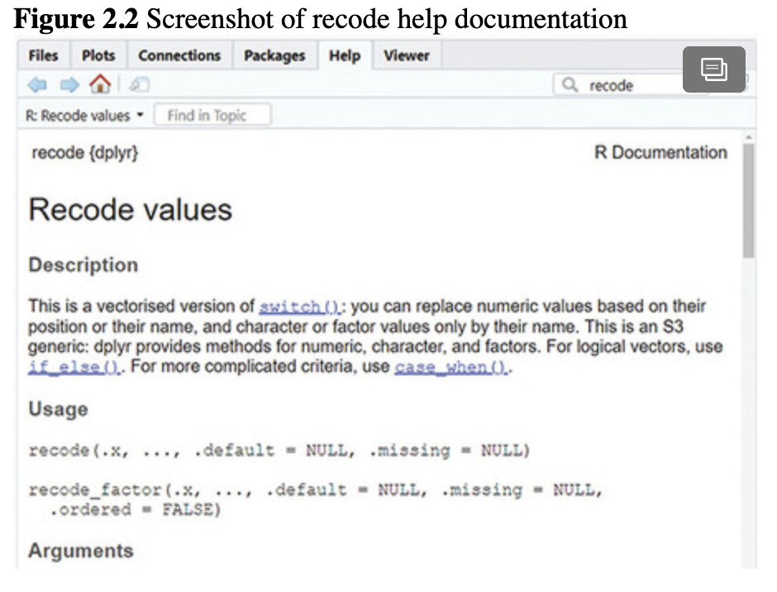

The tricky part is that R will treat each unique value of a factor as a different level. So for a vector saved as a factor that looks like height <- c("short", "tall", "Short", "tll"), R would consider it to have four levels: short, tall, Short, and tll. Leslie looked confused because the first and third observations should be part of the same category. Nancy said that short and Short are different categories because the first letter is capitalized in one and not the other. The same thing is true with tall and tll—spelling matters! So in order to get a factor with two levels, it would need to look like height <- c("short", "tall", "short", "tall"). Nancy suggested that Leslie could check the levels of a factor using levels() to see if the levels need to be cleaned up.

For now, the table looked better, but it still needed some work on the formatting before it was ready to share with others. Leslie started thinking about the summary() function from their last session and wondered if that might be a good way to get frequencies for more than one variable at a time. Nancy thought this was an interesting idea and they tried using summary().

*# use summary for frequencies*

**summary**(object = brfss.2014.cleaned)

##          TRNSGNDR      X_AGEG5YR     X_RACE

## Male to female    :  363  Min.  : 1.000  Min.  : 1.000

## Female to male    :  212  1st Qu.: 5.000 1st Qu.: 1.000

## Gender non-conforming:  116  Median : 8.000 Median : 1.000

## Not transgender    :150765  Mean  : 7.822 Mean  : 1.992

## Not sure        : 1138  3rd Qu.:10.000 3rd Qu.: 1.000

## Refused         : 1468   Max.  :14.000 Max.  : 9.000

## NA's          :310602            NA's  :94

##   X_INCOMG    X_EDUCAG    HLTHPLN1     HADMAM

## Min.  :1.000  Min.  :1.000   Min.  :1.000  Min.  :1.00

## 1st Qu.:3.000  1st Qu.:2.000  1st Qu.:1.000  1st Qu.:1.00

## Median :5.000  Median :3.000  Median :1.000  Median :1.00

## Mean  :4.481  Mean  :2.966   Mean  :1.108  Mean  :1.22

## 3rd Qu.:5.000  3rd Qu.:4.000  3rd Qu.:1.000  3rd Qu.:1.00

## Max.  :9.000  Max.  :9.000   Max.  :9.000  Max.  :9.00

##                             NA's  :208322

##   X_AGE80    PHYSHLTH

## Min.  :18.00   Min.  : 1.0

## 1st Qu.:44.00  1st Qu.:20.0

## Median :58.00  Median :88.0

## Mean  :55.49   Mean  :61.2

## 3rd Qu.:69.00  3rd Qu.:88.0

## Max.  :80.00   Max.  :99.0

##           NA's  :4

They reviewed the results and decided that summary() was really similar to table(), and the format does not look even close to what they want for the formatted table. Leslie wondered if there was any other code like summary() that summarized all the variables at once. Nancy said she has used describe() from the **Hmisc** package. Leslie recalled that a package must be installed once, but after it’s installed there are two ways to access the functions that come from the package. The first way is to load the entire package using library(package = "Hmisc") or using the :: structure. Since they just wanted to test out describe(), Leslie tried using ::.

*# trying describe for descriptive statistics*

Hmisc**::describe**(x = brfss.2014.cleaned)

## brfss.2014.cleaned

##

## 9 Variables   464664 Observations

## ------------------------------------------------------------------------

## TRNSGNDR

##    n missing distinct

##  154062  310602    6

##

## Male to female (363, 0.002), Female to male (212, 0.001), Gender

## non-conforming (116, 0.001), Not transgender (150765, 0.979), Not sure

## (1138, 0.007), Refused (1468, 0.010)

## ------------------------------------------------------------------------

## X_AGEG5YR

##    n missing distinct   Info   Mean   Gmd   .05   .10

##  464664     0    14   0.993  7.822   3.952    1     3

##    .25   .50   .75    .90    .95

##     5    8    10    12    13

##

## Value      1   2   3    4   5   6   7    8   9  10

## Frequency 24198 19891 23662 25444 28597 32686 43366 49432 52620 50680

## Proportion 0.052 0.043 0.051 0.055 0.062 0.070 0.093 0.106 0.113 0.109

##

## Value      11  12  13  14

## Frequency 40160 29310 38840 5778

## Proportion 0.086 0.063 0.084 0.012

## ------------------------------------------------------------------------

## X_RACE

##    n missing distinct   Info   Mean   Gmd

##  464570    94    9  0.546   1.992  1.687

##

## Value      1   2    3   4    5   6   7   8   9

## Frequency 356808 35062  7076  9314  1711  2109  8824 35838 7828

## Proportion 0.768 0.075 0.015a 0.020 0.004 0.005 0.019  0.077 0.017

## ------------------------------------------------------------------------

## X_INCOMG

##    n missing distinct   Info   Mean   Gmd

##  464664     0    6  0.932  4.481  2.522

##

## Value      1    2   3    4   5   9

## Frequency  44142 68042 44315 57418 179351 71396

## Proportion 0.095 0.146 0.095 0.124 0.386 0.154

## ------------------------------------------------------------------------

## X_EDUCAG

##    n missing distinct   Info   Mean   Gmd

##  464664    0    5   0.911  2.966   1.153

##

## Value      1    2   3    4   9

## Frequency  37003 131325 125635 166972  3729

## Proportion 0.080 0.283 0.270 0.359 0.008

## ------------------------------------------------------------------------

## HLTHPLN1

##    n missing distinct   Info   Mean   Gmd

##  464664     0     4   0.233   1.108  0.2022

##

## Value      1    2   7   9

## Frequency 425198 37642   934   890

## Proportion 0.915 0.081 0.002 0.002

## ------------------------------------------------------------------------

## HADMAM

##    n missing distinct   Info   Mean   Gmd

##  256342  208322    4   0.483  1.215  0.3488

##

## Value      1    2   7   9

## Frequency 204705 51067  253  317

## Proportion 0.799  0.199 0.001 0.001

## ------------------------------------------------------------------------

## X_AGE80

##    n missing distinct   Info   Mean   Gmd   .05   .10

##  464664     0    63  0.999   55.49   19.22  24 30

##   .25    .50    .75    .90    .95

##    44    58    69    78    80

##

## lowest : 18 19 20 21 22, highest: 76 77 78 79 80

## ------------------------------------------------------------------------

## PHYSHLTH

##    n missing distinct   Info   Mean   Gmd   .05   .10

##  464660    4    33   0.752   61.2   36.37     2    3

##    .25   .50   .75    .90    .95

##    20    88    88    88    88

##

## lowest : 1 2 3 4 5, highest: 29 30 77 88 99

## ------------------------------------------------------------------------

They looked through the output from describe() and saw that proportions were included, which is something that was not in the summary() output. However, there was a lot of output to read through to find specific information. Kiara mentioned that she prefers to use functions with output that is more targeted to what she is interested in, so she just uses summary() and describe() to get a sense of the data or to confirm that her data management tasks have worked, but uses other options once she is ready to create tables or other displays of data. Leslie thought this was a good strategy, although she was curious about alternatives from other packages.

Nancy said that the **descr** (short for descriptives) package has a good option for a basic table of frequencies and percentages with the freq() function. Nancy also knew that a graph was automatically printed with the freq() output and the graph is not useful at this point, so she showed Leslie how she uses the plot = FALSE option with freq() to stop the graph from printing with the output. Since she just wanted the one function from **descr**, Nancy used the :: format to access the freq() function.

*# use freq from the descr package to make a table of frequencies and percents*

*# suppress the bar plot that automatically prints*

descr**::freq**(x = brfss.2014.cleaned**$**TRNSGNDR, plot = FALSE)

## brfss.2014.cleaned$TRNSGNDR

##             Frequency  Percent Valid Percent

## Male to female       363   0.07812    0.23562

## Female to male       212   0.04562    0.13761

## Gender non-conforming   116   0.02496    0.07529

## Not transgender     150765  32.44603   97.85995

## Not sure           1138   0.24491    0.73866

## Refused           1468   0.31593    0.95286

## NA's            310602  66.84443

## Total           464664 100.00000   100.00000

Leslie noticed that there were two columns in the output that show percentages. She reviewed the columns and found that the Percent column includes the missing data (NA) in the calculation of the percentage of observations in each category. The Valid Percent column removes the NA values and calculates the percentage of observations that falls into each category *excluding the observations missing values on this variable*.

Since they were already using the **tidyverse** package, Nancy suggested they try using it for this instead of opening a new package. She wrote some alternate code to show Leslie how she might create this table.

*# use tidyverse to make table of frequency and percent*

brfss.2014.cleaned **%>%**

**group_by**(TRNSGNDR) **%>%**

**summarize**(freq.trans = **n**()) **%>%**

**mutate**(perc.trans = 100 **\*** (freq.trans **/ sum**(freq.trans)))

## # A tibble: 7 x 3

##  TRNSGNDR        freq.trans perc.trans

##  <fct>             <int>   <dbl>

## 1 Male to female        363   0.0781

## 2 Female to male        212   0.0456

## 3 Gender non-conforming    116   0.0250

## 4 Not transgender      150765  32.4

## 5 Not sure           1138   0.245

## 6 Refused            1468   0.316

## 7 <NA>            310602  66.8

Leslie was not impressed. She thought this looked like a lot more code to get the same information they got from freq(). Nancy agreed that the code was more complicated to get the same table. She explained that sometimes it was worth the time to use the more complicated code in order to keep a consistent style or to be able to use the code again later. Leslie nodded but remained skeptical. Kiara pointed out that this is an example of how you can do the same thing in a number of different ways in R. Often, there is no single correct way.

Nancy noted that both the freq() and **tidyverse** tables included the information needed for reporting, but they were still not formatted in a way that could be directly incorporated into a report or other document. Leslie suggested that they copy these results into a word-processing program and format the table there.

Kiara cringed at this suggestion. Copying from statistical output into another document is where many errors occur in scientific reporting (Harris et al., 2019) and is a major reason why some research results are not reproducible. It is more efficient and accurate to create a formatted table in R and use it without transcribing or changing the contents. Nancy suggested there were two great options for creating reproducible tables directly in R using the **tableone** and **kableExtra** packages. Kiara promised to explain how to make pretty tables later, but for now the R-Team agreed to use the **tidyverse** to make their table.

Before they moved on to numeric variables, Leslie wanted to make sure she understood how to report and interpret the descriptive statistics for factor variables. She wrote a few sentences to share with Nancy and Kiara.

The 2014 BRFSS had a total of 464,664 participants. Of these, 310,602 (66.8%) were not asked or were otherwise missing a response to the transgender status question. A few participants refused to answer (*n* = 1,468; 0.32%), and a small number were unsure of their status (*n* = 1,138; 0.24%). Most reported being not transgender (*n* = 150,765; 32.4%), 116 were gender non-conforming (0.03%), 212 were female to male (0.05%), and 363 were male to female (0.08%).

Nancy and Kiara agreed that this was good for reporting frequencies and percentages. Leslie thought it might be more useful to just include the *valid* percentages for people who responded to the question. Without a word, Nancy used [] to omit the NA from TRNSGNDR to calculate the valid percentages.

*# use tidyverse to make table of frequency and percent*

brfss.2014.cleaned **%>%**

**group_by**(TRNSGNDR) **%>%**

**summarize**(freq.trans = **n**()) **%>%**

**mutate**(perc.trans = 100 **\*** (freq.trans **/ sum**(freq.trans))) **%>%**

**mutate**(valid.perc = 100 **\*** (freq.trans **/** (**sum**(freq.trans[**na.omit**(object = TRNSGNDR)]))))

## # A tibble: 7 x 4

##  TRNSGNDR        freq.trans perc.trans valid.perc

##  <fct>             <int>   <dbl>   <dbl>

## 1 Male to female         363   0.0781   0.236

## 2 Female to male         212   0.0456   0.138

## 3 Gender non-conforming     116   0.0250   0.0753

## 4 Not transgender      150765  32.4    97.9

## 5 Not sure            1138   0.245   0.739

## 6 Refused            1468   0.316   0.953

## 7 <NA>             310602  66.8   202

Nancy said to just ignore the <NA> valid.perc for now; it is a tricky data management problem to delete this value to have a perfect table. Leslie understood and updated her sentences to share with Nancy and Kiara.

The 2014 BRFSS had a total of 464,664 participants. Of these, 310,602 (66.8%) were not asked or were otherwise missing a response to the transgender status question. Of the 33.2% who responded, some refused to answer (*n* = 1,468; 0.95%), and a small number were unsure of their status (*n* = 1,138, 0.74%). Most reported being not transgender (*n* = 150,765; 97.9%), 116 were gender non-conforming (0.08%), 212 were female to male (0.14%), and 363 were male to female (0.24%).

Leslie felt much better about this interpretation. Her R-Team friends agreed.

## 2.5.4 Achievement 2: Check your understanding

Use one of the methods shown to create a table of the frequencies for the HADMAM variable, which indicates whether or not each survey participant had a mammogram. Review the question and response options in the codebook and recode to ensure that the correct category labels show up in the table before you begin.

# 2.6 Achievement 3: Choosing and conducting descriptive analyses for continuous (numeric) variables

## 2.6.1 Why frequency distributions do not work for numeric variables

Now that they had a good table of descriptive statistics for a factor variable, Nancy and Leslie switched to numeric variables. Numeric variables are measured on a continuum and can be truly continuous or just close to continuous. Leslie knew these types of variables were not well described using frequency distributions. For example, a frequency table of the age variable (X_AGE80) looked like this:

*# table with frequencies from the age variable*

**table**(brfss.2014.cleaned**$**X_AGE80)

##

##  18   19  20   21   22  23   24  25   26   27  28  29

## 3447  3209 3147 3470  3470 3632 3825 3982  3723 3943 4191 4054

##  30   31   32   33   34   35   36   37   38  39   40   41

## 4719  4169 4988 4888  4925 5373 5033 5109  5152 4891 5897 4672

##  42   43  44   45   46   47   48  49    50  51   52  53

## 6029  6215 6091 6463  6252 6963 6994 7019  8925 7571 9060 9015

##   54   55  56   57   58   59   60  61   62   63  64  65

## 9268  9876 9546 10346 10052 10293 11651 10310 11842 10955 10683 11513

##   66   67   68   69   70   71   72   73   74   75  76  77

## 10704 11583 9129  8092  9305 8388 8239 7381  6850 6844 6048 5845

##   78   79   80

## 5552 5021 38842

Nancy agreed that this display of age data provides very little useful information and pointed out that there are descriptive statistics to examine numeric variables directly. Leslie knew all about these statistics, which include measures of the central tendency and [***spread***](https://jigsaw.vitalsource.com/books/9781506388144/epub/OEBPS/s9781506388175.i4970.xhtml#s9781506388175.i7266) of the values for a numeric variable.

## 2.6.2 Defining and calculating central tendency

Leslie remembered from her statistics courses that central tendency was a measure of the center, or typical value, of a variable and that there were three measures of central tendency: mean, median, and mode.

* The [***mean***](https://jigsaw.vitalsource.com/books/9781506388144/epub/OEBPS/s9781506388175.i4970.xhtml#s9781506388175.i7156) is the sum of the values divided by the number of values.
* The [***median***](https://jigsaw.vitalsource.com/books/9781506388144/epub/OEBPS/s9781506388175.i4970.xhtml#s9781506388175.i7159) is the middle value (or the mean of the two middle values if there is an even number of observations).
* The [***mode***](https://jigsaw.vitalsource.com/books/9781506388144/epub/OEBPS/s9781506388175.i4970.xhtml#s9781506388175.i7161) is the most common value or values.

### 2.6.2.1 Using the mean

The most well-understood and widely used measure of central tendency is the mean. Leslie knew that the mean is calculated by adding up all the values of a variable and dividing by the number of values. She wrote out [Equation (2.1)](https://jigsaw.vitalsource.com/books/9781506388144/epub/OEBPS/s9781506388175.i1382.xhtml#s9781506388175.i1480).

(2.1)

mx=∑ni=1xinmx=∑i=1nxin

Nancy was not as interested in the statistical theory, and Leslie saw her eyes glaze over as soon as she saw [Equation (2.1)](https://jigsaw.vitalsource.com/books/9781506388144/epub/OEBPS/s9781506388175.i1382.xhtml#s9781506388175.i1480), but Leslie explained anyway. She said that the [***numerator***](https://jigsaw.vitalsource.com/books/9781506388144/epub/OEBPS/s9781506388175.i4970.xhtml#s9781506388175.i7180) (top of the fraction) is the sum (∑) of all the values of *x* from the first value (*i* = 1) to the last value (*n*) divided by the number of values (*n*). Leslie remembered that, to use the mean, a variable should be [***normally distributed***](https://jigsaw.vitalsource.com/books/9781506388144/epub/OEBPS/s9781506388175.i4970.xhtml#s9781506388175.i7177), or have values that resemble a bell curve when graphed. Nancy saw an opportunity and quickly coded a graph of a normal distribution to show Leslie ([Figure 2.3](https://jigsaw.vitalsource.com/books/9781506388144/epub/OEBPS/s9781506388175.i1382.xhtml#s9781506388175.i1497)). Leslie was impressed and confirmed that this is how a variable should be distributed in order to use the mean.

Nancy decided to show off a little and added the bell-shaped normal curve to the normal distribution graph ([Figure 2.4](https://jigsaw.vitalsource.com/books/9781506388144/epub/OEBPS/s9781506388175.i1382.xhtml#s9781506388175.i1499)).

Leslie recognized that the underlying graph in [Figures 2.3](https://jigsaw.vitalsource.com/books/9781506388144/epub/OEBPS/s9781506388175.i1382.xhtml#s9781506388175.i1497) and [2.4](https://jigsaw.vitalsource.com/books/9781506388144/epub/OEBPS/s9781506388175.i1382.xhtml#s9781506388175.i1499) is a [***histogram***](https://jigsaw.vitalsource.com/books/9781506388144/epub/OEBPS/s9781506388175.i4970.xhtml#s9781506388175.i7113), which shows the values of a variable along the horizontal [**x-*axis***](https://jigsaw.vitalsource.com/books/9781506388144/epub/OEBPS/s9781506388175.i4970.xhtml#s9781506388175.i7304) and some kind of probability (or sometimes the frequency) of each value of the variable along the vertical [**y-*axis***](https://jigsaw.vitalsource.com/books/9781506388144/epub/OEBPS/s9781506388175.i4970.xhtml#s9781506388175.i7307). That was all Leslie could remember about this graph, and Kiara assured her that they would talk more about histograms in detail at their next meeting. For now, they would just remember that [***normality***](https://jigsaw.vitalsource.com/books/9781506388144/epub/OEBPS/s9781506388175.i4970.xhtml#s9781506388175.i7176) is signified by the shape of the graph.

Leslie remembered that, for a variable with a distribution that is normal, or near normal, the mean value would be a good representation of the middle of the data. But if the data look [***skewed***](https://jigsaw.vitalsource.com/books/9781506388144/epub/OEBPS/s9781506388175.i4970.xhtml#s9781506388175.i7259), with some very large values on the right ([***right***](https://jigsaw.vitalsource.com/books/9781506388144/epub/OEBPS/s9781506388175.i4970.xhtml#s9781506388175.i7241) or [***positively skewed***](https://jigsaw.vitalsource.com/books/9781506388144/epub/OEBPS/s9781506388175.i4970.xhtml#s9781506388175.i7215)) or left ([***left***](https://jigsaw.vitalsource.com/books/9781506388144/epub/OEBPS/s9781506388175.i4970.xhtml#s9781506388175.i7138) or [***negatively skewed***](https://jigsaw.vitalsource.com/books/9781506388144/epub/OEBPS/s9781506388175.i4970.xhtml#s9781506388175.i7171)), the median would be more appropriate. Nancy got her coding fingers ready and made a couple of skewed histograms as examples ([Figure 2.5](https://jigsaw.vitalsource.com/books/9781506388144/epub/OEBPS/s9781506388175.i1382.xhtml#s9781506388175.i1501)).

**Figure 2.3** The shape of the distribution for a normally distributed variable

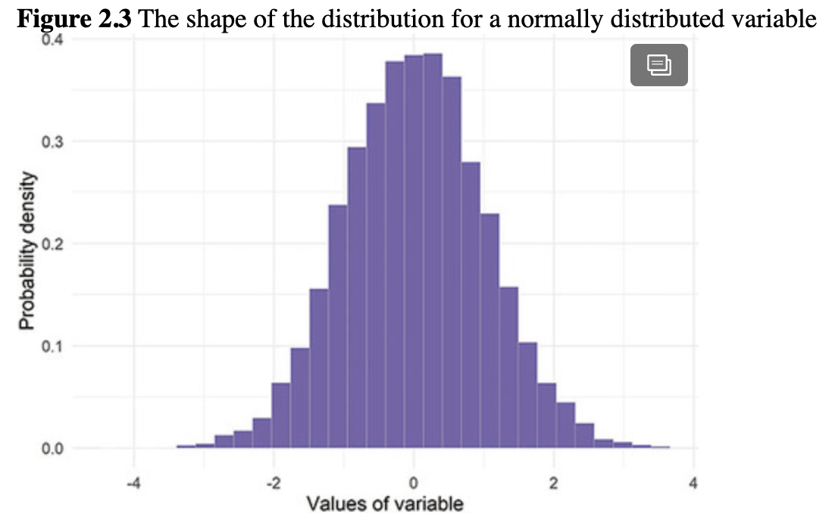

**Figure 2.4** Normally distributed variable with normal curve

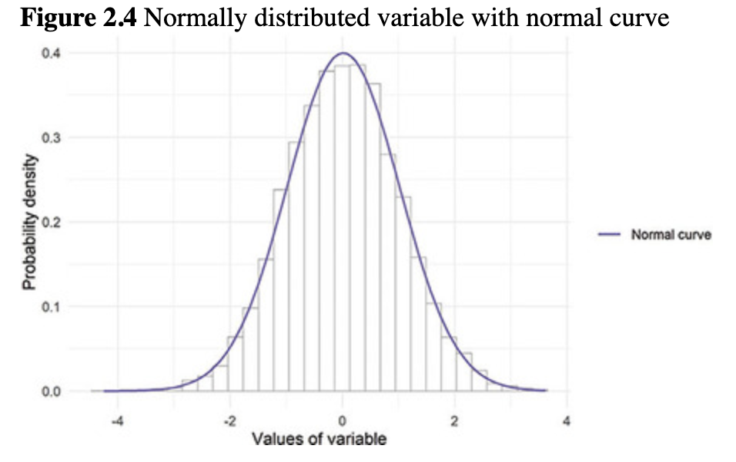

**Figure 2.5** Examples of skewed distributions

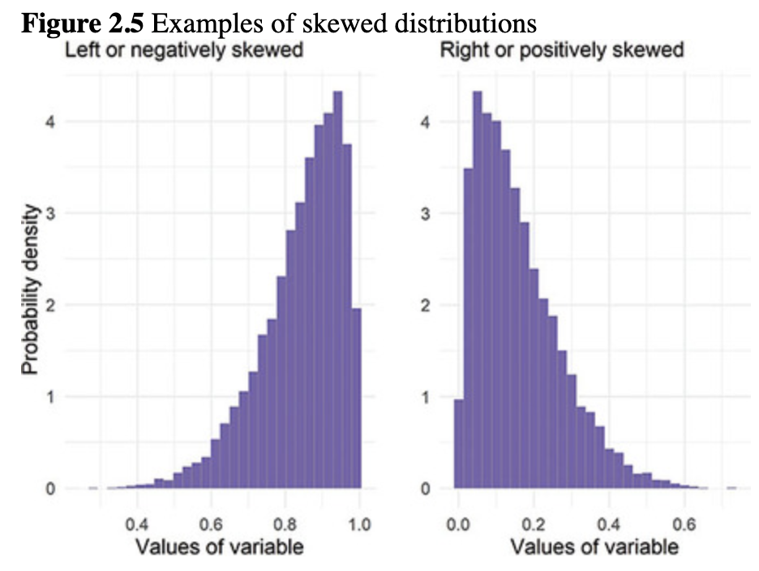

Leslie explained that the reason the mean is not a good representation of skewed data is that adding together a set of values that includes a few very large or very small values like those on the far left of a [***left-skewed***](https://jigsaw.vitalsource.com/books/9781506388144/epub/OEBPS/s9781506388175.i4970.xhtml#s9781506388175.i7138) distribution or the far right of a [***right-skewed***](https://jigsaw.vitalsource.com/books/9781506388144/epub/OEBPS/s9781506388175.i4970.xhtml#s9781506388175.i7241) distribution will result in a large or small total value in the numerator of [Equation (2.1)](https://jigsaw.vitalsource.com/books/9781506388144/epub/OEBPS/s9781506388175.i1382.xhtml#s9781506388175.i1480), and therefore the mean will be a large or small value relative to the actual middle of the data.

That is, she said, the mean is influenced by the very large or very small values and is therefore not representative of a typical value or the middle of the data; instead, the mean of a skewed variable is larger or smaller than the actual middle values in the data. Nancy remembered one example of this that is often used is income. Say you collected the incomes of five of your friends and billionaire Bill Gates. Your friends made the following annual salaries in U.S. dollars: $25,000, $62,000, $41,000, $96,000, and $41,000. Adding these five values together and dividing by five would result in a mean salary among your friends of $53,000. Given the salaries listed, this seems like a reasonable value that accurately represents a typical salary of your friends.

While she explained this to Leslie, Nancy introduced the mean() function.

*# create salaries vector and find its mean*

salaries <- **c**(25000, 62000, 41000, 96000, 41000)

**mean**(x = salaries)

## [1] 53000

However, Nancy explained, if Bill Gates just happened to be a friend of yours, you would include his estimated $11.5 billion annual earnings by adding it to the existing salaries vector. Adding a value to a vector can be done by concatenating the existing values with the new values in a new vector using c(), like this:

*# add Bill Gates*

salaries.gates <- **c**(salaries, 11500000000)

*# find the mean of the vector with gates*

**mean**(x = salaries.gates)

## [1] 1916710833

Now it appears that your friends make a mean salary of $1,916,710,833. While technically this may be true if Bill Gates is among your friends, it is not a good representation of a typical salary for one of the friends. In the case of skewed data, the median is a better choice.

Leslie looked away for a minute, and when she looked back, the code magician (Nancy) had coded a normal distribution with the mean represented by a line in the middle of the distribution ([Figure 2.6](https://jigsaw.vitalsource.com/books/9781506388144/epub/OEBPS/s9781506388175.i1382.xhtml#s9781506388175.i1512)). Visually, the mean for a normally distributed variable would be in the middle like the vertical line in Nancy’s fancy distribution.

Nancy also added means to the skewed-variables graphic ([Figure 2.7](https://jigsaw.vitalsource.com/books/9781506388144/epub/OEBPS/s9781506388175.i1382.xhtml#s9781506388175.i1514)). This demonstrated that the mean was not in the middle, but instead was toward the longer [***tail***](https://jigsaw.vitalsource.com/books/9781506388144/epub/OEBPS/s9781506388175.i4970.xhtml#s9781506388175.i7281) of data. The tails of a distribution are the values to the far right and far left in the distribution. Often, there are fewer values in these parts of the distribution, so they taper off and look like a tail.

### 2.6.2.2 Using the median

Leslie reminded everyone that the median is the middle number when numbers are in order from smallest to largest. When there are an even number of numbers, the median is the mean of the middle two numbers. Nancy typed some quick code to show that, in the examples above, the median for the friend groups with and without Bill Gates would be as follows:

**Figure 2.6** Normally distributed variable with mean

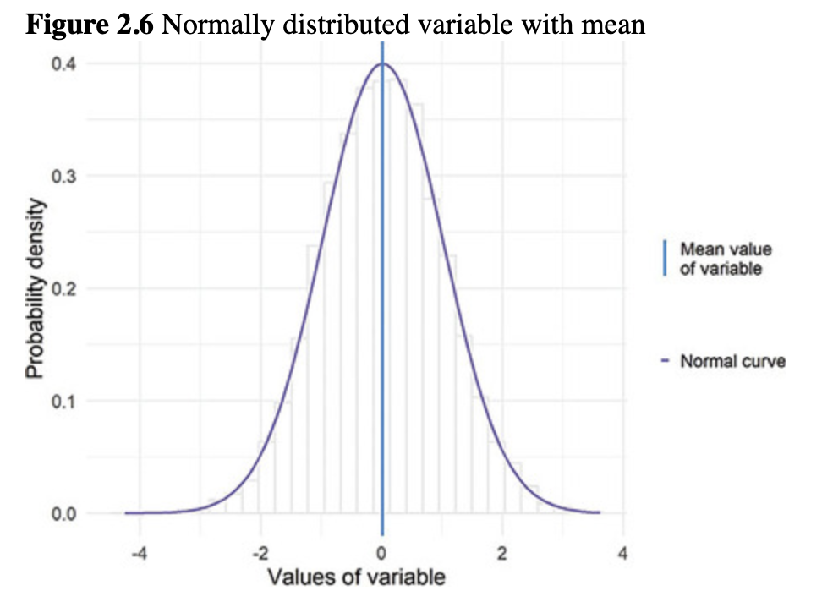

**Figure 2.7** Examples of skewed distributions showing mean values

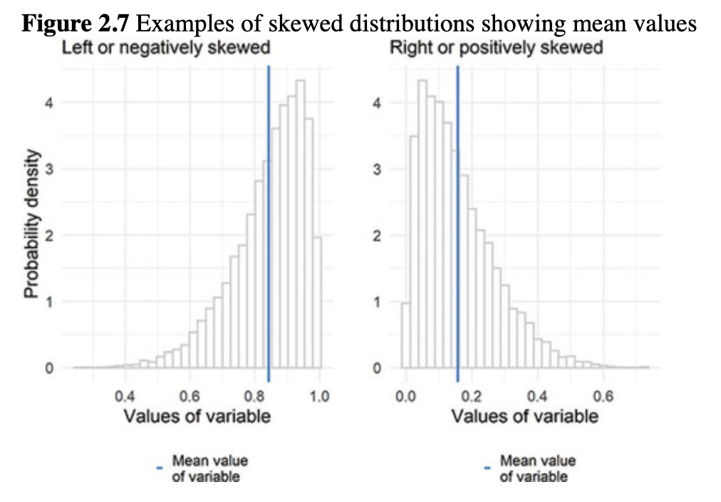

*# median salary without Bill Gates*

**median**(x = salaries)

## [1] 41000

*# median salary with Bill Gates*

**median**(x = salaries.gates)

## [1] 51500

While Leslie noticed that the median increased with the addition of Bill Gates to her friend group, the result was still a reasonable representation of the middle of the salaries of this group of friends, unlike the mean of $1,916,710,833.

Leslie went on to explain that in a perfect normal distribution, the median would be exactly the same as the mean. In skewed distributions, the median will not be the same as the mean. For a variable that is left skewed, the median will usually be to the right of the mean (von Hippel, 2005). For a variable that is right skewed, the median will usually be to the left of the mean. Nancy was not paying close attention but realized she could write some code to show the mean and the median on the skewed distribution to demonstrate Leslie’s point ([Figure 2.8](https://jigsaw.vitalsource.com/books/9781506388144/epub/OEBPS/s9781506388175.i1382.xhtml#s9781506388175.i1519)).

In this case, the median is not too far from the mean. Leslie was curious about how different from normal a distribution has to be before people use the median instead of the mean. From the examples so far, she thought that median salary was a more accurate representation of the middle of the gates.salaries vector than the mean of gates.salaries. However, for the two skewed distribution histogram examples in [Figure 2.8](https://jigsaw.vitalsource.com/books/9781506388144/epub/OEBPS/s9781506388175.i1382.xhtml#s9781506388175.i1519), the median and mean are very close to each other, and since the mean seems like a more widely used and understood measure, might it be a better choice?

She looked through her statistics materials and found that one way some people make this decision is to calculate a measure of skewness. [***Skewness***](https://jigsaw.vitalsource.com/books/9781506388144/epub/OEBPS/s9781506388175.i4970.xhtml#s9781506388175.i7260) is a measure of the extent to which a distribution is skewed. There are a few variations on the formula, but she found one that is commonly used (von Hippel, 2005). She showed Nancy and Kiara [Equation (2.2)](https://jigsaw.vitalsource.com/books/9781506388144/epub/OEBPS/s9781506388175.i1382.xhtml#s9781506388175.i1523).

(2.2)

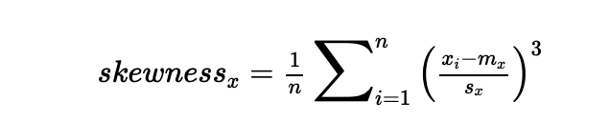

In [Equation (2.2)](https://jigsaw.vitalsource.com/books/9781506388144/epub/OEBPS/s9781506388175.i1382.xhtml#s9781506388175.i1523), *n* is the sample size, *xi* is each observation of *x*, *mx* is the sample mean of *x*, and *sx* is the sample standard deviation of *x*. Leslie reviewed the equation slowly. The first thing she found to note is that the mean of *x*, *mx*, is subtracted from each observation *xi*. These differences between the mean and each observed value are called [***deviation scores***](https://jigsaw.vitalsource.com/books/9781506388144/epub/OEBPS/s9781506388175.i4970.xhtml#s9781506388175.i7070). Each deviation score is divided by the standard deviation, *s*, and the result is cubed. Finally, sum the cubed values and divide by the number of cubed values (which is taking the mean) to get the skewness of *x*. The resulting value is usually *negative* when the skew is to the left and usually *positive* when the skew is toward the right. Because skewness is strongly impacted by the sample size with 1n1n in [Equation (2.2)](https://jigsaw.vitalsource.com/books/9781506388144/epub/OEBPS/s9781506388175.i1382.xhtml#s9781506388175.i1523), the value of skew that is considered *too skewed* differs depending on sample size.

**Figure 2.8** Examples of skewed distributions with means and medians

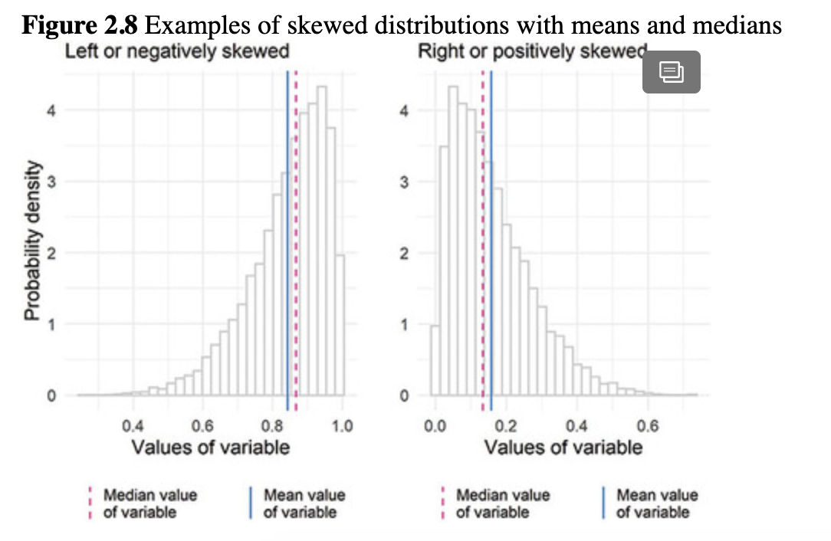

Leslie found this helpful and asked Nancy if there was a way to compute skewness in R. Nancy said the **semTools** package has skew() to compute this value and a few related values. She typed in the code and tried skew() for the salary vector with Bill Gates and for the two variables used to create the skewed histograms in [Figure 2.8](https://jigsaw.vitalsource.com/books/9781506388144/epub/OEBPS/s9781506388175.i1382.xhtml#s9781506388175.i1519), left.skewed for the left-skewed histogram and right.skewed for the right-skewed histogram. Leslie did not have the data Nancy used for these variables, so she could only follow along with the skew() calculation for the salaries.gates object.

*# skewness of salaries variable*

semTools**::skew**(object = salaries.gates)

## skew (g1)      se      z      p

## 2.44948974 1.00000000 2.44948974 0.01430588

*# skewness of Figure 2.8 left-skewed distribution variable*

semTools**::skew**(object = left.skewed)

##  skew (g1)      se       z       p

## -1.0739316  0.0244949 -43.8430756  0.0000000

*# skewness of Figure 2.8 right-skewed distribution variable*

semTools**::skew**(object = right.skewed)

##  skew (g1)     se      z       p

## 1.0454195 0.0244949 42.6790709 0.0000000

Leslie was expecting a single number, but instead each skew() calculation contained four values. She looked in the help documentation and found that the first value is the skewness and the second value is the *se*, or the [***standard error***](https://jigsaw.vitalsource.com/books/9781506388144/epub/OEBPS/s9781506388175.i4970.xhtml#s9781506388175.i7270) of the skew. Leslie remembered that the standard error is often used to quantify how much variation there is in data, but she decided to leave that for later. The third number, *z*, is the value of the skew divided by its *se*. She determined from some of the readings she had in her statistics materials that *z* is the number useful for determining if the level of skew is too much for the variable to be treated as normally distributed (Kim, 2013). If the sample size is small (*n* < 50), *z* values outside the –2 to 2 range are a problem. If the sample size is between 50 and 300, *z* values outside the –3.29 to 3.29 range are a problem. For large samples (*n* > 300), using a visual is recommended over the statistics, but generally *z* values outside the range of –7 to 7 can be considered problematic.

Leslie looked back at the *se*, *z*, and *p* statistics in the output and decided that gaining a deep understanding of these statistics was a little too much for what they were doing in this meeting. She decided to focus on gaining a little more foundation in descriptive statistics and sampling instead. For now, she relied on graphs and the general rules. Since the *z* for the skewness of salaries.gates is greater than 2 (z = 2.45) and the sample size is small, the data have a skew problem. This makes sense given the huge Bill Gates salary included in these data. The *z* statistics for the data underlying the left.skewed and right.skewed distributions in [Figure 2.8](https://jigsaw.vitalsource.com/books/9781506388144/epub/OEBPS/s9781506388175.i1382.xhtml#s9781506388175.i1519) were much larger in magnitude and far beyond the threshold for problematic, which made sense to Leslie since those distributions were clearly not normal.

### 2.6.2.3 Using the mode

Finally, the mode is the most common value in a data set. Leslie suggested that the mode is not widely used in the research she had read, but it was still good to know that it existed as an option. She did recall that, for numeric variables, the mode can be used along with the mean and median as an additional indicator of a normal distribution. In a perfect normal distribution, the mean, median, and mode are all exactly the same.

Nancy explained that, unfortunately, perhaps because it is rarely used, there is no mode function. Instead, she showed Leslie how to use sort() with table() to sort a table from highest to lowest (decreasing order) or lowest to highest (increasing order). Nancy walked Leslie through computing the mode in R. Start with a table, table(salaries), which will show the frequencies of each value in the data.

*# table showing salaries frequencies*

**table**(salaries)

## salaries

## 25000 41000 62000 96000

## 1    2   1    1

There is one salary of $25,000, two salaries of $41,000, and so on. With data this simple, it would be easy to stop here and notice that $41,000 is the mode. However, most data sets will be much larger, and it will be more efficient to have a set of R functions to use. Nancy put the table in order from largest frequency to smallest frequency using sort() with decreasing = TRUE.

*# table showing salaries frequencies*

**sort**(x = **table**(salaries), decreasing = TRUE)

## salaries

## 41000 25000 62000 96000

##    2   1    1    1

This orders the table starting with the salary with the highest frequency, or the most common salary. This salary is the mode. To just have R print the salary (not its frequency), use names(), which will print the salary category names shown in the top row of the table.

*# table showing salaries frequencies*

**names**(x = **sort**(x = **table**(salaries), decreasing = TRUE))

## [1] "41000" "25000" "62000" "96000"

Finally, to just print the first category name, use the square brackets, [ ]. In R, the square brackets are used to grab a particular location (sometimes called an “index”). For example, the salaries vector has 5 observations: 25000, 62000, 41000, 96000, 41000. To get the 4th observation of salaries, you can type salaries[4], which is 96000. Here, to get the first category name, use the same bit of code, and add a [1] to the end.

*# no mode function so find the mode using a table*

*# and sort values in decreasing order*

*# so the most common value comes first*

**names**(x = **sort**(x = **table**(salaries), decreasing = TRUE))[1]

## [1] "41000"

All together, the three measures can be computed for the salaries vector.

*# mean, median, and mode of salaries*

**mean**(x = salaries)

## [1] 53000

**median**(x = salaries)

## [1] 41000

**names**(x = **sort**(x = **table**(salaries), decreasing = TRUE))[1]

## [1] “41000”

The mean is $53,000, and the median and mode are both $41,000. So the mean, median, and mode were not exactly the same, and Leslie concluded that the data are not *perfectly* normally distributed.

The mode is sometimes used to identify the most common (or typical) category of a factor variable. For example, in the tables above, the mode of the TRNSGNDR variable is “Not transgender,” with more than 150,000 observations in that category.

## 2.6.3 Messy data and computing measures of central tendency

Using these functions with variables from a data frame like brfss.2014.cleaned is similar. Nancy wanted to show Leslie how to create a histogram and compute the mean, median, and mode for the PHYSHLTH variable from the 2014 BRFSS data set. PHYSHLTH is the number of physically unhealthy days a survey participant has had in the last 30 days. On page 11 of the BRFSS codebook, the values of 77 and 99 are Don't know/Not sure and Refused, so they could be coded as missing before examining the variable. It also looks like 88 is None for the number of unhealthy days and should be coded as zero. Leslie copied and pasted her data management code from earlier. Nancy was eager to keep coding and slid the laptop over to type in the new code for changing 77 and 99 to NA. She also recoded 88 in PHYSHLTH to be 0, which was a little complicated.

*# pipe in the original data frame*

*# recode the TRNSGNDR factor so it's easy to read*

*# recode 77, 88, 99 on PHYSHLTH*

brfss.2014.cleaned <- brfss.trans.2014 **%>%**

**mutate**(TRNSGNDR = **recode_factor**(.x = TRNSGNDR,

                     11 = 'Male to female',

                     22 = 'Female to male',

                     33 = 'Gender non-conforming',

                     44 = 'Not transgender',

                     77 = 'Not sure',

                     99 = 'Refused')) **%>%**

**mutate**(PHYSHLTH = **na_if**(**x** = PHYSHLTH, y = 77)) **%>%**

**mutate**(PHYSHLTH = **na_if**(**x** = PHYSHLTH, y = 99)) **%>%**

**mutate**(PHYSHLTH = **as.numeric**(**recode**(**.x** = PHYSHLTH, 8888 = 0L)))

Once Nancy had completed and run the code, she checked the recoding of PHYSHLTH.

*# examine PHYSHLTH to check data management*

**summary**(object = brfss.2014.cleaned**$**PHYSHLTH)

##  Min. 1st Qu. Median  Mean 3rd Qu.   Max.  NA's

##  0.000  0.000  0.000  4.224  3.000 30.000  10303

The maximum number of unhealthy days shown in the output for summary() was 30, so the recoding worked as planned. Nancy showed Leslie how to make a histogram from the cleaned data. The code was similar to what they used at the end of the data preparation meeting, but the geom_, or geometry, layer this time is geom_histogram() to make a histogram ([Figure 2.9](https://jigsaw.vitalsource.com/books/9781506388144/epub/OEBPS/s9781506388175.i1382.xhtml#s9781506388175.i1543)).

*# make a histogram*

brfss.2014.cleaned **%>%**

**ggplot**(**aes**(x = PHYSHLTH)) +

**geom_histogram**()

**Figure 2.9** Distribution of the PHYSHLTH variable

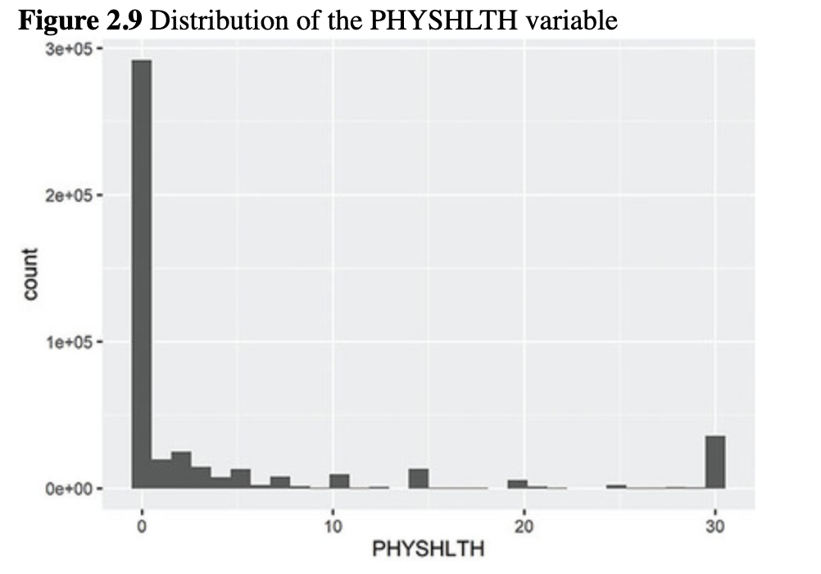

The histogram showed most people have between 0 and 10 unhealthy days per 30 days. Leslie wanted to take a turn coding and wrote the code for the measures of central tendency for the PHYSHLTH variable.

*# get mean, median, mode*

**mean**(x = brfss.2014.cleaned**$**PHYSHLTH)

## [1] NA

**median**(x = brfss.2014.cleaned**$**PHYSHLTH)

## [1] NA

**names**(x = **sort**(x = **table**(brfss.2014.cleaned**$**PHYSHLTH), decreasing = TRUE))[1]

## [1] "0"

Well, that didn’t work very well! The mode looks like 0 unhealthy days. The mean and the median show NA. Nancy explained that the mean() and median() functions require removal of NA values. They worked for the salaries vector because there were no NA values. To fix this, she needed to include a second argument that tells the mean() function how to treat missing data. She added the option na.rm = TRUE, where na stands for NA and rm stands for “remove.”

*# get mean, median, mode*

**mean**(x = brfss.2014.cleaned**$**PHYSHLTH, na.rm = TRUE)

## [1] 4.224106

**median**(x = brfss.2014.cleaned**$**PHYSHLTH, na.rm = TRUE)

## [1] 0

**names**(x = **sort**(**table**(brfss.2014.cleaned**$**PHYSHLTH), decreasing = TRUE))[1]

## [1] "0"

Leslie admitted at this point that she was concerned that she would never be able to remember all the arguments and rules for the different functions. Kiara reassured her that she does *not* need to memorize them! First, Kiara explained, Leslie can always check the help documentation. The help documentation will list what a function does, the arguments it can take, and what the output of the function means, and there are often examples at the bottom of the help documentation that show how to use the function.

Additionally, Kiara showed Leslie how to use tab completion to make her life easier. Kiara told Leslie to start typing the letters “me” in the Console and then hit her laptop’s Tab key. Leslie noticed that a lot of different functions starting with “me” appear, and that mean() was first! Since mean() was first and highlighted, Kiara told Leslie to press the Enter or Return key on her laptop keyboard. Leslie was relieved that she didn’t need to type out the rest of the word “mean” *and* that the parentheses automatically appeared!

Kiara told Leslie to hit the Tab key once again. The first argument x appeared, and a brief description of that argument. Here, x is the variable that you want to get the mean of. Leslie pressed Enter and the x = argument appeared in her code and was ready to be filled in with brfss.2014.cleaned$PHYSHLTH. Leslie started typing the letters “brf” and hit Tab. Sure enough, she saw the name of the data frame she needed and highlighted before she pressed Enter and added the $. After she added $, the same thing happened when she started to type the PHYSHLTH variable name. Kiara explained that arguments within a function are separated by commas. She suggested Leslie type a comma after PHYSHLTH and press Tab. Leslie saw the na.rm argument appear! It was like magic. Leslie finished the line of code using the Tab-complete trick and was relieved that she didn’t have to remember or type so much.

Kiara suggested that **tidyverse** code might be clearer to get the central tendency measures since the name of the data frame would not have to be included in all three functions. To pipe the data frame into the central tendency functions, use summarize(). Nancy mentioned that some code uses British spellings, but the American spellings usually work, too. For example, in **tidyverse**, summarize() is the same as summarise().

*# get mean, median, mode*

brfss.2014.cleaned **%>%**

**summarize**(mean.days = **mean**(x = PHYSHLTH,

                   na.rm = TRUE),

        med.days = **median**(x = PHYSHLTH,

                   na.rm = TRUE),

        mode.days = **names**(x = **sort**(**table**(PHYSHLTH),

                          decreasing = TRUE))[1])

##  mean.days med.days mode.days

## 1 4.224106     0     0

So the mean number of unhealthy days per month is 4.22 and the median and mode are 0. This makes sense given the right skew of the histogram. The people with 30 poor health days are making the mean value higher than the median. A few very large (or very small) values relative to the rest of the data can make a big difference for a mean.

Leslie wanted to calculate the skewness to see what it is for a variable that looks this skewed. Based on what she learned above, she expected the z for skewness of PHYSHLTH to be a positive number and greater than 7. She wrote and ran the code.

*# skewness for PHYSHLTH*

semTools**::skew**(object = brfss.2014.cleaned**$**PHYSHLTH)

##   skew (g1)      se       z       p

## 2.209078e+00 3.633918e-03 6.079054e+02 0.000000e+00

Leslie noticed that the results were shown using [***scientific notation***](https://jigsaw.vitalsource.com/books/9781506388144/epub/OEBPS/s9781506388175.i4970.xhtml#s9781506388175.i7252). While she was familiar with scientific notation, which is useful for printing large numbers in small spaces, she knew it is not well-understood by most audiences. Kiara said they would see more of it later ([Box 3.2](https://jigsaw.vitalsource.com/books/9781506388144/epub/OEBPS/s9781506388175.i1734.xhtml#s9781506388175.i1898)), but for now, they should just remember that the 2.209078e+00, 3.633918e−03, 6.079054e+02, and 0.000000e+00 were shorthand ways of writing 2.209078 × 100, 3.633918 × 10−3, 6.079054 × 102, and 0.000000 × 100. Kiara suggested that they think of the +00, –03, and +02 as the direction and how many places to move the decimal point. So, +00 is move the decimal point 0 places to the right, –03 is move the decimal point 3 places to the left, and +02 is move the decimal point 2 places to the right.

Since 2.209078 × 100 is just 2.209078 after moving the decimal point 0 places (or after recognizing that anything raised to the power of zero is 1, so 100 = 1), PHYSHLTH has a skewness of 2.209078. After moving the decimal point 2 places to the right, z is 607.9054, which is much higher than 7. The graph showed a clear right skew, so there is plenty of evidence that this variable is not normally distributed.

## 2.6.4 Defining and calculating spread

In addition to using central tendency to characterize a variable, Leslie remembered that reporting a corresponding measure of how spread out the values are around the central value is also important to understanding numeric variables. Each measure of central tendency has one or more corresponding measures of spread.

* Mean: use [***variance***](https://jigsaw.vitalsource.com/books/9781506388144/epub/OEBPS/s9781506388175.i4970.xhtml#s9781506388175.i7292) or [***standard deviation***](https://jigsaw.vitalsource.com/books/9781506388144/epub/OEBPS/s9781506388175.i4970.xhtml#s9781506388175.i7269) to measure spread
* Median: use [***range***](https://jigsaw.vitalsource.com/books/9781506388144/epub/OEBPS/s9781506388175.i4970.xhtml#s9781506388175.i7231) or [***interquartile range***](https://jigsaw.vitalsource.com/books/9781506388144/epub/OEBPS/s9781506388175.i4970.xhtml#s9781506388175.i7128) (IQR) to measure spread
* Mode: use an [***index of qualitative variation***](https://jigsaw.vitalsource.com/books/9781506388144/epub/OEBPS/s9781506388175.i4970.xhtml#s9781506388175.i7123) to measure spread

### 2.6.4.1 Spread to report with the mean

The variance is the average of the squared differences between each value of a variable and the mean of the variable. Leslie showed Nancy the formula from an old statistics textbook, and Nancy wrote [Equation (2.3)](https://jigsaw.vitalsource.com/books/9781506388144/epub/OEBPS/s9781506388175.i1382.xhtml#s9781506388175.i1560) so they could review how it worked.

(2.3)

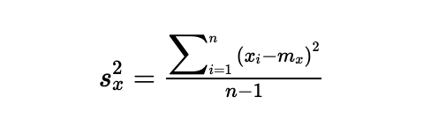

Leslie saw that the s2xsx2 is the variance of *x*, the ∑ symbol is sum, the *xi* is each individual value of *x*, the *mx* is the mean of *x*, and *n* is the sample size. The variance is the sum of the squared differences between each value of *x* and the mean of *x* (or the sum of squared deviation scores) divided by the sample size minus 1. “Fun fact,” said Nancy, “the *n* – 1 in the formula is called the Bessel correction.”

“I’m not sure how that’s fun,” Leslie said, smiling, “but OK.”

Nancy showed her that, in R, the var() function finds the variance.

*# variance of unhealthy days*

**var**(x = brfss.2014.cleaned**$**PHYSHLTH, na.rm = TRUE)

## [1] 77.00419

After looking it up in her statistics textbook and online, Leslie determined there was no direct interpretation of the variance. It is a general measure of how much variation there is in the values of a variable. She found that a more useful measure of spread is the standard deviation, which is the square root of the variance. She shared [Equation (2.4)](https://jigsaw.vitalsource.com/books/9781506388144/epub/OEBPS/s9781506388175.i1382.xhtml#s9781506388175.i1564) showing the standard deviation of *x*, or *sx*.

(2.4)

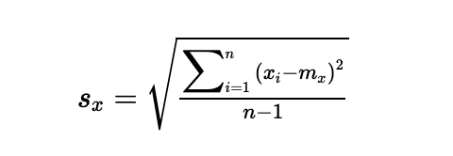

Nancy continued her coding and added the variance and standard deviation to the **tidyverse** descriptive statistics code they had been accumulating.

*# get mean, median, mode, and spread*

brfss.2014.cleaned **%>%**

**summarize**(mean.days = **mean**(x = PHYSHLTH, na.rm = TRUE),

        sd.days = **sd**(x = PHYSHLTH, na.rm = TRUE),

        var.days = **var**(x = PHYSHLTH, na.rm = TRUE),

        med.days = **median**(x = PHYSHLTH, na.rm = TRUE),

        mode.days = **names**(x = **sort**(x = **table**(PHYSHLTH),

                       decreasing = TRUE))[1])

##  mean.days sd.days var.days med.days mode.days

## 1  4.224106 8.775203 77.00419    0     0

Leslie remembered that the standard deviation was sometimes interpreted as the average amount an observation differs from the mean. After walking through [Equation (2.4)](https://jigsaw.vitalsource.com/books/9781506388144/epub/OEBPS/s9781506388175.i1382.xhtml#s9781506388175.i1564) one more time, Leslie concluded that this is conceptually close and a good way to think about it, but not 100% accurate. Regardless, she found that the standard deviation was the best measure of spread to report with means. Nancy thought a visual representation might help and added lines to the normal distribution graph showing how far away one standard deviation is from the mean in the histogram in [Figure 2.10](https://jigsaw.vitalsource.com/books/9781506388144/epub/OEBPS/s9781506388175.i1382.xhtml#s9781506388175.i1573).

The R-Team noticed that most of the observations of the variable were between the standard deviation lines. Most observations are within one standard deviation away from the mean. This reminded Kiara of a picture she took in Brussels at an R conference there in 2017 ([Figure 2.11](https://jigsaw.vitalsource.com/books/9781506388144/epub/OEBPS/s9781506388175.i1382.xhtml#s9781506388175.i1575)).

Leslie had a feeling that there was something else they needed to look at before they were done discussing normal distributions. Kiara suggested that maybe she was remembering [***kurtosis***](https://jigsaw.vitalsource.com/books/9781506388144/epub/OEBPS/s9781506388175.i4970.xhtml#s9781506388175.i7134). Kiara explained that kurtosis measures how many observations are in the tails of a distribution. She said that some distributions look bell-shaped, but have a lot of observations in the tails (platykurtic) or very few observations in the tails (leptokurtic) (Westfall, 2004). Leslie asked Kiara whether she was remembering correctly that [***platykurtic***](https://jigsaw.vitalsource.com/books/9781506388144/epub/OEBPS/s9781506388175.i4970.xhtml#s9781506388175.i7210) distributions are more *flat* (as in a *platy*pus has a flat beak) and [***leptokurtic***](https://jigsaw.vitalsource.com/books/9781506388144/epub/OEBPS/s9781506388175.i4970.xhtml#s9781506388175.i7139) distributions are more *pointy*. Kiara said this is a common way of describing the shapes of these distributions, but that, technically, kurtosis measures whether there are many or few observations in the tails of the distribution (Westfall, 2004).

**Figure 2.10** Normally distributed variable showing mean plus and minus one standard deviation

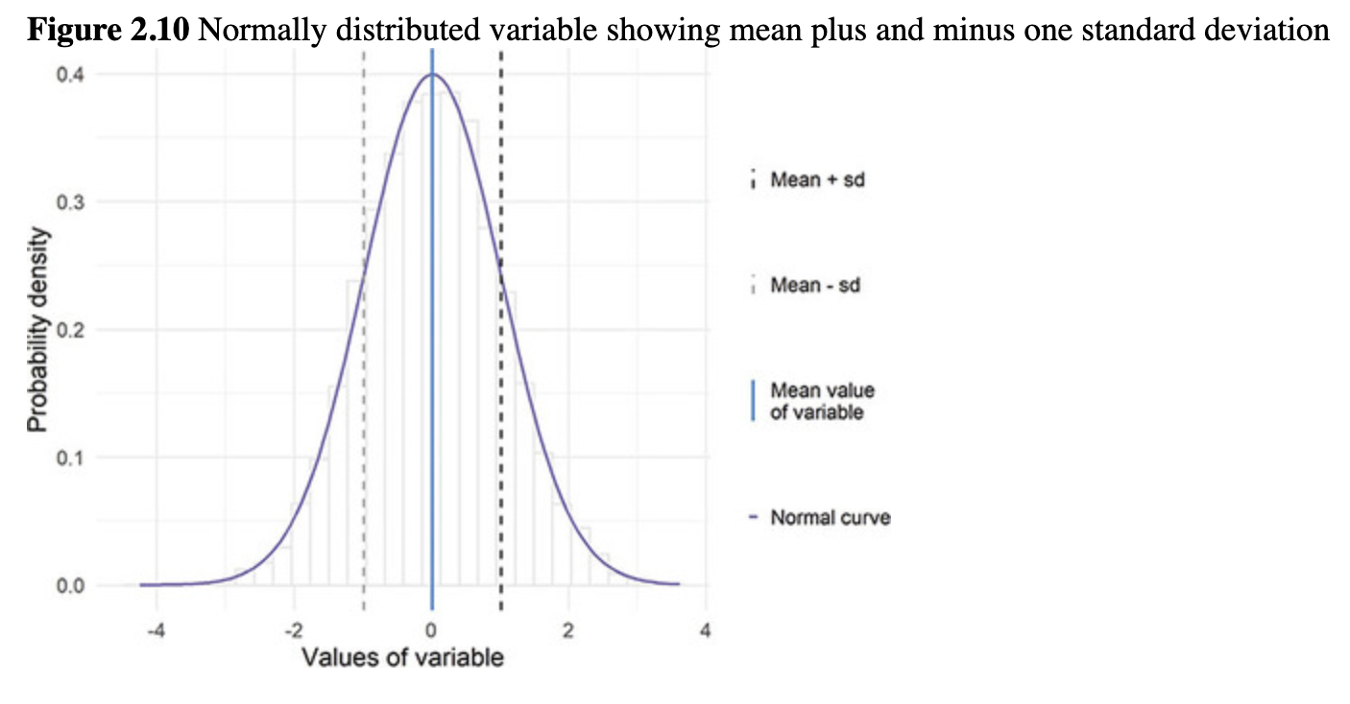

**Figure 2.11** Street sign from Brussels, Belgium (2017)

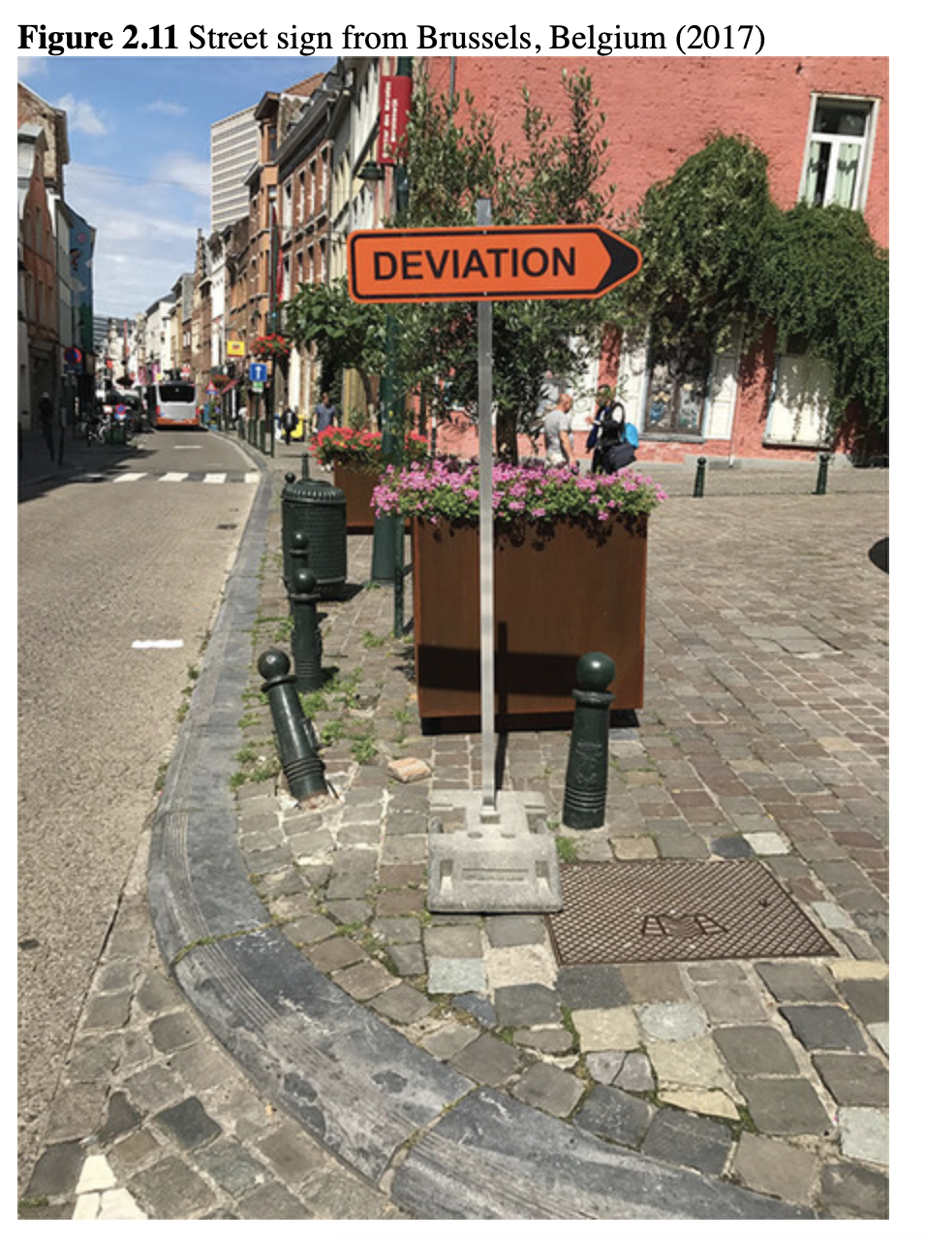

*Source:* Jenine K. Harris.

Nancy saw an opening for more coding and made [Figure 2.12](https://jigsaw.vitalsource.com/books/9781506388144/epub/OEBPS/s9781506388175.i1382.xhtml#s9781506388175.i1583) with histograms that had problems with kurtosis so the team could get an idea of what they are looking for.

From her data management work, Kiara learned that platykurtic and leptokurtic deviations from normality do not necessarily influence the mean, since it will still be a good representation of the middle of the data *if the distribution is symmetrical and not skewed*. However, platykurtic and leptokurtic distributions will have smaller and larger values of variance and standard deviation, respectively, compared to a normal distribution. The variance and standard deviation are not only used to quantify spread, but also used in many of the common statistical tests.

Leslie found the formula for kurtosis (Westfall, 2004) and showed [Equation (2.5)](https://jigsaw.vitalsource.com/books/9781506388144/epub/OEBPS/s9781506388175.i1382.xhtml#s9781506388175.i1579) to the team.

(2.5)

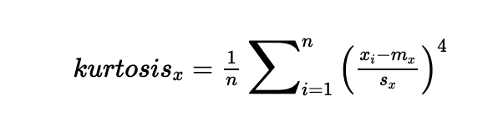

Leslie read that, in [Equation (2.5)](https://jigsaw.vitalsource.com/books/9781506388144/epub/OEBPS/s9781506388175.i1382.xhtml#s9781506388175.i1579), *n* is the sample size, *sx* is the standard deviation of *x*, *xi* is each value of *x*, and *mx* is the mean of *x*. The ∑ni=1∑i=1n symbol indicates the values from the first value of *x* (*i* = 1) to the last value of *x* (*i* = *n*) should be summed. A normal distribution will have a kurtosis value of 3; distributions with kurtosis = 3 are described as [***mesokurtic***](https://jigsaw.vitalsource.com/books/9781506388144/epub/OEBPS/s9781506388175.i4970.xhtml#s9781506388175.i7160). If kurtosis is above or below 3, there is excess kurtosis. Values of kurtosis above 3 indicate the distribution is *leptokurtic*, with fewer observations in the tails than a normal distribution (the fewer observations in the tails often give a distribution a pointy look). Values of kurtosis below 3 indicate the distribution is *platykurtic*, with more observations in the tails than a normal distribution would have given the mean, standard deviation, and sample size.

**Figure 2.12** Examples of different-shaped distributions with means of 55

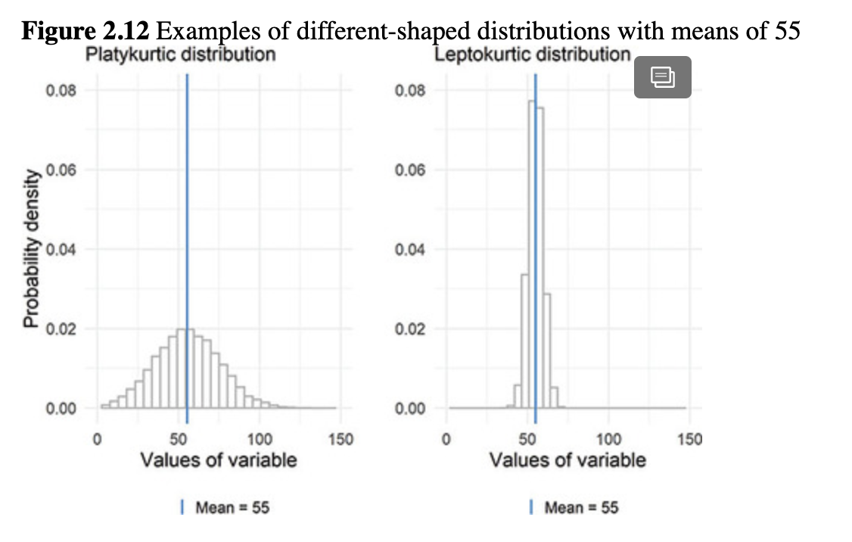

Leslie looked at the **semTools** package documentation and found kurtosis() to compute the kurtosis and a few related values. The kurtosis() function subtracts 3 from the kurtosis, so positive values will indicate a leptokurtic distribution and negative will indicate a platykurtic distribution. The same cutoff values from skew also apply for the *z* for small, medium, and large sample sizes in kurtosis. Leslie tried it for the two variables used in the leptokurtic and platykurtic graph above, saved as var1 in lepto.plot and platy.plot respectively.

*# kurtosis of Figure 2.12 leptokurtic distribution variable*

semTools**::kurtosis**(object = lepto.plot**$**var1)

## Excess Kur (g2)       se         z        p

##   0.05206405    0.04898979   1.06275295   0.28789400

*# kurtosis of Figure 2.12 platykurtic distribution variable*

semTools**::kurtosis**(object = platy.plot**$**var1)

## Excess Kur (g2)       se         z        p

##   -0.04920369    0.04898979   -1.00436604    0.31520221

The values of *z* for the two variables used in the example graphs are relatively small and so are not problematic regardless of sample size, so using statistics that rely on a normal distribution seems OK. Kiara mentioned that they would learn some additional statistical tests later that are useful for identifying non-normal distributions. Often, values of kurtosis and skewness will be reported with these statistical tests as additional information describing the nature of the non-normality (DeCarlo, 1997), rather than as the only piece of information on which to base a decision about normality.

### 2.6.4.2 Spread to report with the median

When distributions are not normally distributed, the median is often a better choice than the mean. For medians, however, the variance and standard deviation will not work to report the spread. Just like the very large values influence the mean, they also influence the standard deviation since the mean is part of the standard deviation formula. The R-Team found two options for reporting spread for non-normal variables. First, the range is the span between the largest and smallest values of a variable. Nancy added the ranges to the skewed distributions ([Figure 2.13](https://jigsaw.vitalsource.com/books/9781506388144/epub/OEBPS/s9781506388175.i1382.xhtml#s9781506388175.i1589)).

The range does not seem too informative on these graphs, Leslie noted, because it marks the very highest and very lowest values for a variable, but there is no indication of how the observations are spread out between these values. In order to get exact values, Nancy demonstrated by computing the range for the PHYSHLTH variable.

*# range of days of physical health*

**range**(brfss.2014.cleaned**$**PHYSHLTH, na.rm = TRUE)

## [1] 0 30

Leslie noticed that they *finally* had values that were easy to interpret: The range of unhealthy days in a month is 0 to 30. For the PHYSHLTH variable, the ends of the range are the highest and lowest possible values of the variable. The range does not provide any indication of how the data are distributed across the possible values. For example, maybe there is one person who has 30 days of poor physical health and everyone else is between 0 and 10. Or, maybe half the people have 0 and half the people have 30 and no people have anything in between. Leslie thought another option would be better for understanding spread.

**Figure 2.13** Examples of skewed distributions with medians and range boundaries

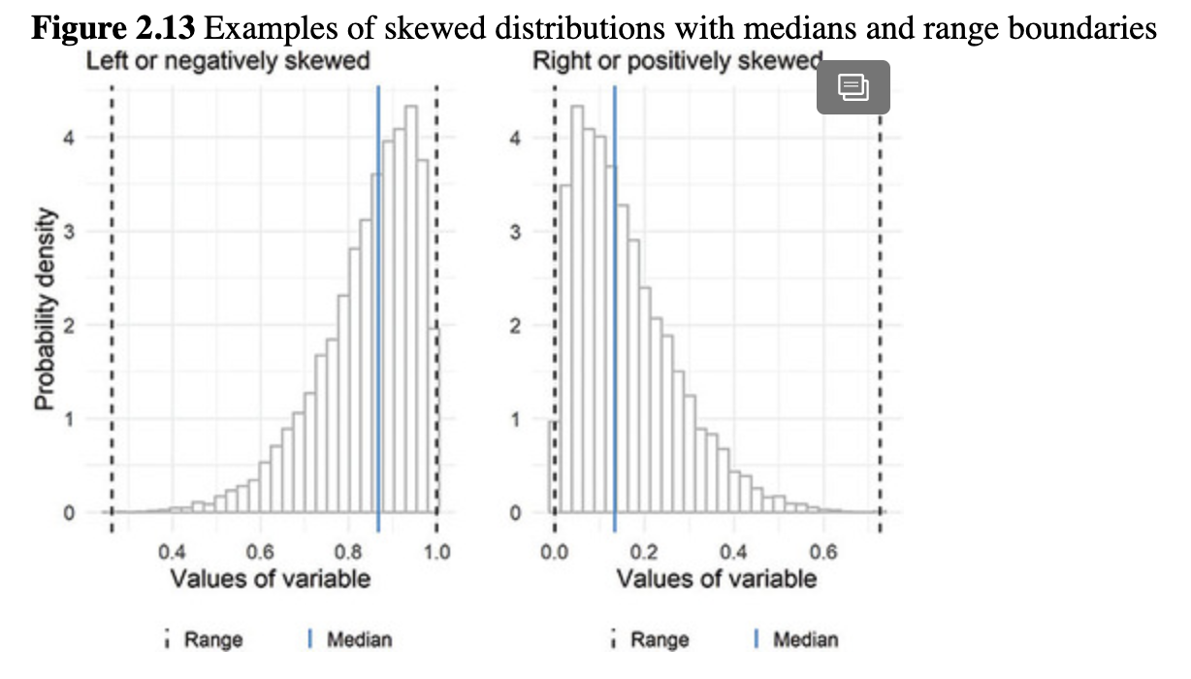

**Figure 2.14** Examples of skewed distributions with medians and IQR boundaries

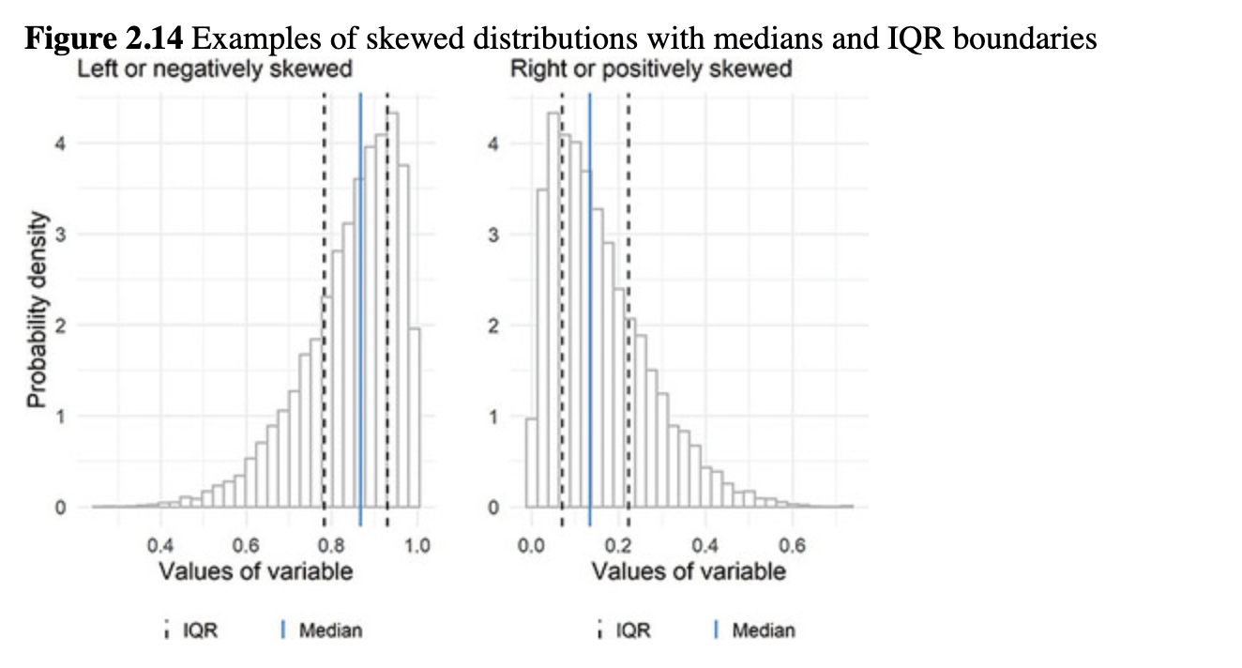

Leslie looked up the interquartile range, or IQR, and found that it might be more appropriate for these data, or for data that are highly skewed. The IQR is the difference between the first and third quartiles. A quartile is one-quarter of the data, so the difference between the first and third quartiles would be the boundaries around the middle 50% of the data. Nancy plotted the IQR on the skewed distributions ([Figure 2.14](https://jigsaw.vitalsource.com/books/9781506388144/epub/OEBPS/s9781506388175.i1382.xhtml#s9781506388175.i1591)).

This was more useful to Leslie. To find the IQR of PHYSHLTH, Nancy used IQR() and added it to the **tidyverse** descriptive statistics list.

*# get descriptive statistics for PHYSHLTH*

brfss.2014.cleaned **%>%**

**summarize**(mean.days = **mean**(x = PHYSHLTH, na.rm = TRUE),

        sd.days = **sd**(x = PHYSHLTH, na.rm = TRUE),

        var.days = **var**(x = PHYSHLTH, na.rm = TRUE),

        med.days = **median**(x = PHYSHLTH, na.rm = TRUE),

        iqr.days = **IQR**(x = PHYSHLTH, na.rm = TRUE),

        mode.days = **names**(x = **sort**(x = **table**(PHYSHLTH),

                        decreasing = TRUE))[1])

##  mean.days sd.days var.days med.days iqr.days mode.days

## 1 4.224106 8.775203 77.00419     0     3     0

Leslie noticed that they had typed na.rm = TRUE for all but one of the statistics in the summarize() code. She asked Nancy if there was some way to remove NA to make the code less repetitive. Nancy was delighted that Leslie was starting to think about the format of her code. She reminded Leslie that there was a way to omit NA values using drop_na() with the name of the variable of interest, like this:

*# get descriptive statistics for PHYSHLTH*

brfss.2014.cleaned **%>%**

**drop_na**(PHYSHLTH) **%>%**

**summarize**(mean.days = **mean**(x = PHYSHLTH),

        sd.days = **sd**(x = PHYSHLTH),

        var.days = **var**(x = PHYSHLTH),

        med.days = **median**(x = PHYSHLTH),

        iqr.days = **IQR**(x = PHYSHLTH),

        mode.days = **names**(x = **sort**(x = **table**(PHYSHLTH),

                        decreasing = TRUE))[1])

##  mean.days sd.days var.days med.days iqr.days mode.days

## 1 4.224106 8.775203 77.00419     0     3     0

Leslie examined the statistics so far. She noted that the IQR value makes sense; there is a 3-day difference between the first and third quartiles for unhealthy days. She remembered she had usually seen the IQR reported without much interpretation, like this: IQR = 3.

Leslie would rather see the upper and lower bounds of the IQR. Nancy said there was no way to do this in the IQR() function, but the quantile() function could be used to find the bounds around the middle 50%, which are the IQR boundaries.

*# interquartile range of unhealthy days*

**quantile**(x = brfss.2014.cleaned**$**PHYSHLTH, na.rm = TRUE)

##  0% 25% 50% 75% 100%

##   0  0  0  3  30

The middle 50% of the data is between the 25% and 75% quantiles. Leslie could now report the bounds around the middle 50% of unhealthy days, 0 to 3. Fifty percent of observations (people) in this data set have between 0 and 3 physically unhealthy days per month. Nancy added the median and IQR boundaries to the PHYSHLTH plot with new layers and did a little formatting so they are easier to see ([Figure 2.15](https://jigsaw.vitalsource.com/books/9781506388144/epub/OEBPS/s9781506388175.i1382.xhtml#s9781506388175.i1599)).

Leslie noticed that the lower boundary of the IQR is the same as the median in the graph. Kiara said this was due to so many values being zero and this being the lowest possible value of the variable. Leslie was curious about the graph code, but Nancy said it had some complex features and suggested they save it for next time when they are working on graphs.

### 2.6.4.3 Spread to report with the mode

Leslie remembered that spread is not often reported for categorical variables. Leslie and Kiara discussed what the idea of spread or variability even means for a categorical variable. They reviewed some options in textbooks that describe how observations are spread across categories, sometimes described as *diversity*.

Kiara and Leslie found several options for the *index of qualitative variation*, which quantified how much the observations are spread across categories of a categorical variable. While these indexes are computed in different ways, they all have a range from 0 to 1. The resulting values are *high* when observations are spread out among categories and *low* when they are not. For example, if a data set had a marital status variable and there were 3 people in each marital status category, the data would be considered perfectly spread across groups and the index value would be 1. Likewise, if everyone in the data set was in one category (e.g., unmarried), the index value would be 0 for no spread at all.

**Figure 2.15** Distribution of days of poor physical health showing median and IQR boundaries

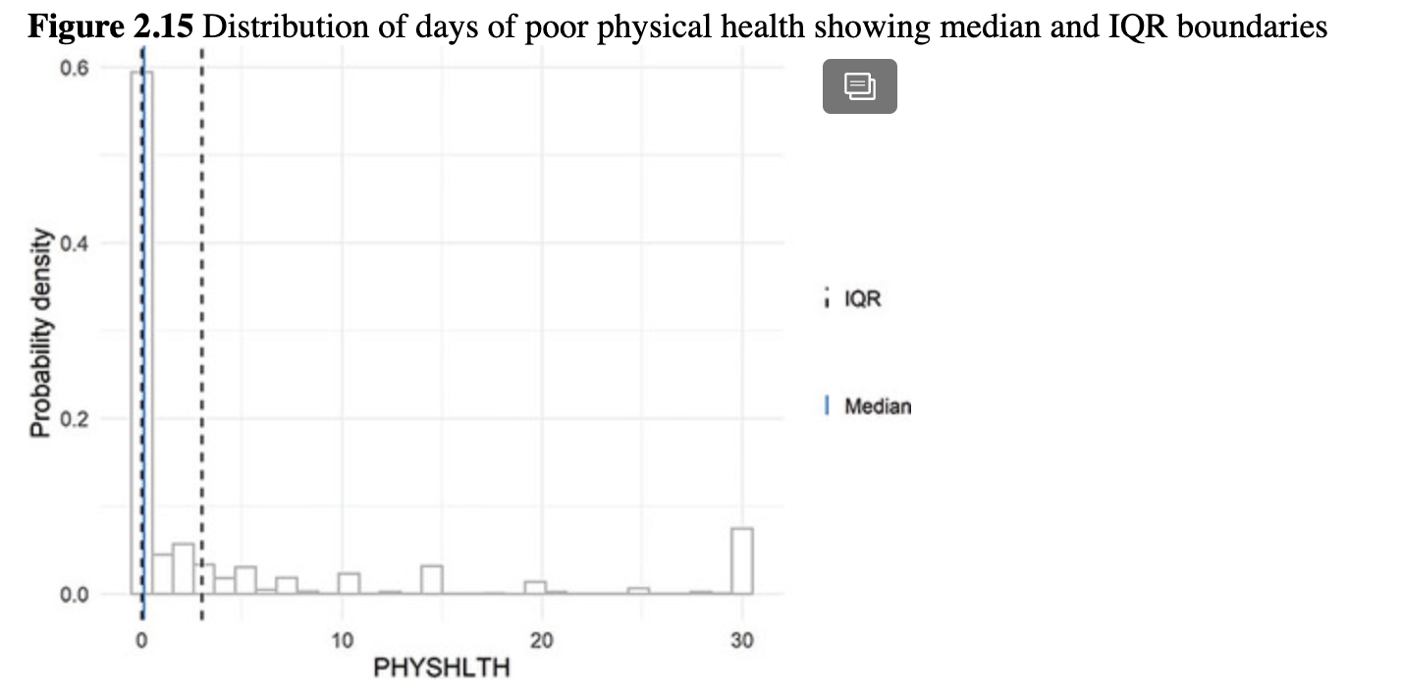

After reading through the R help documentation for the **qualvar** package, which includes several options, Kiara and Leslie found the [***B index***](https://jigsaw.vitalsource.com/books/9781506388144/epub/OEBPS/s9781506388175.i4970.xhtml#s9781506388175.i7014) to be their favorite.

They shared their finding with Nancy, who was playing on her phone because she had run out of things to code for the moment. Nancy had not used the B index, but she found B() in the **qualvar** package. She looked up the help documentation for the B() function and saw that the first argument is x, which is described as “a vector of frequencies.” The PHYSHLTH variable is numeric, so it would not use the B index. Instead, Leslie went back to the TRNSGNDR variable. To get a vector of frequencies for TRNSGNDR, Nancy thought the table() function might work. Instead of making a table as a new object, Nancy added the table() code directly into the B() function. It worked perfectly.

*# B index of TRNSGNDR variable*

qualvar**::B**(x = **table**(brfss.2014.cleaned**$**TRNSGNDR))

## [1] 0.0009940017

The resulting value of 0.00099 is close to zero and therefore indicates that observations in this data set are not well spread out among the six categories of TRNSGNDR. While it is true that there are people in all categories, the “Not transgender” category contains a much larger number of observations than any of the other categories, so the small value of B reflects this lack of even spread of observations across categories of TRNSGNDR.

Leslie wanted to make sure she had the chance to practice reporting and interpreting the descriptive statistics for numeric variables, so she wrote a few sentences to make sure she understood.

The mean number of days of poor health per month for participants in the 2014 BRFSS was 4.22 (*s* = 8.78).

Leslie recognized that she would not report the mean and the median for the variable; instead, she would choose the most appropriate one. However, for the sake of practicing, she wrote an interpretation of the median.

The median number of days of poor health per month for participants in the 2014 BRFSS was 0 (IQR = 3).

The mode would not commonly be reported for the PHYSHLTH variable, so she reported the mode and B index for TRNSGNDR instead.

The most common response (mode) to the transgender question was “Not transgender.” The responses were not spread out very evenly among the categories, with over 150,000 in the “Not transgender” category and just 116 in the “Gender non-conforming” category (B = .00099).

Kiara and Nancy approved of these interpretations and told Leslie her writing was similar to interpretations in published manuscripts.

## 2.6.5 Achievement 3: Check your understanding

Find central tendency and spread for the age variable (**X_AGE80**). Examine the variable and the codebook first to see if it needs to be cleaned.

# 2.7 Achievement 4: Developing clear tables for reporting descriptive statistics

Although Leslie felt like she now had a great grasp of descriptive statistics, Kiara explained that they were only halfway done! After all, Kiara stated, statistics are only useful when people can understand them. In the case of descriptive statistics, she said, making a clear table is the key to good communication. Clear tables tend to have the following features:

* A title that explains what is in the table
  + The number of observations if possible
  + Key pieces of information that describe the sample such as the year of data collection and the data source
  + The units of measurement (people, organizations, etc.)
* Consistent use of the same number of decimal places throughout the table
* Numbers aligned to the right so that the decimal points line up
* Words aligned to the left
* Indentation and shading to differentiate rows or sections
* Limited internal lines
* Clearly labeled rows and columns

If the table contains only factor-type variables, Kiara explained, it may look like [Table 2.1](https://jigsaw.vitalsource.com/books/9781506388144/epub/OEBPS/s9781506388175.i1382.xhtml#s9781506388175.i1393) including only percentages. They decided that reproducing that table would be good practice for making publication-quality tables. To reproduce [Table 2.1](https://jigsaw.vitalsource.com/books/9781506388144/epub/OEBPS/s9781506388175.i1382.xhtml#s9781506388175.i1393), Kiara had Leslie note the variables included in the table and find them in the BRFSS codebook (<https://www.cdc.gov/brfss/annual_data/2014/pdf/CODEBOOK14_LLCP.pdf>). After she reviewed the variables in the codebook, the team got to work to reproduce [Table 2.1](https://jigsaw.vitalsource.com/books/9781506388144/epub/OEBPS/s9781506388175.i1382.xhtml#s9781506388175.i1393). Kiara recommended they refer to this table as [Table 2.1](https://jigsaw.vitalsource.com/books/9781506388144/epub/OEBPS/s9781506388175.i1382.xhtml#s9781506388175.i1393) as they work, with the understanding that it was a reproduction of the Table 1 printed in the Narayan et al. (2017) paper.

## 2.7.1 Data cleaning before analysis

### 2.7.1.1 Creating a smaller data frame to work with

Looking back at [Table 2.1](https://jigsaw.vitalsource.com/books/9781506388144/epub/OEBPS/s9781506388175.i1382.xhtml#s9781506388175.i1393) and reviewing the Narayan et al. paper (2017), Leslie and Kiara determined that it contained only those who answered the transgender status question, were in the 40- to 74-year-old age groups, and were asked the mammogram question. They found these three variables in the codebook:

* TRNSGNDR: codebook page 83
* _AGEG5YR: codebook page 108
* HADMAM: codebook page 37

Kiara shared one of her favorite data management tips with Leslie, which was to create a smaller data set by limiting the data to the observations that will be analyzed. There are several ways to create a subset that contains only particular observations. One method is to simply grab the observations wanted using the square brackets [ ]. Kiara reminded Leslie that she had already used [ ] to get the 4th element of the salaries vector using salaries[4]. Vectors are one-dimensional, and therefore Leslie would just put one number inside the brackets. Data frames are two-dimensional, Kiara explained, since there are both rows and columns. So to index a data frame, the square brackets require two numbers, separated by a comma, and the order will always be [rows, columns]. Kiara wrote a few examples.

* Get the value of the 3rd row and 2nd column: data.frame[3, 2].
* Get all of the values in the 5th column: data.frame[ ,5]. A blank in the rows part means “all,” but it still needs to be separated by a comma.
* Get the values for rows 2 through 6 and columns 4 through 10: data.frame[2:6, 4:10]. The colon : can be read as “through.”
* Get the values for rows 1, 7, 18 and columns 4 through 10: data.frame[c(1, 7, 18), 4:10].

Since the R-Team has been using **tidyverse**, Nancy thought they should create a subset with the filter() function instead of the square brackets. She suggested that Leslie look up the help documentation for the filter() function on her own. Leslie found that filter() “choose[s] rows/cases where conditions are true.” Nancy explained that this meant she should write a statement that is either TRUE or FALSE and R will use this to keep the observations where the statement is true and filter out the observations where the statement is false. Nancy knew the importance of understanding logical statements, so she gave Leslie a few examples to try before she wrote filter() code.

* Is the object on the left equal to the object on the right? Use ==.
  + 3 == 9 is FALSE because 3 does not equal 9.
  + If a = 10 and b = 10, then a == b is TRUE.
* Is the object on the left *not* equal to the object on the right? Use !=.
  + 3 != 9 is TRUE because 3 does not equal 9.
  + If a = 10 and b = 10, then a != b is FALSE.
* Is the object on the left greater than or less than the object on the right? Use > or <.
  + 3 > 9 is FALSE.
  + 3 < 9 is TRUE.
  + 3 < 3 is FALSE.
  + 3 <= 3 is TRUE.

Nancy then told Leslie that she could combine these logical statements. To require two conditions to both be true, use the &, so 3 < 9 & 4 == 4 would be TRUE. This is because *both* statements are true. However, 3 > 9 & 4 == 4 is FALSE. This is because the first statement 3 > 9 is FALSE, therefore it doesn’t matter that the second part of the statement (4 == 4) is OK—the whole combined statement is FALSE.

Nancy explained that if you want to know if one *or* the other is true, use the | symbol. 3 > 9 | 4 == 4 is TRUE because 4 == 4 is TRUE.

Leslie had a better grasp of logical conditions after that and was ready to use filter(). When she reviewed the data frame before coding, Leslie noticed that the _AGEG5YR variable was imported with an X at the beginning of the variable name, so she incorporated this into the code.

*# create a subset of the data set to keep*

*# transgender status of MtF OR FtM OR Gender non-conforming*

*# age group higher than group 4 and lower than group 12*

*# was asked mammogram question*

brfss.2014.small <- brfss.2014.cleaned **%>%**

**filter**(TRNSGNDR **==** 'Male to female'**|**

       TRNSGNDR **==** 'Female to male'**|**

       TRNSGNDR **==** 'Gender non-conforming') **%>%**

**filter**(X_AGEG5YR **>** 4 **&** X_AGEG5YR **<** 12) **%>%**

**filter**(**!is.na**(HADMAM))

*# check the new data frame*

**summary**(object = brfss.2014.small)

##           TRNSGNDR   X_AGEG5YR     X_RACE

## Male to female    : 77  Min.  : 5.000  Min.  :1.000

## Female to male    :113  1st Qu.: 7.000  1st Qu.:1.000

## Gender non-conforming: 32  Median : 8.000  Median :1.000

## Not transgender    : 0  Mean  : 7.986  Mean  :2.054

## Not sure        : 0  3rd Qu.: 9.000  3rd Qu.:2.000

## Refused        : 0  Max.  :11.000  Max.  :9.000

##

##   X_INCOMG    X_EDUCAG    HLTHPLN1     HADMAM

## Min.  :1.000  Min.  :1.000  Min.  :1.000  Min.  :1.000

## 1st Qu.:2.000  1st Qu.:2.000  1st Qu.:1.000  1st Qu.:1.000

## Median :4.000  Median :3.000  Median :1.000  Median :1.000

## Mean  :3.685  Mean  :2.595  Mean  :1.108  Mean  :1.171

## 3rd Qu.:5.000  3rd Qu.:3.000  3rd Qu.:1.000  3rd Qu.:1.000

## Max.  :9.000  Max.  :4.000  Max.  :2.000  Max.  :9.000

##

##   X_AGE80     PHYSHLTH

## Min.  :40.00  Min.  : 0.000

## 1st Qu.:50.00  1st Qu.: 0.000

## Median :57.00  Median : 1.000

## Mean  :56.83  Mean  : 7.528

## 3rd Qu.:63.75  3rd Qu.:11.000

## Max.  :74.00  Max.  :30.000

##          NA's  :10

Leslie summarized what she wrote. The first filter() chose observations that were any one of the three categories of transgender included in the data. She used the | “or” operator for this filter(). The second filter() chose people in an age category above category 4 but below category 12, in the age categories 5 through 11. Leslie asked why they did not use the X_AGE80 to choose people 40 to 74. Nancy replied that she had tried that first while Leslie was reading the codebook, but she found a few observations in X_AGE80 to be coded strangely, and since the age categories variable X_AGEG5YR was the one used in the table they were trying to reproduce, she thought that was a better idea.

The last filter() used the !is.na to choose observations where the HADMAM variable was not NA. Applying all of these filters resulted in a smaller data frame with 222 observations. Leslie noticed that the breast cancer screening article included 220 people who fit the criteria and wondered why she and Nancy had 2 additional people in their data frame. She decided she would review the percentages closely in creating the table to see where these 2 people fit in and to determine if they should be excluded.

Kiara told Leslie that small mistakes seem to be common in published research, often due to errors in transferring numbers from statistical software into a word-processing program. She suggested that creating fully formatted tables directly in R or another software program could reduce errors and increase the reproducibility of published research.

Now that the data set contained the observations used to create the table, Kiara suggested that it may be useful to reduce the data set to contain only the variables used to create the table. In addition to transgender status, age categories, and mammogram information, the table contained percentages for race/ethnicity, income category, education category, and health insurance status. The complete list of variables for the table is as follows:

* TRNSGNDR
* X_AGEG5YR
* X_RACE
* X_INCOMG
* X_EDUCAG
* HLTHPLN1
* HADMAM

Nancy helped Leslie write some variable selection code to add to the filtering code they just wrote.

*# create a subset of observations and variables*

brfss.2014.small <- brfss.2014.cleaned **%>%**

**filter**(TRNSGNDR **==** 'Male to female'**|**

       TRNSGNDR **==** 'Female to male'**|**

       TRNSGNDR **==** 'Gender non-conforming') **%>%**

**filter**(X_AGEG5YR **>** 4 **&** X_AGEG5YR **<** 12) **%>%**

**filter**(**!is.na**(HADMAM)) **%>%**

**select**(TRNSGNDR, X_AGEG5YR, X_RACE, X_INCOMG, X_EDUCAG, HLTHPLN1, HADMAM)

Leslie used the summary() function to examine the new data set to see what it contained.

*# summary statistics for the new data frame*

**summary**(object = brfss.2014.small)

##            TRNSGNDR   X_AGEG5YR     X_RACE

## Male to female     : 77  Min.  : 5.000  Min.  :1.000

## Female to male     :113  1st Qu.: 7.000  1st Qu.:1.000

## Gender non-conforming: 32  Median : 8.000  Median :1.000

## Not transgender    : 0  Mean  : 7.986  Mean  :2.054

## Not sure        : 0  3rd Qu.: 9.000  3rd Qu.:2.000

## Refused        : 0   Max.  :11.000  Max.  :9.000

##   X_INCOMG    X_EDUCAG    HLTHPLN1     HADMAM

## Min.  :1.000   Min.  :1.000  Min.  :1.000  Min.  :1.000

## 1st Qu.:2.000  1st Qu.:2.000  1st Qu.:1.000  1st Qu.:1.000

## Median :4.000  Median :3.000  Median :1.000  Median :1.000

## Mean  :3.685   Mean  :2.595  Mean  :1.108  Mean  :1.171

## 3rd Qu.:5.000  3rd Qu.:3.000  3rd Qu.:1.000  3rd Qu.:1.000

## Max.  :9.000   Max.  :4.000  Max.  :2.000  Max.  :9.000

Leslie noticed that some of the variables were the wrong data type, since R had computed the mean and median for each one when they were all categorical and should have been the factor data type. Luckily, Nancy knew of a variation on mutate() that could be used to change all the variables in this small data set to factor types. The mutate_all() function can be used to do something to every variable in a data frame. Nancy added mutate_all(as.factor) to the code and they tested to see if it worked.

*# change variables to factor data types*

brfss.2014.small <- brfss.2014.cleaned **%>%**

**filter**(TRNSGNDR **==** 'Male to female'**|**

       TRNSGNDR **==** 'Female to male'**|**

       TRNSGNDR **==** 'Gender non-conforming') **%>%**

**filter**(X_AGEG5YR **>** 4 **&** X_AGEG5YR **<** 12) **%>%**

**filter**(**!is.na**(HADMAM)) **%>%**

**select**(TRNSGNDR, X_AGEG5YR, X_RACE, X_INCOMG,

      X_EDUCAG, HLTHPLN1, HADMAM) **%>%**

**mutate_all**(as.factor)

*# summary statistics for the new data frame*

**summary**(object = brfss.2014.small)

##           TRNSGNDR  X_AGEG5YR   X_RACE  X_INCOMG X_EDUCAG

## Male to female    : 77  5 :27   1    :152   1:46   1:24

## Female to male    :113  6 :27   2   : 31   2:44   2:86

## Gender non-conforming: 32  7 :32   8   : 11   3:19   3:68

## Not transgender    : 0  8 :44   7   : 8    4:26   4:44

## Not sure        : 0  9 :44   5   : 7    5:65

## Refused         : 0  10:24   4   : 6    9:22

##                  11:24   (Other): 7

## HLTHPLN1 HADMAM

## 1:198  1:198

## 2: 24  2: 22

##       9: 2

##

##

##

##

### 2.7.1.2 Adding labels to variables

Leslie noticed that, while the variables were all factors, many did not have labels for each category. Nancy reminded Leslie that they could use mutate() and recode_factor() to add the category labels like they did for the TRNSGNDR variable. Leslie and Nancy reviewed the codebook and worked together to write the code to add the labels. Leslie was having some trouble with the apostrophe in “Don’t know,” and Nancy told her that adding the \ character before punctuation allows R to read the punctuation correctly. Leslie added the \ and it appeared to work.

*# add labels to factor variables*

brfss.2014.small <- brfss.2014.cleaned **%>%**

**filter**(TRNSGNDR **==** 'Male to female'**|**

       TRNSGNDR **==** 'Female to male'**|**

       TRNSGNDR **==** 'Gender non-conforming') **%>%**

**filter**(X_AGEG5YR **>** 4 **&** X_AGEG5YR **<** 12) **%>%**

**filter**(**!is.na**(HADMAM)) **%>%**

**select** (TRNSGNDR, X_AGEG5YR, X_RACE, X_INCOMG,

      X_EDUCAG, HLTHPLN1, HADMAM) **%>%**

**mutate_all**(as.factor) **%>%**

**mutate**(X_AGEG5YR = **recode_factor**(.x = X_AGEG5YR,

                     55 = '40-44',

                     66 = '45-49',

                     77 = '50-54',

                     88 = '55-59',

                     99 = '60-64',

                     1010 = '65-69',

                     1111 = '70-74')) **%>%**

**mutate**(X_INCOMG = **recode_factor**(.x = X_INCOMG,

                     11 = 'Less than $15,000',

                     22 = '$15,000 to less than $25,000',

                     33 = '$25,000 to less than $35,000',

                     44 = '$35,000 to less than $50,000',

                     55 = '$50,000 or more',

                     99 = 'Don\'t know/not sure/missing')) **%>%**

**mutate**(X_EDUCAG = **recode_factor**(.x = X_EDUCAG,

                     11 = 'Did not graduate high school',

                     22 = 'Graduated high school',

                     33 = 'Attended college/technical school',

                     44 = 'Graduated from college/technical school',

                     99 = NA_character_)) **%>%**

**mutate**(HLTHPLN1 = **recode_factor**(.x = HLTHPLN1,

                     11 = 'Yes',

                     22 = 'No',

                     77 = 'Don\'t know/not sure/missing',

                     99 = 'Refused'))

*# check the work so far*

**summary**(object = brfss.2014.small)

##           TRNSGNDR  X_AGEG5YR   X_RACE

## Male to female     : 77  40-44:27  1   :152

## Female to male    :113  45-49:27  2   : 31

## Gender non-conforming: 32  50-54:32  8   : 11

## Not transgender    : 0  55-59:44  7   : 8

## Not sure        : 0  60-64:44  5   : 7

## Refused         : 0   65-69:24  4   : 6

##                  70-74:24  (Other): 7

##             X_INCOMG

## Less than $15,000       :46

## $15,000 to less than $25,000:44

## $25,000 to less than $35,000:19

## $35,000 to less than $50,000:26

## $50,000 or more        :65

## Don't know/not sure/missing :22

##

##                      X_EDUCAG HLTHPLN1 HADMAM

## Did not graduate high school      :24  Yes :198  1:198

## Graduated high school           :86  No : 24  2: 22

## Attended college/technical school    :68        9: 2

## Graduated from college/technical school:44

##

##

##

Everything looked good so far, but X_RACE and HADMAM still needed to be recoded. Leslie noticed that, based on the percentages reported in [Table 2.1](https://jigsaw.vitalsource.com/books/9781506388144/epub/OEBPS/s9781506388175.i1382.xhtml#s9781506388175.i1393), Pacific Islanders were included in the “Other race” category and not in the “Asian/Pacific Islander” category. To reproduce the exact percentages in the table, she needed to include Pacific Islanders as “Other.” Reviewing the BRFSS codebook, page 106, she found the following:

* 1) White only, non-Hispanic
* 2) Black only, non-Hispanic
* 3) American Indian or Alaskan Native only, Non-Hispanic
* 4) Asian only, non-Hispanic
* 5) Native Hawaiian or other Pacific Islander only, Non-Hispanic
* 6) Other race only, non-Hispanic
* 7) Multiracial, non-Hispanic
* 8) Hispanic
* 9) Don’t know/Not sure/Refused

[Table 2.1](https://jigsaw.vitalsource.com/books/9781506388144/epub/OEBPS/s9781506388175.i1382.xhtml#s9781506388175.i1393) used the following categories:

* 1) White
* 2) Black
* 3) Native American
* 4) Asian/Pacific Islander
* 5) Other

Leslie mapped the categories in the codebook into the categories in the table.

* Category 1 (White only, non-Hispanic) from the BRFSS data was labeled as White in the table
* Category 2 (Black only, non-Hispanic) from the BRFSS data was labeled as Black in the table
* Category 3 (American Indian or Alaskan Native only, Non-Hispanic) from BRFSS was Native American in the table
* Category 4 (Asian only, non-Hispanic) from BRFSS was Asian/Pacific Islander in the table
* Due to the mistake in labeling in the paper, categories 5, 6, 7, and 8 from BRFSS were Other in the table

Nancy watched closely while Leslie wrote the recoding for the levels of X_RACE exactly as it was written in the 2017 paper for the purposes of reproducing the table.

*# add labels to factor variables*

brfss.2014.small <- brfss.2014.cleaned **%>%**

**filter**(TRNSGNDR **==** 'Male to female'**|**

      TRNSGNDR **==** 'Female to male'**|**

      TRNSGNDR **==** 'Gender non-conforming') **%>%**

**filter**(X_AGEG5YR **>** 4 **&** X_AGEG5YR **<** 12) **%>%**

**filter**(**!is.na**(HADMAM)) **%>%**

**select**(TRNSGNDR, X_AGEG5YR, X_RACE, X_INCOMG,

      X_EDUCAG, HLTHPLN1, HADMAM) **%>%**

**mutate_all**(as.factor) **%>%**

**mutate**(X_AGEG5YR = **recode_factor**(.x = X_AGEG5YR,

                     55 = '40-44',

                     66 = '45-49',

                     77 = '50-54',

                     88 = '55-59',

                     99 = '60-64',

                     1010 = '65-69',

                     1111 = '70-74')) **%>%**

**mutate**(X_INCOMG = **recode_factor**(.x = X_INCOMG,

                     11 = 'Less than $15,000',

                     22 = '$15,000 to less than $25,000',

                     33 = '$25,000 to less than $35,000',

                     44 = '$35,000 to less than $50,000',

                     55 = '$50,000 or more',

                     99 = 'Don\'t know/not sure/missing')) **%>%**

**mutate**(X_EDUCAG = **recode_factor**(.x = X_EDUCAG,

                     11 = 'Did not graduate high school',

                     22 = 'Graduated high school',

                     33 = 'Attended college/technical school',

                     44 = 'Graduated from college/technical school',

                     99 = NA_character_)) **%>%**

**mutate**(HLTHPLN1 = **recode_factor**(.x = HLTHPLN1,

                     11 = 'Yes',

                     22 = 'No',

                     77 = 'Don\'t know/not sure/missing',

                     99 = 'Refused')) **%>%**

**mutate**(X_RACE = **recode_factor**(.x = X_RACE,

                   11 = 'White',

                   22 = 'Black',

                   33 = 'Native American',

                   44 = 'Asian/Pacific Islander',

                   55 = 'Other',

                   66 = 'Other',

                   77 = 'Other',

                   88 = 'Other',

                   99 = 'Other')) **%>%**

**mutate**(HADMAM = **recode_factor**(.x = HADMAM,

                   11 = 'Yes',

                   22 = 'No',

                   77 = 'Don\'t know/not sure/missing',

                   99 = 'Refused'))

*#check the work so far*

**summary**(object = brfss.2014.small)

##           TRNSGNDR  X_AGEG5YR           X_RACE

## Male to female     : 77  40-44:27  White          :152

## Female to male     :113  45-49:27  Black          : 31

## Gender non-conforming: 32  50-54:32  Native American     : 4

## Not transgender    : 0  55-59:44  Asian/Pacific Islander: 6

## Not sure        : 0  60-64:44   Other          : 29

## Refused         : 0  65-69:24

##                70-74:24

##               X_INCOMG

## Less than $15,000       :46

## $15,000 to less than $25,000:44

## $25,000 to less than $35,000:19

## $35,000 to less than $50,000:26

## $50,000 or more        :65

## Don't know/not sure/missing :22

##

##                      X_EDUCAG HLTHPLN1   HADMAM

## Did not graduate high school       :24  Yes:198  Yes  :198

## Graduated high school           :86  No : 24  No   : 22

## Attended college/technical school    :68        Refused: 2

## Graduated from college/technical school:44

##

##

##

### 2.7.1.3 Checking work and recoding problematic values

Leslie wanted to figure out why there were 222 observations in her data frame and 220 in [Table 2.1](https://jigsaw.vitalsource.com/books/9781506388144/epub/OEBPS/s9781506388175.i1382.xhtml#s9781506388175.i1393), which was showing the exact numbers from the Narayan et al. paper. Since the table only contained percentages, she thought she would review the percentages to find where the problem was. She remembered that percentages were produced with the prop.table() function, which needs a table() as input. To get a table of transgender status percentages, she used the following:

*# get percents for TRNSGNDR*

**prop.table**(x = **table**(brfss.2014.small**$**TRNSGNDR))

##

##    Male to female    Female to male Gender non-conforming

##       0.3468468        0.5090090        0.1441441

##    Not transgender        Not sure         Refused

##        0.0000000       0.0000000        0.0000000

These values were slightly different from those in the original table. Kiara thought this was likely due to the two-observation difference. Using her well-developed data-sleuthing skills, Kiara found that the difference was because the two observations where the HADMAM variable was coded as 9, or “Refused,” were dropped before computing percentages of the TRNSGNDR variable but were kept for computing the percentages of all the other variables.

This was a really tricky data management problem! Leslie asked if they could change TRNSGNDR to NA when the HADMAM variable was category 9, which is the code for “Refused.” Kiara said this would work, but it required learning a new function, if_else().

Kiara explained that the if_else() function takes three arguments. The first argument is a logical statement (or condition) that must be either TRUE or FALSE. The second argument is true =. This is where you tell R what to do if the statement from the first argument is TRUE. The third argument, false =, is what you want to happen if the statement from the first argument is FALSE. The second and third arguments have to be the same data type. Before they wrote the code, Kiara first had Leslie say out loud what she wanted the if_else() function to do. She responded with the following:

“For each person in the data set, if that person’s value in HADMAM was *not* equal to 9, then leave their TRNSGNDR value as it is (do nothing). For everyone else that *does* have a value of 9 in HADMAM, change their TRNSGNDR value to be NA.”

Kiara and Nancy looked at each other and were quite impressed with Leslie! Nancy added a line to the data management before select() and tested it.

*# complete data management code*

brfss.2014.small <- brfss.2014.cleaned **%>%**

**filter**(TRNSGNDR **==** 'Male to female'**|**

       TRNSGNDR **==** 'Female to male'**|**

       TRNSGNDR **==** 'Gender non-conforming') **%>%**

**filter**(X_AGEG5YR **>** 4 **&** X_AGEG5YR **<** 12) **%>%**

**filter**(**!is.na**(HADMAM)) **%>%**

**mutate**(TRNSGNDR = **if_else**(condition = HADMAM **!=** 9,

                 true = TRNSGNDR,

                 false = **factor**(NA))) **%>%**

**select**(TRNSGNDR, X_AGEG5YR, X_RACE, X_INCOMG, X_EDUCAG, HLTHPLN1) **%>%**

**mutate_all**(as.factor) **%>%**

**mutate**(X_AGEG5YR = **recode_factor**(.x = X_AGEG5YR,

                     55 = '40-44',

                     66 = '45-49',

                     77 = '50-54',

                     88 = '55-59',

                     99 = '60-64',

                     1010 = '65-69',

                     1111 = '70-74')) **%>%**

**mutate**(X_INCOMG = **recode_factor**(.x = X_INCOMG,

                     11 = 'Less than $15,000',

                     22 = '$15,000 to less than $25,000',

                     33 = '$25,000 to less than $35,000',

                     44 = '$35,000 to less than $50,000',

                     55 = '$50,000 or more',

                     99 = 'Don\'t know/not sure/missing')) **%>%**

**mutate**(X_EDUCAG = **recode_factor**(.x = X_EDUCAG,

                     11 = 'Did not graduate high school',

                     22 = 'Graduated high school',

                     33 = 'Attended college/technical school',

                     44 = 'Graduated from college/technical school',

                     99 = NA_character_)) **%>%**

**mutate**(HLTHPLN1 = **recode_factor**(.x = HLTHPLN1,

                     11 = 'Yes',

                     22 = 'No',

                     77 = 'Don\'t know/not sure/missing',

                     99 = 'Refused')) **%>%**

**mutate**(X_RACE = **recode_factor**(.x = X_RACE,

                   11 = 'White',

                   22 = 'Black',

                   33 = 'Native American',

                   44 = 'Asian/Pacific Islander',

                   55 = 'Other',

                   66 = 'Other',

                   77 = 'Other',

                   88 = 'Other',

                   99 = 'Other')) **%>%**

**droplevels**()

*#check the work*

**prop.table**(x = **table**(brfss.2014.small**$**TRNSGNDR))

##

##    Male to female    Female to male Gender non-conforming

##       0.3500000        0.5090909       0.1409091

It worked. The R-Team took a second to admire the results before continuing their conversation. Leslie noticed that there was now a droplevels() line at the end of the code. Nancy forgot to say she had snuck that into the code to remove the empty levels after recoding. After all that, Leslie vowed again that she would use good practices for organizing and annotating her code to avoid data management issues. She raised her right hand as if in court and swore to the team that she would annotate and organize her code. Kiara took that moment to explain another useful strategy for ensuring reproducibility, and that was to work with a [***co-pilot***](https://jigsaw.vitalsource.com/books/9781506388144/epub/OEBPS/s9781506388175.i4970.xhtml#s9781506388175.i7044) whenever coding. A co-pilot is another person who can write the code with you or run the code you have written and let you know if it worked.

## 2.7.2 Creating a table from the clean data

Creating well-formatted tables easily is one of the few things that R *does not do very well*. Nancy thought the **tableone** package (Yoshida, n.d.) was the best place to start, even though the tables it creates are not in the easiest format to use for formal reporting. The **tableone** package can create a table that includes all the variables in a data frame, and it automatically selects descriptive statistics to report based on the variable type. Nancy wrote a little code and showed Leslie how easy it is to create a table using CreateTableOne().

*# open tableone*

**library**(package = "tableone")

*# create a basic table*

**CreateTableOne**(data = brfss.2014.small)

##

##                           Overall

##  n                         222

##  TRNSGNDR (%)

##   Male to female                77 (35.0)

##   Female to male               112 (50.9)

##   Gender non-conforming            31 (14.1)

##  X_AGEG5YR (%)

##   40-44                     27 (12.2)

##   45-49                      27 (12.2)

##   50-54                     32 (14.4)

##   55-59                     44 (19.8)

##   60-64                     44 (19.8)

##   65-69                     24 (10.8)

##   70-74                     24 (10.8)

##  X_RACE (%)

##   White                     152 (68.5)

##   Black                     31 (14.0)

##   Native American                4 ( 1.8)

##   Asian/Pacific Islander            6 ( 2.7)

##   Other                     29 (13.1)

##  X_INCOMG (%)

##   Less than $15,000              46 (20.7)

##   $15,000 to less than $25,000        44 (19.8)

##   $25,000 to less than $35,000        19 ( 8.6)

##   $35,000 to less than $50,000        26 (11.7)

##   $50,000 or more                65 (29.3)

##   Don't know/not sure/missing        22 ( 9.9)

##  X_EDUCAG (%)

##   Did not graduate high school        24 (10.8)

##   Graduated high school            86 (38.7)

##   Attended college/technical school     68 (30.6)

##   Graduated from college/technical school 44 (19.8)

##  HLTHPLN1 = No (%)                24 (10.8)

After all the complicated data management, that was surprisingly easy! Leslie compared the table to [Table 2.1](https://jigsaw.vitalsource.com/books/9781506388144/epub/OEBPS/s9781506388175.i1382.xhtml#s9781506388175.i1393) and noticed a few things to work on to reproduce it more closely:

* [Table 2.1](https://jigsaw.vitalsource.com/books/9781506388144/epub/OEBPS/s9781506388175.i1382.xhtml#s9781506388175.i1393) only has percentages and not frequencies
* The HLTHPLN1 variable shows the “Yes” group in [Table 2.1](https://jigsaw.vitalsource.com/books/9781506388144/epub/OEBPS/s9781506388175.i1382.xhtml#s9781506388175.i1393)
* The headings for different sections are not variable names in [Table 2.1](https://jigsaw.vitalsource.com/books/9781506388144/epub/OEBPS/s9781506388175.i1382.xhtml#s9781506388175.i1393)
* The percent signs can be removed from the section headers

Nancy had used **tableone** only a few times, so she didn’t know if these things could be changed. She checked the help documentation by typing CreateTableOne into the search box in the help tab. She noticed a print() function in the help documentation that had some options for changing how the table prints, including an option to add variable labels, which will address the third bullet. To use this feature, the variables must have labels in the data frame, though.

To check and see if the variables had labels, Nancy used str(brfss.2014.small), which shows the *structure* of the data frame.

*# check the labels for the data frame*

**str**(object = brfss.2014.small)

## 'data.frame':  222 obs. of 6 variables:

## $ TRNSGNDR : Factor w/ 3 levels "Male to female",..: 1 1 2 3 1 3 2 1 1 2 …

## $ X_AGEG5YR: Factor w/ 7 levels "40-44","45-49",..: 4 7 2 6 3 4 1 2 4 1 …

## $ X_RACE  : Factor w/ 5 levels "White","Black",..: 1 1 5 5 1 1 1 1 1 5 …

## $ X_INCOMG : Factor w/ 6 levels "Less than $15,000",..: 6 5 6 1 3 2 5 1 5 6 …

## $ X_EDUCAG : Factor w/ 4 levels "Did not graduate high school",..: 2 4 4 1 2 2 4 2 4 1 …

## $ HLTHPLN1 : Factor w/ 2 levels "Yes","No": 2 1 1 2 2 1 2 1 1 2 …

The output from str() did not include anything that looked like labels. Nancy noticed that the **tableone** package uses labels created in the **labelled** package. She read the documentation for the **labelled** package and wrote some code to add labels to the brfss.2014.small data frame using var_label(), with the labels for the table listed in a vector. To indicate that the TRNSGNDR variable was missing two of the observations, Nancy included “(*n* = 220)” in the label for the transgender status variable.

*# add variable labels to print in table*

labelled**::var_label**(x = brfss.2014.small) <- **c**("Transition status (n = 220)",

                             "Age category",

                             "Race/ethnicity",

                             "Income category",

                             "Education category",

                             "Health insurance?")

*# check data frame for labels*

**str**(object = brfss.2014.small)

## 'data.frame':  222 obs. of 6 variables:

## $ TRNSGNDR : Factor w/ 3 levels "Male to female",..: 1 1 2 3 1 3 2 1 1 2 …

## ..- attr(*, "label")= chr "Transition status (n = 220)"

## $ X_AGEG5YR: Factor w/ 7 levels "40-44","45-49",..: 4 7 2 6 3 4 1 2 4 1 …

## ..- attr(*, "label")= chr "Age category"

## $ X_RACE  : Factor w/ 5 levels "White","Black",..: 1 1 5 5 1 1 1 1 1 5 …

## ..- attr(*, "label")= chr "Race/ethnicity"

## $ X_INCOMG : Factor w/ 6 levels "Less than $15,000",..: 6 5 6 1 3 2 5 1 5 6 …

## ..- attr(*, "label")= chr "Income category"

## $ X_EDUCAG : Factor w/ 4 levels "Did not graduate high school",..: 2 4 4 1 2 2 4 2 4 1 …

## ..- attr(*, "label")= chr "Education category"

## $ HLTHPLN1 : Factor w/ 2 levels "Yes","No": 2 1 1 2 2 1 2 1 1 2 …

## ..- attr(*, "label")= chr "Health insurance?"

The data frame now showed labels with each variable. Now that the labels were in place, Nancy showed Leslie the print() function used with CreateTableOne(). To use print(), the table is first saved as an object with a name.

*# create a basic table as an object*

trans.hc.table <- **CreateTableOne**(data = brfss.2014.small)

*# use print to show table with labels*

**print**(x = trans.hc.table, varLabels = TRUE)

##

##                          Overall

##  n                        222

##  Transition status (n = 220) (%)

##   Male to female               77 (35.0)

##   Female to male               112 (50.9)

##   Gender non-conforming           31 (14.1)

##  Age category (%)

##   40-44                     27 (12.2)

##   45-49                     27 (12.2)

##   50-54                     32 (14.4)

##   55-59                     44 (19.8)

##   60-64                     44 (19.8)

##   65-69                     24 (10.8)

##   70-74                     24 (10.8)

##  Race/ethnicity (%)

##   White                     152 (68.5)

##   Black                      31 (14.0)

##   Native American                 4 ( 1.8)

##    Asian/Pacific Islander            6 ( 2.7)

##   Other                      29 (13.1)

##  Income category (%)

##   Less than $15,000              46 (20.7)

##    $15,000 to less than $25,000        44 (19.8)

##   $25,000 to less than $35,000        19 ( 8.6)

##   $35,000 to less than $50,000        26 (11.7)

##    $50,000 or more                65 (29.3)

##    Don't know/not sure/missing         22 ( 9.9)

##  Education category (%)

##   Did not graduate high school        24 (10.8)

##   Graduated high school            86 (38.7)

##    Attended college/technical school     68 (30.6)

##   Graduated from college/technical school 44 (19.8)

##  Health insurance? = No (%)           24 (10.8)

Now that the labels were working, the R-Team wanted to limit the numbers reported to just percentages. Nancy and Leslie read through all the help documentation under the help tab, and Nancy noticed a way to just print the percentages. She added the format = "p" argument to the print() function. She then saw that the percent (%) symbols could be removed with explain = FALSE, so she added this as well.

*# use print to show table with labels and percent*

**print**(x = trans.hc.table,

    varLabels = TRUE,

    format = "p",

    explain = FALSE)

##

##                         Overall

##  n                       222

##  Transition status (n = 220)

##   Male to female              35.0

##   Female to male               50.9

##    Gender non-conforming          14.1

##  Age category

##   40-44                    12.2

##   45-49                    12.2

##   50-54                    14.4

##   55-59                    19.8

##   60-64                    19.8

##   65-69                    10.8

##   70-74                    10.8

##  Race/ethnicity

##   White                    68.5

##    Black                    14.0

##   Native American               1.8

##    Asian/Pacific Islander          2.7

##   Other                     13.1

##  Income category

##   Less than $15,000              20.7

##   $15,000 to less than $25,000        19.8

##    $25,000 to less than $35,000        8.6

##   $35,000 to less than $50,000        11.7

##   $50,000 or more               29.3

##   Don't know/not sure/missing        9.9

##  Education category

##   Did not graduate high school       10.8

##   Graduated high school            38.7

##   Attended college/technical school     30.6

##   Graduated from college/technical school 19.8

##  Health insurance? = No             10.8

The last thing they wanted to fix was to show the “Yes” category for the health insurance variable; however, they did not see an option to do this in the help documentation. They decided to leave this for another day, and Leslie looked forward to figuring it out on her own before the next meeting, unless Nancy figured it out first!

Nancy and Leslie reviewed the table and found that it looked ready to use in a report or manuscript and had almost identical content to [Table 2.1](https://jigsaw.vitalsource.com/books/9781506388144/epub/OEBPS/s9781506388175.i1382.xhtml#s9781506388175.i1393). Leslie complained that it felt like a lot more work than just retyping the numbers from R into a word-processing program. Kiara reminded her that this may be why they had to spend so much time to find the two observations and suggested three reasons to spend the time developing tables directly in R or another software program:

1. Transcribing the numbers can (and does) result in errors.
2. Small changes to table contents can be made more easily.
3. Code can be reused, so developing new tables will take less time after the first one is complete.

Leslie begrudgingly agreed and asked Nancy if they could try creating a table that included numeric variables as well. She explained that many of the articles she has read have long tables with both categorical and continuous variables displayed together.

Nancy thought this was a great idea, especially since it would allow her to write some more code. In order to create this table, the data frame needed to include continuous variables. Leslie went back to the data management code they created and added the PHYSHLTH variable to the select() list. PHYSHLTH shows the number of days of poor physical health in the last 30 days, so it is not categorical. Nancy removed the mutate_all(as.factor) %>% function since the recode_factor() worked to change these variables anyhow. Leslie wondered how long ago Nancy had realized that they did not need the mutate_all(as.factor) %>% once they had all the factors recoding with recode_factor().

*# complete data management code*

brfss.2014.small <- brfss.2014.cleaned **%>%**

**filter**(TRNSGNDR **==** 'Male to female'**|**

       TRNSGNDR **==** 'Female to male'**|**

       TRNSGNDR **==** 'Gender non-conforming') **%>%**

**filter**(X_AGEG5YR **>** 4 **&** X_AGEG5YR **<** 12) **%>%**

**filter**(**!is.na**(HADMAM)) **%>%**

**mutate**(TRNSGNDR = **if_else**(HADMAM **!=** 9, TRNSGNDR, **factor**(NA))) **%>%**

**select**(TRNSGNDR, X_AGEG5YR, X_RACE, X_INCOMG,

      X_EDUCAG, HLTHPLN1, PHYSHLTH) **%>%**

**mutate**(X_AGEG5YR = **recode_factor**(.x = X_AGEG5YR,

                     55 = '40-44',

                     66 = '45-49',

                     77 = '50-54',

                     88 = '55-59',

                     99 = '60-64',

                     1010 = '65-69',

                     1111 = '70-74')) **%>%**

**mutate**(X_INCOMG = **recode_factor**(.x = X_INCOMG,

                     11 = 'Less than $15,000',

                     22 = '$15,000 to less than $25,000',

                     33 = '$25,000 to less than $35,000',

                     44 = '$35,000 to less than $50,000',

                     55 = '$50,000 or more',

                     99 = 'Don\'t know/not sure/missing')) **%>%**

**mutate**(X_EDUCAG = **recode_factor**(.x = X_EDUCAG,

                     11 = 'Did not graduate high school',

                     22 = 'Graduated high school',

                     33 = 'Attended college/technical school',

                     44 = 'Graduated from college/technical school',

                     99 = NA_character_)) **%>%**

**mutate**(HLTHPLN1 = **recode_factor**(.x = HLTHPLN1,

                     11 = 'Yes',

                     22 = 'No',

                     77 = 'Don\'t know/not sure/missing',

                     99 = 'Refused')) **%>%**

**mutate**(X_RACE = **recode_factor**(.x = X_RACE,

                   11 = 'White',

                   22 = 'Black',

                   33 = 'Native American',

                   44 = 'Asian/Pacific Islande',

                   55 = 'Other',

                   66 = 'Other',

                   77 = 'Other',

                   88 = 'Other',

                   99 = 'Other')) **%>%**

**droplevels**()

*#check the work*

**prop.table**(x = **table**(brfss.2014.small**$**TRNSGNDR))

##

##    Male to female    Female to male Gender non-conforming

##       0.3500000        0.5090909        0.1409091

To include PHYSHLTH in the table, they needed a variable label for it as well. Leslie added the variable label to the labeling code.

*# add variable labels to print in table*

labelled**::var_label**(x = brfss.2014.small) <- **c**("Transition status (n = 220)",

                             "Age category",

                             "Race/ethnicity",

                             "Income category",

                             "Education category",

                             "Health insurance?",

                             "Days/month poor physical health")

*# check data frame for labels*

**str**(object = brfss.2014.small)

## 'data.frame':   222 obs. of 7 variables:

## $ TRNSGNDR : Factor w/ 3 levels "Male to female",..: 1 1 2 3 1 3 2 1 1 2 …

## ..- attr(*, "label")= chr "Transition status (n = 220)"

## $ X_AGEG5YR: Factor w/ 7 levels "40-44","45-49",..: 4 7 2 6 3 4 1 2 4 1 …

## ..- attr(*, "label")= chr "Age category"

## $ X_RACE  : Factor w/ 5 levels "White","Black",..: 1 1 5 5 1 1 1 1 1 5 …

## ..- attr(*, "label")= chr "Race/ethnicity"

## $ X_INCOMG : Factor w/ 6 levels "Less than $15,000",..: 6 5 6 1 3 2 5 1 5 6 …

## ..- attr(*, "label")= chr "Income category"

## $ X_EDUCAG : Factor w/ 4 levels "Did not graduate high school",..: 2 4 4 1 2 2 4 2 4 1 …

## ..- attr(*, "label")= chr "Education category"

## $ HLTHPLN1 : Factor w/ 2 levels "Yes","No": 2 1 1 2 2 1 2 1 1 2 …

## ..- attr(*, "label")= chr "Health insurance?"

## $ PHYSHLTH : num 30 5 4 30 0 NA 0 25 0 0 …

## ..- attr(*, "label")= chr "Days/month poor physical health"

Then, Leslie copied the table code and ran it to see what would happen.

*# create a basic table as an object*

trans.hc.table <- **CreateTableOne**(data = brfss.2014.small)

*# use print to show table with labels*

**print**(x = trans.hc.table, varLabels = TRUE)

##

##                            Overall

##  n                           222

##  Transition status (n = 220) (%)

##   Male to female                  77 (35.0)

##    Female to male                  112 (50.9)

##   Gender non-conforming              31 (14.1)

##  Age category (%)

##   40-44                        27 (12.2)

##   45-49                        27 (12.2)

##   50-54                        32 (14.4)

##   55-59                        44 (19.8)

##   60-64                        44 (19.8)

##   65-69                        24 (10.8)

##   70-74                        24 (10.8)

##  Race/ethnicity (%)

##   White                       152 (68.5)

##   Black                        31 (14.0)

##   Native American                  4 ( 1.8)

##   Asian/Pacific Islander              6 ( 2.7)

##   Other                        29 (13.1)

##  Income category (%)

##   Less than $15,000                46 (20.7)

##    $15,000 to less than $25,000          44 (19.8)

##    $25,000 to less than $35,000          19 ( 8.6)

##   $35,000 to less than $50,000          26 (11.7)

##    $50,000 or more                  65 (29.3)

##   Don't know/not sure/missing           22 ( 9.9)

##  Education category (%)

##   Did not graduate high school          24 (10.8)

##   Graduated high school              86 (38.7)

##   Attended college/technical school       68 (30.6)

##   Graduated from college/technical school   44 (19.8)

##  Health insurance? = No (%)            24 (10.8)

##  Days/month poor physical health (mean (SD)) 7.53 (11.37)

The mean and standard deviation were added to the table! Kiara reminded Leslie that the mean and standard deviation were only good measures for the continuous variables when the variables were normally distributed. Leslie remembered that they had looked at the distribution of PHYSHLTH with a histogram. She took another look at [Figure 2.16](https://jigsaw.vitalsource.com/books/9781506388144/epub/OEBPS/s9781506388175.i1382.xhtml#s9781506388175.i1653).

*# make a histogram of* PHYSHLTH (Figure 2.16)

brfss.2014.small **%>%**

**ggplot**(**aes**(x = PHYSHLTH)) +

**geom_histogram**()

The histogram confirmed that the variable is not normally distributed. Leslie remembered that median and IQR are good options for descriptive statistics when a variable is the numeric data type but not normally distributed. She looked in the documentation for the print() options for her table to see if there was any way to include the median and IQR instead of the mean and standard deviation. She found an argument for nonnormal = for adding the names of any numeric variables that are not normally distributed. Adding this to the print options, she got the following:

**Figure 2.16** Distribution of the days of poor physical health variable

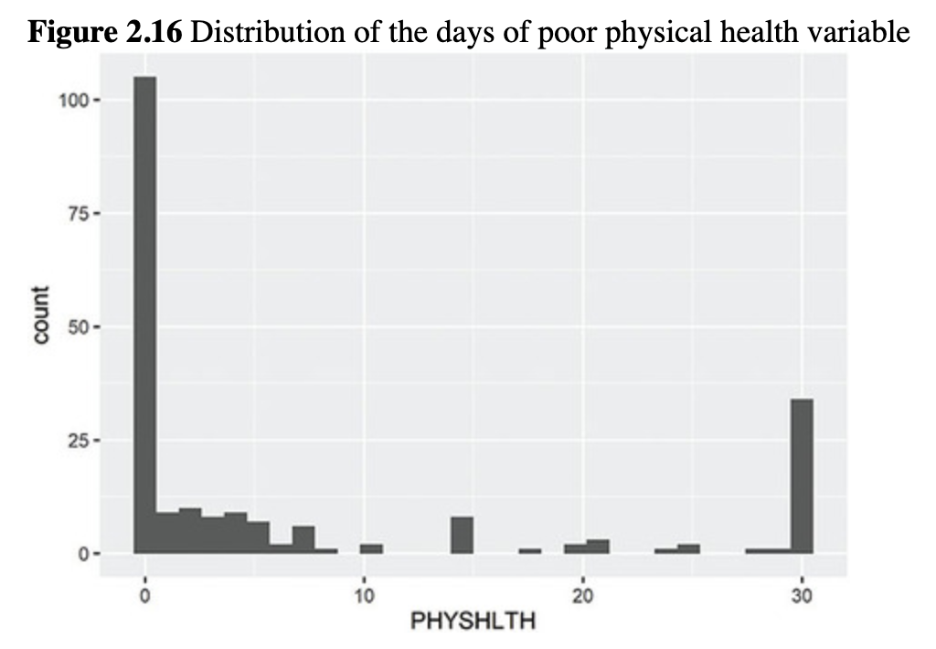

*# use print to show table*

**print**(x = trans.hc.table,

    varLabels = TRUE,

    nonnormal = 'PHYSHLTH')

##

##                            Overall

##  n                           222

##  Transition status (n = 220) (%)

##   Male to female                  77 (35.0)

##   Female to male                  112 (50.9)

##   Gender non-conforming              31 (14.1)

##  Age category (%)

##   40-44                        27 (12.2)

##   45-49                        27 (12.2)

##   50-54                        32 (14.4)

##   55-59                        44 (19.8)

##   60-64                        44 (19.8)

##   65-69                        24 (10.8)

##   70-74                        24 (10.8)

##  Race/ethnicity (%)

##   White                       152 (68.5)

##    Black                        31 (14.0)

##   Native American                   4 ( 1.8)

##    Asian/Pacific Islander               6 ( 2.7)

##    Other                        29 (13.1)

##  Income category (%)

##   Less than $15,000                 46 (20.7)

##    $15,000 to less than $25,000          44 (19.8)

##   $25,000 to less than $35,000          19 ( 8.6)

##   $35,000 to less than $50,000           26 (11.7)

##   $50,000 or more                   65 (29.3)

##    Don't know/not sure/missing           22 ( 9.9)

##  Education category (%)

##   Did not graduate high school           24 (10.8)

##   Graduated high school                86 (38.7)

##   Attended college/technical school         68 (30.6)

##   Graduated from college/technical school     44 (19.8)

##  Health insurance? = No (%)            24 (10.8)

##  Days/month poor physical health (median [IQR]) 1.00 [0.00, 11.00]

The R-Team was happy with the final product. Nancy explained that there is an R package called **kableExtra** that is more difficult to use, but offers more flexibility in formatting. She wanted to show Leslie the alternate way using **kableExtra**, but she knew that it might be a little overwhelming. Leslie suggested a quick coffee break first ☕. Kiara said that sounded perfect. They would caffeinate and then regroup to figure out a **kableExtra** table.

## 2.7.3 Creating a table from clean data (another way)

### 2.7.3.1 Creating a new data frame with summary statistics

Leslie joked that they had promised if she organized and annotated her code that she would not have to redo her work, and yet here she was, making the same table again. Nancy and Kiara smiled. Instead of continuing to work with the **tidyverse** formatting, Nancy suggested working in base R to get the summary statistics for this second way of building the table. She found this to be more straightforward for categorical variables and valuable to practice in general. Nancy explained that what they needed was a data frame with all the descriptive statistics they wanted listed in the table. Leslie started by creating a table of the percentages for the TRNSGNDR variable.

*# get percents for TRNSGNDR*

( trans.p <- **prop.table**(x = **table**(brfss.2014.small**$**TRNSGNDR)) )

##

##    Male to female    Female to male Gender non-conforming

##       0.3500000        0.5090909        0.1409091

These percentages needed some work. Leslie tried multiplying them by 100 and then rounding them to one decimal place, like the percentages in the table in the manuscript.

*# get percents for TRNSGNDR*

( trans.perc <- **round**(x = 100 **\* prop.table**(x = **table**(brfss.2014.small**$**TRNSGNDR)), 1) )

##

##    Male to female    Female to male Gender non-conforming

##         35.0            50.9           14.1

Perfect! However, there were six more variables in the table. Nancy explained they could easily merge the percentages from all the variables in the brfss.2014.small data frame by converting each table of percentages into a data frame, giving the data frame a name, and using rbind() to merge the data frames, like this:

*# get percents and assign a name for trans and race*

*# turn into data frames for easier merging*

( trans.perc <- **data.frame**(**round**(x = **prop.table**(x = **table**(brfss.2014.small**$**TRNSGNDR)) **\*** 100, 1)) )

##            Var1 Freq

## 1     Male to female 35.0

## 2     Female to male 50.9

## 3 Gender non-conforming 14.1

( race.perc <- **data.frame**(**round**(x = **prop.table**(x = **table**(brfss.2014.small**$**X_RACE)) **\*** 100, 1)) )

##             Var1 Freq

## 1           White 68.5

## 2           Black 14.0

## 3     Native American 1.8

## 4 Asian/Pacific Islander 2.7

## 5           Other 13.1

*# merge together into one data frame*

( table.perc <- **rbind**(trans.perc, race.perc) )

##             Var1 Freq

## 1      Male to female 35.0

## 2      Female to male 50.9

## 3  Gender non-conforming 14.1

## 4            White 68.5

## 5           Black 14.0

## 6      Native American 1.8

## 7 Asian/Pacific Islander 2.7

## 8            Other 13.1

Leslie thought Nancy must have had several cups of coffee on their break given how fast she typed the code.

### 2.7.3.2 Using a custom function for repeated code

Leslie noted that rbind() worked great to create a data frame with each category and the percentage in that category. However, with seven variables to work with, Nancy suggested that they could be more efficient by writing their own [***function***](https://jigsaw.vitalsource.com/books/9781506388144/epub/OEBPS/s9781506388175.i4970.xhtml#s9781506388175.i7100), known as a [***custom function***](https://jigsaw.vitalsource.com/books/9781506388144/epub/OEBPS/s9781506388175.i4970.xhtml#s9781506388175.i7055). Kiara wondered if they could also use a [***for loop***](https://jigsaw.vitalsource.com/books/9781506388144/epub/OEBPS/s9781506388175.i4970.xhtml#s9781506388175.i7095). Nancy thought this would work, too, but they would try writing a function first. Leslie thought they should just use rbind() to do the whole thing, which Nancy said would also work, but she wanted to at least try one custom function. Nancy showed Leslie that she could put the code used to get the percentages into a function with the name of the object being replaced by x. She reminded Leslie that function names are in upper camel case ([Section 1.6.3.3](https://jigsaw.vitalsource.com/books/9781506388144/epub/OEBPS/s9781506388175.i1081.xhtml#s9781506388175.i1186)) and began writing the TableFun() function.

*# finding percents and rounding to one decimal place*

*# putting all percents in one column with cbind*

TableFun <- ***function***(x){

**data.frame**(**round**(x = **prop.table**(x = **table**(x)) **\*** 100, 1))

}

This code creates a function called TableFun() that would apply the code inside the curly brackets {} to any variable. To use TableFun() on a single variable, Nancy showed Leslie she could just type TableFun() with the name of the variable in parentheses, like this:

*# using the TableFun function for the TRNSGNDR variable*

**TableFun**(x = brfss.2014.small**$**TRNSGNDR)

##              x Freq

## 1     Male to female 35.0

## 2     Female to male 50.9

## 3 Gender non-conforming 14.1

### 2.7.3.3 Using the apply family

However, said Nancy, it is complicated to use the function on all the variables in the brfss.2014.small data set at one time. One way to do it is to use the lapply() function, which is part of the apply family of functions ([Box 2.2](https://jigsaw.vitalsource.com/books/9781506388144/epub/OEBPS/s9781506388175.i1382.xhtml#s9781506388175.i1670)). The lapply() function is used to apply some code to each item in a list. In this case, use lapply() to apply TableFun()to each variable in the brfss.2014.small data frame. Nancy told Leslie that data frames are a special type of list where each variable is an element of the list.

2.2 Nancy’s fancy code: *apply* and *lapply*



The *apply* family of functions can be used to do something to every row or column or both of a data frame or matrix or list. For example, if there were a small data frame that included the number of hot dogs several cousins ate each year for the last 2 years, the apply() function could be used to find the mean for each cousin (the rows) or each year (the columns).

*#vectors for each variable*

hotdogs.2016 <- **c**(6, 2, 0, 3, 9, 1)

hotdogs.2017 <- **c**(8, 3, 0, 2, 6, 2)

cousins <- **c**("Therese", "Geoff", "Nick", "John", "Jim", "Karen")

*#make a data frame from vectors*

*#use cousins vector as row name rather than variable*

cuz.hot.dogs <- **data.frame**(hotdogs.2016, hotdogs.2017)

**row.names**(x = cuz.hot.dogs) <- cousins

cuz.hot.dogs

##     hotdogs.2016 hotdogs.2017

## Therese       6       8

## Geoff        2       3

## Nick         0        0

## John         3       2

## Jim         9        6

## Karen        1       2

To find the mean for each cousin, use apply() for rows. The apply() function takes three arguments: data frame or matrix name (X =), rows or columns (MARGIN =), and function name (FUN =). For rows, the MARGIN = argument would be 1. For columns, the MARGIN = argument would be 2.

*# mean by observation*

**apply**(X = cuz.hot.dogs, MARGIN = 1, FUN = mean)

## Therese  Geoff   Nick  John   Jim   Karen

##   7.0   2.5    0.0   2.5   7.5    1.5

To find the mean for each year, use apply() for columns.

*# mean by variable*

**apply**(X = cuz.hot.dogs, MARGIN = 2, FUN = mean)

## hotdogs.2016 hotdogs.2017

##      3.5      3.5

Use lapply() instead if there is a list rather than a data frame. Perhaps it is a list of the pets the cousins have and also their favorite ice cream flavor.

*# make a list*

cuz.list <- **list**(pet = **c**('cat', 'dog', 'dog', 'cat', 'bird', 'cat'),

           ice.cream = **c**('vanilla', 'chocolate',

                    'chocolate', 'chocolate',

                    'strawberry', 'strawberry'))

*# print the list*

cuz.list

## $pet

## [1] "cat" "dog" "dog" "cat" "bird" "cat"

##

## $ice.cream

## [1] "vanilla" "chocolate" "chocolate" "chocolate" "strawberry"

## [6] "strawberry"

To create a frequency table for each variable, use lapply() with two arguments. The first argument is the name of the list; the second is the function to use on each element of the list.

*# make a table for each*

*# variable in cuzList list*

**lapply**(X = cuz.list, FUN = table)

## $pet

##

## bird cat dog

##  1  3   2

##

## $ice.cream

##

## chocolate strawberry  vanilla

##      3      2      1

Nancy went on to explain that using lapply() to apply TableFun()to the brfss.2014.small data frame would result in a list of tables of percentages, one table for each variable in the data frame. Once this list of tables is ready, she said, combine the tables using rbind() to merge objects by rows. Because there are seven tables to merge together, use the do.call() function to apply the rbind() function to each item in the list.

The do.call() function acts like a loop, conducting the same analyses for each element in the object, then starting over on the next element. So, Nancy summarized, TableFun()is applied to get tables of percentages from each variable in the brfss.2014.small data frame and then the do.call() function puts the table of percentages together using rbind() by going through and adding each table to the others one at a time. Leslie thought they should just have used rbind() and they would have been done by now.

Nancy explained that this process results in a new data frame containing each of the categories for each variable and the percentage of survey participants in the category. Leslie remembered that the brfss.2014.small data frame included the PHYSHLTH variable, which was not in the table. To exclude the PHYSHLTH variable from the calculations, they could take a subset of the variables by using the square brackets and subtracting the column where the variable was stored from the data frame. Leslie opened the data frame by clicking on it once under the Environment tab and counted to see that the PHYSHLTH variable was in column 7. They added −7 to the code to remove this column.

*# use lapply to apply the TableFun function to*

*# all the variables in the data frame*

*# use the do.call function to call the rbind function*

*# to combine the list items into rows*

( table.data <- **do.call**(rbind, (**lapply**(X = brfss.2014.small[ , -7], FUN = TableFun))) )

##                             x Freq

## TRNSGNDR.1               Male to female 35.0

## TRNSGNDR.2               Female to male 50.9

## TRNSGNDR.3            Gender non-conforming 14.1

## X_AGEG5YR.1                    40-44 12.2

## X_AGEG5YR.2                    45-49 12.2

## X_AGEG5YR.3                    50-54 14.4

## X_AGEG5YR.4                    55-59 19.8

## X_AGEG5YR.5                    60-64 19.8

## X_AGEG5YR.6                    65-69 10.8

## X_AGEG5YR.7                    70-74 10.8

## X_RACE.1                      White 68.5

## X_RACE.2                      Black 14.0

## X_RACE.3                 Native American 1.8

## X_RACE.4            Asian/Pacific Islander 2.7

## X_RACE.5                      Other 13.1

## X_INCOMG.1               Less than $15,000 20.7

## X_INCOMG.2        $15,000 to less than $25,000 19.8

## X_INCOMG.3        $25,000 to less than $35,000 8.6

## X_INCOMG.4       $35,000 to less than $50,000 11.7

## X_INCOMG.5               $50,000 or more 29.3

## X_INCOMG.6         Don't know/not sure/missing 9.9

## X_EDUCAG.1        Did not graduate high school 10.8

## X_EDUCAG.2            Graduated high school 38.7

## X_EDUCAG.3     Attended college/technical school 30.6

## X_EDUCAG.4 Graduated from college/technical school 19.8

## HLTHPLN1.1                       Yes 89.2

## HLTHPLN1.2                       No 10.8

After she had looked at the table.data object, Leslie noticed that there were 27 observations (or rows) with row labels and two variables per row, x for the category name, and Freq for the percentage in the category. The last row was the No category for health care, which was not in the original table. She removed the last row by taking a subset of the table.data data frame so it included just rows 1 through 26.

*# remove health care No category*

table.data <- **data.frame**(table.data[**c**(1**:**26), ])

Finally, Leslie labeled the columns of the data frame to be consistent with the table columns.

*# label the columns*

**colnames**(x = table.data) <- **c**("Survey participant demographics (n = 220)", "Percent")

Nancy reassured Leslie that all of the functions used here would be used and explained multiple times throughout their meetings, so not to worry if rbind() or do.call() or anything else was not yet 100% clear. There would be additional opportunities to use these and all the other functions. Nancy suggested copying and pasting any new functions Leslie was trying to use and changing little things to see what would happen. In this way, the purpose of each part of the code might become clearer. Nancy also suggested that the help documentation in the lower left pane of RStudio and searching online can be useful for finding examples of code to play with and use.

Nancy also reminded Leslie that, if a function seems like too much at this point, she could always use the rbind() method they used earlier and wait until she was more comfortable with R to write her own functions. Kiara still thought for loops might be better, so she wrote some instructions about for loops for Leslie to review if she wanted yet another option ([Box 2.3](https://jigsaw.vitalsource.com/books/9781506388144/epub/OEBPS/s9781506388175.i1382.xhtml#s9781506388175.i1682)).

2.3 Kiara’s reproducibility resource: Using for loops instead of functions

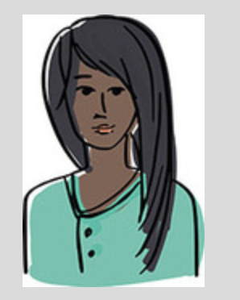

The function worked well to get the data ready for a **kableExtra** table. However, Kiara suggested that some people prefer to write functions only when they will be useful for more than one project. For loops are another option and are a fundamental aspect of computer programming. There are for loops in all programming languages, not just R. They are a way of doing the same thing multiple times, or doing something [***iteratively***](https://jigsaw.vitalsource.com/books/9781506388144/epub/OEBPS/s9781506388175.i4970.xhtml#s9781506388175.i7129). A for loop can be read as “for each item in (things you want to iterate over), do something.” Kiara wrote the basic structure of a for loop.

*# basic format of a for loop*

***for*** (i ***in*** 1**:**some number) {

  do something

}

The parts of the loop are as follows:

* The 1:some number contains the elements you want to iterate over. For the **kableExtra** table, the same function would be used for the 7 variables from the brfss.2014.small data frame. This would be 1:7. However, sometimes it is not clear how many iterations to do. For example, if you knew you wanted to do the same thing for each row in a data frame, but you didn’t know off the top of your head how many rows there were, you could do 1:nrow(data.frame). The nrow() function counts the number of rows.
* The i stands for “each” and is the same type of i seen in equations. The top line then reads: “For each element in 1 through some number.”
* The curly brackets { } are around the body of the for loop. Whatever it is that should be done a lot of times, put that in the { }.
* Most of the time the output would be stored, which requires one extra step of making an *empty* object that will store the output. This is called *initializing*.

For example, to use a for loop to square some numbers, here is how it might look:

*# basic example of a for loop*

squared.numbers <- NULL *# initialize an empty vector that will*

*# contain the output*

***for*** (i ***in*** 1**:**10) {

 squared.numbers[i] <- i**^**2 *# body of the for loop*

}

*# print out the result*

**print**(squared.numbers)

## [1]  1  4  9  16  25  36  49  64  81 100

Kiara wrote out the meaning in text.

First, make an empty vector called squared.numbers. For each item in numbers 1 through 10, take that number or i and square it (i^2). Whatever the result of squaring i is, store that result in the squared.numbers vector.

She thought it might be necessary to explain why there is an [i] next to squared.numbers. The i is the element. So on the first iteration, i = 1. The squared.numbers[i] bit is saying to store the result of the 1st iteration in the 1st location of squared.numbers. On the 7th iteration, i = 7, make sure to store that result in the 7th location of the output squared.numbers.

Kiara wrote the initial for loop to use this structure to make the data frame for the **kableExtra** table that contains percentage per category of all 7 factors in the brfss.2014.small data set. As she wrote, she thought, “For each variable (or column) in brfss.2014.small, get the percentages via the prop.table function, and then combine the results into a single data frame.”

*# initialize an empty data frame*

table.data <- **data.frame**()

*# make the for loop*

***for*** (i ***in*** 1**:ncol**(brfss.2014.small)) {

*# get the percents for a variable and put them in table.each*

 table.each <-

**data.frame**(**round**(x = **prop.table**(x = **table**(brfss.2014.small[, i])) **\*** 100, 1))

*# combine table.each with whatever is in table.data already*

 table.data <- **rbind**(table.data, table.each)

}

*# print table.data*

table.data

##                       Var1 Freq

## 1                Male to female 35.0

## 2                Female to male 50.9

## 3            Gender non-conforming 14.1

## 4                      40-44 12.2

## 5                      45-49 12.2

## 6                      50-54 14.4

## 7                      55-59 19.8

## 8                      60-64 19.8

## 9                      65-69 10.8

## 10                     70-74 10.8

## 11                     White 68.5

## 12                     Black 14.0

## 13               Native American 1.8

## 14           Asian/Pacific Islander 2.7

## 15                     Other 13.1

## 16              Less than $15,000 20.7

## 17        $15,000 to less than $25,000 19.8

## 18        $25,000 to less than $35,000 8.6

## 19       $35,000 to less than $50,000 11.7

## 20               $50,000 or more 29.3

## 21       Don't know/not sure/missing 9.9

## 22       Did not graduate high school 10.8

## 23           Graduated high school 38.7

## 24    Attended college/technical school 30.6

## 25 Graduated from college/technical school 19.8

## 26                       Yes 89.2

## 27                       No 10.8

## 28                       0 49.5

## 29                        1 4.2

## 30                        2 4.7

## 31                        3 3.8

## 32                        4 4.2

## 33                        5 3.3

## 34                        6 0.9

## 35                        7 2.8

## 36                        8 0.5

## 37                        10 0.9

## 38                        14 0.9

## 39                       15 2.8

## 40                       18 0.5

## 41                       20 0.9

## 42                       21 1.4

## 43                       24 0.5

## 44                       25 0.9

## 45                       28 0.5

## 46                       29 0.5

## 47                       30 16.0

After this, there were still a couple details to work out. First, it was hard to tell which variable each of the categories was from in the first column, and the PHYSHLTH variable should have been excluded. Kiara edited the code to account for this by labeling the new data frame and removing the PHYSHLTH column from the loop.

*# initialize an empty data frame*

table.data <- **data.frame**()

*# write the for loop*

***for*** (i ***in*** 1**:**(**ncol**(brfss.2014.small) **-** 1)) {

*# first, get the table*

 table.each <-

**data.frame**(**round**(x = **prop.table**(x = **table**(brfss.2014.small[, i])) **\*** 100, 1))

*# store the column name of that iteration for labels*

 c.name <- **colnames**(brfss.2014.small[i])

*# make a new data frame that just contains the labels*

 label.names <- **data.frame**(Variable = **rep**(c.name, times = **nrow**(table.each)))

*# combine the label.names data frame and table.each data frame via columns*

 table.each.labelled <- **cbind**(label.names, table.each)

*# combine this with the table.data via rbind*

 table.data <- **rbind**(table.data, table.each.labelled)

}

*# print the new data frame*

table.data

##   Variable                    Var1 Freq

## 1  TRNSGNDR              Male to female 35.0

## 2  TRNSGNDR              Female to male 50.9

## 3  TRNSGNDR           Gender non-conforming 14.1

## 4 X_AGEG5YR                    40-44 12.2

## 5 X_AGEG5YR                    45-49 12.2

## 6 X_AGEG5YR                    50-54 14.4

## 7 X_AGEG5YR                    55-59 19.8

## 8 X_AGEG5YR                    60-64 19.8

## 9 X_AGEG5YR                    65-69 10.8

## 10 X_AGEG5YR                    70-74 10.8

## 11  X_RACE                    White 68.5

## 12  X_RACE                    Black 14.0

## 13  X_RACE               Native American 1.8

## 14  X_RACE           Asian/Pacific Islander 2.7

## 15  X_RACE                     Other 13.1

## 16 X_INCOMG              Less than $15,000 20.7

## 17 X_INCOMG       $15,000 to less than $25,000 19.8

## 18 X_INCOMG        $25,000 to less than $35,000 8.6

## 19 X_INCOMG        $35,000 to less than $50,000 11.7

## 20 X_INCOMG               $50,000 or more 29.3

## 21 X_INCOMG         Don't know/not sure/missing 9.9

## 22 X_EDUCAG        Did not graduate high school 10.8

## 23 X_EDUCAG            Graduated high school 38.7

## 24 X_EDUCAG     Attended college/technical school 30.6

## 25 X_EDUCAG Graduated from college/technical school 19.8

## 26 HLTHPLN1                      Yes 89.2

## 27 HLTHPLN1                       No 10.8

Two more adjustments were needed, making a subset of the table.data to exclude the last row and labeling the columns of the data frame to be consistent with the table columns.

*# subset and add labels*

table.data <- table.data[**c**(1**:**26), **c**(2**:**3)]

**colnames**(table.data) <- **c**("Survey participant demographics (n = 220)",

                 "Percent")

*# print the new data frame*

table.data

##     Survey participant demographics (n = 220) Percent

## 1                    Male to female   35.0

## 2                     Female to male   50.9

## 3                 Gender non-conforming  14.1

## 4                          40-44   12.2

## 5                          45-49   12.2

## 6                          50-54   14.4

## 7                          55-59   19.8

## 8                          60-64   19.8

## 9                          65-69   10.8

## 10                          70-74   10.8

## 11                           White   68.5

## 12                           Black   14.0

## 13                     Native American   1.8

## 14                 Asian/Pacific Islander   2.7

## 15                           Other   13.1

## 16                    Less than $15,000   20.7

## 17             $15,000 to less than $25,000   19.8

## 18             $25,000 to less than $35,000   8.6

## 19             $35,000 to less than $50,000   11.7

## 20                     $50,000 or more   29.3

## 21              Don't know/not sure/missing   9.9

## 22             Did not graduate high school   10.8

## 23                 Graduated high school   38.7

## 24          Attended college/technical school   30.6

## 25       Graduated from college/technical school   19.8

## 26                             Yes   89.2

The table.data data frame was now ready to go into a **kableExtra** table in [Section 2.7.3.4](https://jigsaw.vitalsource.com/books/9781506388144/epub/OEBPS/s9781506388175.i1382.xhtml#s9781506388175.i1693).

### 2.7.3.4 Formatting tables with *kable()*

Finally, with a clean data frame containing all the information for the table, Nancy showed Leslie that the pipe structure can be used to send the data frame to kable() for formatting. Two packages are used in creating well-formatted kable tables, **knitr** and **kableExtra**. The **knitr** package is used to get the basic table, while the **kableExtra** package is used for some of the formatting options like adding sections.

**Table 2.2** Transgender Survey Participant Demographics

| Table 2.2 Transgender Survey Participant Demographics | | |
| --- | --- | --- |
| Variable | Survey participant demographics (*n* = 220) | Percent |
| TRNSGNDR.1 | Male to female | 35.0 |
| TRNSGNDR.2 | Female to male | 50.9 |
| TRNSGNDR.3 | Gender non-conforming | 14.1 |
| X_AGEG5YR.1 | 40–44 | 12.2 |
| X_AGEG5YR.2 | 45–49 | 12.2 |
| X_AGEG5YR.3 | 50–54 | 14.4 |
| X_AGEG5YR.4 | 55–59 | 19.8 |
| X_AGEG5YR.5 | 60–64 | 19.8 |
| X_AGEG5YR.6 | 65–69 | 10.8 |
| X_AGEG5YR.7 | 70–74 | 10.8 |
| X_RACE.1 | White | 68.5 |
| X_RACE.2 | Black | 14.0 |
| X_RACE.3 | Native American | 1.8 |
| X_RACE.4 | Asian/Pacific Islander | 2.7 |
| X_RACE.5 | Other | 13.1 |
| X_INCOMG.1 | Less than $15,000 | 20.7 |
| X_INCOMG.2 | $15,000 to less than $25,000 | 19.8 |
| X_INCOMG.3 | $25,000 to less than $35,000 | 8.6 |
| X_INCOMG.4 | $35,000 to less than $50,000 | 11.7 |
| X_INCOMG.5 | $50,000 or more | 29.3 |
| X_INCOMG.6 | Don’t know/not sure/missing | 9.9 |
| X_EDUCAG.1 | Did not graduate high school | 10.8 |
| X_EDUCAG.2 | Graduated high school | 38.7 |
| X_EDUCAG.3 | Attended college/technical school | 30.6 |
| X_EDUCAG.4 | Graduated from college/technical school | 19.8 |
| HLTHPLN1.1 | Yes | 89.2 |

*# open libraries*

**library**(package = "knitr")

**library**(package = "kableExtra")

*# send the table.data to kable and add a title (Table 2.2)*

table.data **%>%**

**kable**(format = "html",

    caption = "Transgender Survey Participant Demographics") **%>%**

**kable_styling()**

“Well, [Table 2.2](https://jigsaw.vitalsource.com/books/9781506388144/epub/OEBPS/s9781506388175.i1382.xhtml#s9781506388175.i1694) is a start,” thought Leslie after she finally found the table in the viewer pane. For the final formatting, Nancy showed Leslie how to add labels by using the pipe structure. For each variable, use the group_rows() argument with the name of the variable and the rows the variable categories are in. For example, rows 1 to 3 are the transition status, so the first group_rows() argument shows: group_rows("Transition status", 1, 3).

Unfortunately, group_rows() is one of those functions that is in more than one R package. It is in the **dplyr** package, which is part of the **tidyverse**, and it is in the **kableExtra** package. There are a couple of options to avoid the conflict: remove the **dplyr** package while creating the table, or use the :: format to specify that the group_rows() function should be from the **kableExtra** package. Since **dplyr** is used for most of the data management tasks, Leslie decided to go with the :: option and created [Table 2.3](https://jigsaw.vitalsource.com/books/9781506388144/epub/OEBPS/s9781506388175.i1382.xhtml#s9781506388175.i1701).

*# add the section names (Table 2.3)*

table.data **%>%**

**kable**(format = "html",

 caption = "Transgender Survey Participant Demographics",

    row.names = FALSE) **%>%**

kableExtra**::group_rows**(group_label = "Transition status",

        start_row = 1, end_row = 3) **%>%**

kableExtra**::group_rows**(group_label = "Age category",

        start_row = 4, end_row = 10) **%>%**

kableExtra**::group_rows**(group_label = "Race/ethnicity",

        start_row = 11, end_row = 15) **%>%**

kableExtra**::group_rows**(group_label = "Income category",

        start_row = 16, end_row = 21) **%>%**

kableExtra**::group_rows**(group_label = "Education category",

        start_row = 22, end_row = 25) **%>%**

kableExtra**::group_rows**(group_label = "Health insurance?",

        start_row = 26, end_row = 26)

Now that she had the manuscript table reproduced, Leslie was interested in making the bigger table with frequencies, and the median and IQR of PHYSHLTH. The first step, said Nancy, is to create a function (or expand TableFun()) to compute both frequencies and percentages. The table() function computes frequencies, so add it to TableFun and rename TableFun something logical like TableFreqPerc. Nancy wrote the code, but Leslie did not see the difference between TableFun() and TableFreqPerc(). Nancy showed her there was now a table() function before the prop.table() part.

**Table 2.3** Transgender Survey Participant Demographics

| Table 2.3 Transgender Survey Participant Demographics | |
| --- | --- |
| Variable Survey participant demographics (*n* = 220) | Percent |
| **Transition status** | |
| Male to female | 35.0 |
| Female to male | 50.9 |
| Gender non-conforming | 14.1 |
| **Age category** | |
| 40–44 | 12.2 |
| 45–49 | 12.2 |
| 50–54 | 14.4 |
| 55–59 | 19.8 |
| 60–64 | 19.8 |
| 65–69 | 10.8 |
| 70–74 | 10.8 |
| **Race/ethnicity** | |
| White | 68.5 |
| Black | 14.0 |
| Native American | 1.8 |
| Asian/Pacific Islander | 2.7 |
| Other | 13.1 |
| **Income category** | |
| Less than $15,000 | 20.7 |
| $15,000 to less than $25,000 | 19.8 |
| $25,000 to less than $35,000 | 8.6 |
| $35,000 to less than $50,000 | 11.7 |
| $50,000 or more | 29.3 |
| Don’t know/not sure/missing | 9.9 |
| **Education category** | |
| Did not graduate high school | 10.8 |
| Graduated high school | 38.7 |
| Attended college/technical school | 30.6 |
| Graduated from college/technical school | 19.8 |
| **Health insurance?** | |
| Yes | 89.2 |

*# revise the TableFun function to compute both*

*# frequencies and percentages for Table 2.4*

TableFreqPerc<- ***function***(x){

**data.frame**(**table**(x), **round**(x = **prop.table**(x = **table**(x)) **\*** 100, 1))

}

*# apply new function to brfss.2014.small data frame*

bigger.table <- **do.call**(rbind, (**lapply**(X = brfss.2014.small, FUN = TableFreqPerc)))

*# click on the bigger.table object in the Environment*

*# pane to see the resulting table*

*# note that the categories show up twice in the data frame*

*# delete the second occurrence by making a subset of the data*

bigger.table <- bigger.table[**-**3]

*# remove Health insurance No category and PHYSHLTH numbers*

bigger.table <- **data.frame**(bigger.table[**c**(1**:**26), ])

*#add variable names*

**names**(x = bigger.table) <- **c**("Survey participant demographics (n = 220)", "Frequency", "Percent")

Now with a clean data frame, Leslie used the code from the smaller table—replacing "table.data" with "bigger.table"—to create a table with both frequencies and percentages ([Table 2.4](https://jigsaw.vitalsource.com/books/9781506388144/epub/OEBPS/s9781506388175.i1382.xhtml#s9781506388175.i1705)).

**Table 2.4** Transgender Survey Participant Demographics

| Table 2.4 Transgender Survey Participant Demographics | | |
| --- | --- | --- |
| Survey participant demographics (*n* = 220) | Frequency | Percent |
| **Transition status** | | |
| Male to female | 77 | 35.0 |
| Female to male | 112 | 50.9 |
| Gender non-conforming | 31 | 14.1 |
| **Age category** | | |
| 40–44 | 27 | 12.2 |
| 45–49 | 27 | 12.2 |
| 50–54 | 32 | 14.4 |
| 55–59 | 44 | 19.8 |
| 60–64 | 44 | 19.8 |
| 65–69 | 24 | 10.8 |
| 70–74 | 24 | 10.8 |
| **Race/ethnicity** | | |
| White | 152 | 68.5 |
| Black | 31 | 14.0 |
| Native American | 4 | 1.8 |
| Asian/Pacific Islander | 6 | 2.7 |
| Other | 29 | 13.1 |
| **Income category** | | |
| Less than $15,000 | 46 | 20.7 |
| $15,000 to less than $25,000 | 44 | 19.8 |
| $25,000 to less than $35,000 | 19 | 8.6 |
| $35,000 to less than $50,000 | 26 | 11.7 |
| $50,000 or more | 65 | 29.3 |
| Don’t know/not sure/missing | 22 | 9.9 |
| **Education category** | | |
| Did not graduate high school | 24 | 10.8 |
| Graduated high school | 86 | 38.7 |
| Attended college/technical school | 68 | 30.6 |
| Graduated from college/technical school | 44 | 19.8 |
| **Health insurance?** | | |
| Yes | 198 | 89.2 |

Although the original table creation was tedious, Leslie found that adding frequencies and rerunning the table code was not nearly as time-consuming.

The last thing, said Nancy, is to add the continuous PHYSHLTH variable to the table. Leslie reminded herself of the median and IQR for PHYSHLTH first.

*# descriptive statistics for PHYSHLTH*

**median**(x = brfss.2014.small**$**PHYSHLTH, na.rm = TRUE)

## [1] 1

**IQR**(x = brfss.2014.small**$**PHYSHLTH, na.rm = TRUE)

## [1] 11

The median days of poor physical health per month in this group was 1, and the IQR shows that there is an 11-day spread for the middle half of the people in this group. She hadn’t been paying attention to the

values in the CreateTableOne process and noticed that this was quite different from the median of 0 and the IQR of 3 for the full data set. This group of transgender survey participants had a higher median number of days of poor health and more variation than the full sample. The other thing she noticed was the spread of people across income categories. Large percentages were in the lowest income category and the highest income category, with fewer people in between. Leslie wondered how this compared to all people in this age group, not just people who are transgender.

Now that Leslie was aware of what she was looking for in the table, Nancy told her that adding the code to the table required a few steps. She wrote the code with lots of comments and then walked Leslie through it. She decided to remove the “(*n* = 220)” from the column header now that they were expanding the table beyond reproducing [Table 2.1](https://jigsaw.vitalsource.com/books/9781506388144/epub/OEBPS/s9781506388175.i1382.xhtml#s9781506388175.i1393).

*# revise the TableFreqPerc function to compute*

*# frequencies and percents for factors*

*# median and IQR for numeric data types for Table 2.5*

TableFreqPerc<- ***function***(x){

***if***(**is.factor**(x))

**data.frame**(**table**(x), **round**(x = **prop.table**(x = **table**(x)) **\*** 100, 1))

}

*# apply new function to brfss.2014.small data frame*

bigger.table <- **do.call**(rbind, (**lapply**(X = brfss.2014.small, FUN = TableFreqPerc)))

*# note that the categories show up twice in the data frame*

*# delete the second occurrence by making a subset of the data*

bigger.table <- bigger.table[**-**3]

*# remove Health insurance No category*

bigger.table <- **data.frame**(bigger.table[**c**(1**:**26), ])

*# add the age summary data*

*# make a small data frame for the age information*

bigger.table <- **rbind**(bigger.table, **data.frame**(x="Poor health (days/mo)",

                      Freq = **median**(x = brfss.2014.small**$**PHYSHLTH,

                            na.rm = TRUE),

                      Freq.1 = **IQR**(x = brfss.2014.small**$**PHYSHLTH,

                            na.rm = TRUE)))

*# add variable names*

**names**(bigger.table) <- **c**("Survey participant demographics", "Frequency", "Percent")

Once the values were all together in the new data frame, Nancy told Leslie that she could reuse code from earlier to create a formatted [Table 2.5](https://jigsaw.vitalsource.com/books/9781506388144/epub/OEBPS/s9781506388175.i1382.xhtml#s9781506388175.i1712). Leslie left the “(*n* = 220)” out of the “Survey participant demographics” column title and added the overall sample size and the sample size for the transition status variable since the table was no longer truly a reproduced version of [Table 2.1](https://jigsaw.vitalsource.com/books/9781506388144/epub/OEBPS/s9781506388175.i1382.xhtml#s9781506388175.i1393). Finally, she added one more kableExtra:: section for row 27 to add the group_label = "Days poor physical health per month (median, IQR)" to the last section.

**Table 2.5** Transgender Survey Participant Demographics (*n* = 222)

| Table 2.5 Transgender Survey Participant Demographics (n = 222) | | |
| --- | --- | --- |
| Survey participant demographics | Frequency | Percent |
| **Transition status (*n* = 220)** | | |
| Male to female | 77 | 35.0 |
| Female to male | 112 | 50.9 |
| Gender non-conforming | 31 | 14.1 |
| **Age category** | | |
| 40–44 | 27 | 12.2 |
| 45–49 | 27 | 12.2 |
| 50–54 | 32 | 14.4 |
| 55–59 | 44 | 19.8 |
| 60–64 | 44 | 19.8 |
| 65–69 | 24 | 10.8 |
| 70–74 | 24 | 10.8 |
| **Race/ethnicity** | | |
| White | 152 | 68.5 |
| Black | 31 | 14.0 |
| Native American | 4 | 1.8 |
| Asian/Pacific Islander | 6 | 2.7 |
| Other | 29 | 13.1 |
| **Income category** | | |
| Less than $15,000 | 46 | 20.7 |
| $15,000 to less than $25,000 | 44 | 19.8 |
| $25,000 to less than $35,000 | 19 | 8.6 |
| $35,000 to less than $50,000 | 26 | 11.7 |
| $50,000 or more | 65 | 29.3 |
| Don’t know/not sure/missing | 22 | 9.9 |
| **Education category** | | |
| Did not graduate high school | 24 | 10.8 |
| Graduated high school | 86 | 38.7 |
| Attended college/technical school | 68 | 30.6 |
| Graduated from college/technical school | 44 | 19.8 |
| **Health insurance?** | | |
| Yes | 198 | 89.2 |
| **Days poor physical health per month (median, IQR)** | | |
| Poor health (days/mo) | 1 | 11.0 |

Leslie took a few minutes to write an interpretation of the results and the information reported in [Table 2.5](https://jigsaw.vitalsource.com/books/9781506388144/epub/OEBPS/s9781506388175.i1382.xhtml#s9781506388175.i1712).

Of the participants in the 2014 BRFSS, 222 people identified as transgender, were 40–74 years old (the age range when mammograms are recommended), and were asked about having a mammogram. Of these, 77 were male-to-female (35.0%), 112 were female-to-male (50.9%), and 31 were gender non-conforming (14.1%). Most were White (*n* = 152; 68.5%) or Black (*n* = 31; 14.0%). The most common age groups were 50–54 (*n* = 44; 19.8%) and 55–59 (*n* = 44; 19.8%).

Kiara stopped Leslie before she finished to let her know that, when there is a table in a report or manuscript, it is usually not necessary to interpret every number in the table. In fact, she said, this can be seen as repetition and a poor use of space. Kiara recommended that Leslie report information from the table that is important to the study at hand or that is unusual in some way. Leslie thought that made sense, since the entire purpose of a table is to report results in a clear way. Kiara commented that the interpretation she started to write was correct and clear, just that it had more detail than needed.

Everyone was exhausted, but before quitting, they went back over what they had learned about R and about transgender health care. Leslie felt like she learned a lot about descriptive statistics but that they did not get too much into the issue of transgender health care and cancer screening other than learning that this group has a high median number of days of poor health per month and a strange distribution of income, which were both things that might be important to explore further. Nancy and Kiara agreed and thought they might have some meetings where this happens just due to what they had learned that day. The team made a plan to meet soon to learn about graphing, which, as Nancy reminded everyone, is one of the biggest strengths of R.

It had been so long since they walked into the café that Leslie was hungry for another snack. Nancy and Kiara were chatting while they walked toward the door when they noticed that Leslie was not with them. They turned around to see her back in the line for food. Leslie waved. “See you next time.”

Kiara and Nancy paused for a second but decided not to wait. Nancy waved back. “Not if I see you first!” she joked.

Kiara just rolled her eyes, ready to head home and relax after such an intense meeting.

# 2.8 Chapter summary

Congratulations! Like Leslie, you’ve learned and practiced the following in this chapter.

## 2.8.1 Achievements unlocked in this chapter: Recap

### 2.8.1.1 Achievement 1 recap: Understanding variable types and data types

The main variable types in social science are continuous and categorical, which are *numeric* and *factor* data types in R. True continuous variables can take any value along a continuum (e.g., height), while categorical variables are measured in categories (e.g., marital status).

### 2.8.1.2 Achievement 2 recap: Choosing and conducting descriptive analyses for categorical (factor) variables

Descriptive statistics most appropriate for factor-type variables are frequencies, which show the number of observations for each category, and percentages, which show the percentage of observations for each category.

### 2.8.1.3 Achievement 3 recap: Choosing and conducting descriptive analyses for continuous (numeric) variables

If a numeric variable is normally distributed, the appropriate descriptive statistics to report are the mean and

standard deviation. The mean is a measure of central tendency that provides some idea of where the middle of the data is. The standard deviation is a measure of spread that indicates how spread out the values are. If a numeric variable is not normally distributed, the median and range or median and IQR are reported. The median is the middle value, while the IQR is the boundaries around the middle 50% of values.

### 2.8.1.4 Achievement 4 recap: Developing clear tables for reporting descriptive statistics

Computing the correct statistics is a great start, but organizing statistics in formats that are easy to understand is a key part of being an effective analyst. Creating tables that follow good formatting practices is one way to do this. Good formatting practices include number alignment, use of descriptive titles, choosing and reporting a consistent number of decimal places, and other formatting options.

## 2.8.2 Chapter exercises

The coder and hacker exercises are an opportunity to apply the skills from this chapter to a new scenario or a new data set. The coder edition evaluates the application of the concepts and functions learned in this R-Team meeting to new scenarios similar to those in the meeting. The hacker edition evaluates the use of the concepts and functions from this R-Team meeting in new scenarios, often going a step beyond what was explicitly explained.

The coder edition might be best for those who found some or all of the Check Your Understanding activities to be challenging or if they needed review before picking the correct responses to the multiple-choice questions. The hacker edition might be best if the Check Your Understanding activities were not too challenging and the multiple-choice questions were a breeze.

The multiple-choice questions and materials for the exercises are online at [**edge.sagepub.com/harris1e**](http://edge.sagepub.com/harris1e).

* Q1: What is a measure of spread that is appropriate for each central tendency?
  1. Mean
  2. Median
  3. Mode
* Q2: Which of the following measures would be most appropriate for describing the central tendency of a variable that is continuous and normally distributed?
  1. Mean
  2. Variance
  3. Median
  4. Mode
* Q3: Which of the following measures would be most appropriate for describing the spread of a variable that is extremely right-skewed?
  1. Standard deviation
  2. Range
  3. IQR
  4. Mode
* Q4: In R, categorical variables are best represented by the _____________ data type and continuous variables are best represented by the _____________ data type.
* Q5: Custom functions are useful when doing which of the following?
  1. Loading a library
  2. Visualizing the distribution of one variable
  3. Working with continuous variables
  4. Doing the same thing multiple times

### 2.8.2.1 Chapter exercises: Coder edition

Use the BRFSS data in the **transgender_hc_ch2.csv** file at [**edge.sagepub.com/harris1e**](http://edge.sagepub.com/harris1e) to create a table of appropriate descriptive statistics for *all* transgender participants in the 2014 BRFSS. Spend a few minutes looking through the BRFSS website before beginning. Include variables representing transition status, days of poor physical health (PHYSHLTH), race/ethnicity, income, education, age, and age category. Write a paragraph using the numbers in the table to describe the characteristics of the transgender participants of the 2014 BRFSS.

* 1) Open the **transgender_hc_ch2.csv** 2014 BRFSS data file.
* 2) Select the data including only transgender participants.
* 3) Select the data including only the variables of interest.
* 4) Check the data types of all the variables and fix any that seem incorrect (Achievement 1).
* 5) Based on the BRFSS codebook, code missing values and add category labels appropriately.
* 6) Choose and conduct appropriate descriptive statistics for all variables in the small data set (Achievements 2 and 3).
* 7) Develop a well-formatted table of results including all variables in the small data set (Achievement 4).
* 8) Add a prolog and comments to your code.
* 9) Summarize the characteristics of transgender survey participants in the 2014 BRFSS.

### 2.8.2.2 Chapter exercises: Hacker edition

Complete #1–#5 from the coder edition; then do the following:

* 6) Find the mean or median value of PHYSHLTH (whichever is most appropriate) and recode to create a new factor variable with values above the mean or median labeled as “poor physical health” and values below the mean labeled as “good physical health”; check your coding (Achievement 3).
* 7) Choose and conduct appropriate descriptive statistics for all variables in the small data set (Achievements 2 and 3).
* 8) Develop a well-formatted table of results including all variables in the small data set (Achievement 4).
* 9) Add a prolog and comments to your code.
* 10) Summarize the characteristics of transgender survey participants in the 2014 BRFSS.

### 2.8.2.3 Instructor note

Solutions to exercises can be found on the website for this book, along with ideas for gamification for those who want to take it further.

Visit [**edge.sagepub.com/harris1e**](http://edge.sagepub.com/harris1e) to download the datasets, complete the chapter exercises, and watch R tutorial videos.